

<https://s3.amazonaws.com/codecademy-content/courses/freelance-1/unit-2/pattern.jpeg>

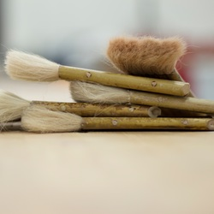

<https://s3.amazonaws.com/codecademy-content/courses/freelance-1/unit-2/hacksaw.jpeg>



<https://s3.amazonaws.com/codecademy-content/courses/freelance-1/unit-2/frames.jpeg>



<https://s3.amazonaws.com/codecademy-content/courses/freelance-1/unit-2/finnish.jpeg>