Name:
Introductory Economics Lab http://www.depauw.edu/learn/introeconlab
Excel Workbook: SupplyDemand.xls

Supply and Demand Lab

Introduction

Welcome to the first lab! These computer-based labs are designed to enable you to practice with concrete problems and data. They are integrated with Excel workbooks and web sites so you will be moving across a variety of programs on your computer as you work through the lab.

The Excel workbooks are the primary delivery vehicle for the content. The fundamental pedagogical principle at work is that concrete, visual presentation of abstract ideas is an excellent way to learn. By clicking on buttons or changing cells, you see how a graph or solution changes. Instead of dead, printed graphs, you have dynamic charts that instantly reflect shocks you impose. In economics, a shock is a change in the environment in which agents operate.

The labs are not designed to be standalone. You will need an introductory Economics textbook to help you answer some of the questions. There are many available and it doesn’t really matter which one you use because they are all going to cover the basics.

You complete the labs by reading the appropriate sections or chapters in your textbook, then following the instructions in the lab and answering the questions. You type your answers in this Word document and submit it via printout and/or electronically.

Like labs in biology or chemistry, these labs ask you to describe your procedure and document your sources as you discover and learn. Often, the final answer will vary from one student to the next. Keep in mind that the method is more important than the final answer.

A marker will be used to indicate that you are to do a specific task.
The marker alerts you that there is a task and a question to be answered.
Keep your eye out for these markers and follow the instructions carefully.

Properly Configuring Excel

If you are unsure of what to do, see the ExcelBasics.doc file available at http://www.depauw.edu/learn/introeconlab/lab0.htm for instructions on how to open macro-enabled files and how to make a chart in Excel.
Supply and Demand

Open the SupplyDemand.xls workbook and read the Intro sheet. Make sure you enable macros when you open the file. If you haven’t already, you should read the chapter or chapters in your textbook on supply and demand. Don’t go too far. Read about the basics of supply and demand, including movement along versus shifts in demand and supply. Read about equilibrium in a market, including the process by which a market reaches equilibrium. Shortages lead to increases in price and surpluses cause price to fall. Shifts in supply and demand (caused by changes in the underlying variables of each curve) lead to new equilibrium price-quantity combinations. Supply and demand analysis is the process by which we figure out the effect on price and quantity from a given shock.

Q1) Find the Law of Demand in your textbook and quote it (by typing in the text in the box below). Document your quotation, including the author’s name, title of the textbook, edition, year of publication, and page number.

Enter your answer in this box. The box expands as you type in text.

Proceed to the Demand sheet.

The Demand sheet is designed to give you practice understanding demand curves and the difference between movements along a demand curve versus shifts in demand.

The sheet is built on a family’s demand for ground beef. The amount they want to buy obviously depends on the price of ground beef, but other variables also matter. They use ground beef to make hamburgers on occasion so we’ve included the price of hamburger buns and ketchup. We also threw in a few other variables that we will work with a bit later.

You will use the scroll bars to change the variables in range F5:F11 and the Demand for Ground Beef chart will automatically update whenever you change a value.

Let’s begin.

Use the scroll bar to change the price of ground beef. You can always see the price of ground beef in cell F5. If you click on the arrows at either end of scroll bar, it changes the price by one cent. The scroll box is in the middle of the scroll bar. You can click it and drag it left or right to make big changes in the price of ground beef. Finally, you can click between the arrows (at either end) and the scroll box to change the price by 10 cent increments. Try all three ways to use the scroll bar to change the price.

Q2) As you change the price of ground beef, describe what happens in the Demand for Ground Beef chart.

Enter your answer in this box.

Click the 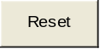 button to return the variables to their initial values.

Use the scroll bar to change the price of hamburger buns. Make the price of hamburger buns 300 cents.
Take a picture of the Demand for Ground Beef chart. You can take pictures in Excel 2007 or greater by selecting the desired object or cells, copying (right-click and choose Copy from the context menu or click Copy on the Home tab), and then pasting as shown below:
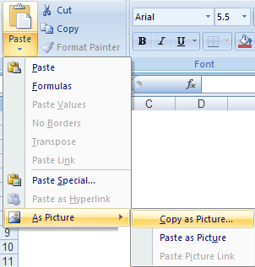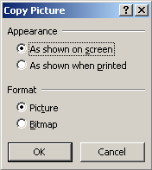

In Excel 97-2003, right-click the selected item while holding down the Shift key and select Copy as Picture.

So, to take a picture of the Demand for Ground Beef chart, click once on the Demand for Ground Beef chart, and then use one of the options for taking a picture that is mentioned above.

Q3-A) Paste your Demand for Ground Beef chart in the box below.

Paste your picture in this box.

Q3-B) Are ground beef and hamburger buns substitutes or complements? Why?
HINT: Your answer needs to refer to the way demand shifted.

Enter your answer in this box.

Click the button.

Use the scroll bar to change the price of ketchup. The price of hamburger buns and price of ketchup affect the demand the same way in a qualitative sense. In other words, demand shifts in the same direction.

Difficult
Q4) Do changes in the price of hamburger buns and the price of ketchup affect the Demand for Ground Beef in the same way quantitatively? That is, are the sizes of the shifts the same? Describe your procedure in answering this question.

Enter your answer in this box.

Click the button.

Use the scroll bar to change the price of hotdogs.

Q5) How do changes in the price of hotdogs affect the Demand for Ground Beef differently than changes in the prices of hamburger buns and ketchup?
HINT: Consider changes in the prices of hamburger buns and ketchup as having the same effect.

Enter your answer in this box.

Key Question
Q6) You’ve changed four prices thus far: ground beef, hamburger buns, ketchup, and hot dogs. What is the essential difference in the effect that these four variables have on the Demand for Ground Beef?
HINT: Group the changes into two types: changes in the price of ground beef are different from changes in prices of the other three goods.

Enter your answer in this box.

The price in cell F9 is not a misprint. This was the price of this car in 2010. Use your favorite search engine to find the latest price (MSRP) for the Lamborghini Murcielago car. Enter this price in cell F9. Demand does not change. Change the cell to other prices. Try zero or a crazy huge number like 123456789. Demand does not change.

Q7) What’s going on with the effect of the price of the Lamborghini Murcielago car on the Demand for Ground Beef? Explain your procedure in answering this question.

Enter your answer in this box.

Click the button.

Use the scroll bar to change household income. Be careful here. This variable has a complicated effect on demand. Starting from the initial value of 30, click on the right arrow of the scroll bar to increase household income to 35. Click the right arrow again and again to increase household income by 5 each time.

Difficult
Q8) Is Ground Beef a normal or inferior good for this family?
HINT: Look up normal and inferior goods in your textbook. Also, click the 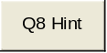 button.

Enter your answer in this box.

Suppose the family members are all vegetarian. Use the scroll bar to model this preference. Use the 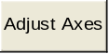 button as needed.

Q9) Copy and Paste your Demand for Ground Beef chart as a picture for a vegetarian family in the box below.

Paste your picture in this box.

Click the button.

Use the data in cells G16:H25 to make a chart (that is, a graph) of the Demand for Ground Beef. Your chart needs to have x and y axis labels and a title (just like the Demand for Ground Beef chart in the Demand sheet). You do not need a legend because there is only one relationship being graphed on the chart. Note that the P variable is the y axis and Q is on the x axis.

If you are unfamiliar with Excel and do not know how to make a graph, please see the Word document called ExcelBasics.doc. It explains exactly, in detailed steps with many screenshots, how to make a chart in Excel and shows how to quickly edit a chart to flip the axes, a useful little trick when working with demand curves!

Q10) Copy and Paste the Demand for Ground Beef chart, as a picture, that you just created in the box below.

Paste your picture in this box.

You have finished with the Demand sheet. Remember that, ceteris paribus, changes in the price of the good under consideration cause movements along the demand curve; while changes in any other variable that affects demand will shift the entire curve left (decrease) or right (increase).

Proceed to the Supply sheet by clicking on the worksheet tab.

The Supply sheet has the same layout as the Demand sheet, but notice that, other than the price of Ground Beef, the variables are different.

Put your cursor over cell G17 (the cell with the red triangle in the upper right corner of the cell). You are reading a cell Comment. Cell G20 also has a comment for you to read. Comments are a good way to document sources and provide additional information in Excel.

Instead of tediously walking through each of the variables (as you did in the Demand sheet), let’s go straight to the crucial question here.

Key Question
Q11) Change each of the five variables that affect the Supply of Ground Beef by adjusting the scroll bars and using the button. Keep your eye on the supply curve. What is the essential difference in the effects that each these five variables have on the Supply of Ground Beef? (Hint: There will be two general types of change.)

Enter your answer in this box.

Click the button.

Q12) Increase the Expectations variable. Supply decreases (shifts left). Why does an increase in Expectations about future price lead to a decrease in the Supply of Ground Beef?

Enter your answer in this box.

Since Supply is so similar to Demand, there’s no need to go over each variable.
Remember that, ceteris paribus, changes in the price of the good under consideration cause movements along the supply curve; while changes in any other variable that affects supply will shift the entire curve left (decrease) or right (increase).

Proceed to the Market sheet.

Here’s where we put supply and demand together. Before we begin, however, notice that we have included the number of buyers and sellers (in cells F12 and F23). The Demand and Supply sheets modeled the behavior of individual agents. To get market demand and supply, we add up the individual demand and supply curves.

Of course, individual demanders and suppliers need not have the same demand and supply curves. At a given price, we add up how much each individual wants to buy (that’s market demand) and sell (giving market supply).

If the number of buyers or sellers increases, it stands to reason that demand or supply shifts right (that is, increases).

We’ll break up the work in this section into two parts: finding equilibrium and changes in equilibrium.

Finding Market Equilibrium

When we put demand and supply together, we radically change the perspective from when we study demand and supply individually. Instead of offering different prices and asking how much the individual wants to buy or sell, a market works by pushing price up or down based on the decisions of the buyers and sellers.

The Market sheet opens with the current price set at 169 (if not, please click the button). Let’s examine how the market reacts to this price.

The table next to the chart shows that, at P = 169, there is a surplus of 450,000 pounds of ground beef.

Q13) How is the surplus of 450,000 pounds of ground beef at a price of 169 cents per pound calculated?

Enter your answer in this box.

Q14) What will happen to the price of ground beef? Why?
Hint: Your textbook has an explanation of how a market reacts to a surplus.

Enter your answer in this box.

Q15) Click the 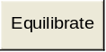 button. Describe what you see on your computer screen.
Click and again if needed.

Enter your answer in this box.

Click the button.

Q16) What happens to the price when it is below the equilibrium price? Why?
Hint: Use the Current Price Scroll Bar to set a price below 139, then click the button.

Enter your answer in this box.

Q17) What is the equilibrium solution for the Market for Ground Beef?
Hint: You must report both the equilibrium price and equilibrium quantity.

Enter your answer in this box.
Use the Speed of Convergence scroll bar to demonstrate that markets may equilibrate fast or slow. In the real world, the speed of convergence depends on the commodity being traded. Financial markets usually equilibrate very quickly, while a market for labor (say engineers) may tend toward equilibrium very slowly. After all, if there’s a shortage of engineers, as the wage rises, we’ll get more people to decide to become engineers, but it takes time to train them.

Q18) How can you tell if a market is in equilibrium?

Enter your answer in this box.

The button makes is easy to find equilibrium, but a chart makes that pretty easy also—the intersection of demand and supply is obviously the equilibrium solution.

The button reinforces a key idea: markets work through the interaction of buyers and sellers to establish a price. There is no external control imposed to set the price. The idea that a market would settle to an equilibrium solution without someone setting the price, called the “invisible hand” by Adam Smith, was a radical idea. To this day, many people doubt that a market can work by itself.

Changes in Market Equilibrium

Now that you know how a market equilibrates, you are ready to put into play the shifts in demand and supply that we worked on in the beginning of the lab. Remember the crucial difference between a movement along and a shift in demand or supply as you work through this section.

The analysis of changes in market equilibrium follows a simple recipe:

1) Determine how the shock (in this case, a change in a variable that shifts demand or supply) shifts supply or demand.
2) Find the new equilibrium solution.
3) Compare the initial to the new equilibrium solution.

Let’s practice with this recipe.

Click the button in the Market sheet, then click the button to allow the market to equilibrate. The initial equilibrium price is 139 cents per pound and the initial equilibrium quantity is 1,029,200 pounds of ground beef.

Suppose the price of feeder cattle fell to 80 cents a pound. We want to determine the effect this will have on the market for ground beef. We apply the recipe.

1) Use the scroll bar to set the price of feeder cattle to 80 cents a pound.
2) Click the button.
Q19) Step 3 is to compare the initial to the new equilibrium solution. What happened to the equilibrium price and quantity as a result of the decrease in the price of feeder cattle?

Enter your answer in this box.

Notice how the market works to allocate resources. A decrease in the cost of producing a product leads to lower prices and more of the product. While buyers and sellers are focused on price, as economists, we are more interested in how price is used to determine the quantity that is produced.

Sometimes, the shock is not explicitly given in terms of a particular variable, but it needs to be interpreted. Consider, for example, the effect on the market for ground beef from an announcement of Mad Cow disease.

A web search of “mad cow disease” yields hundreds of thousands of hits. An informative government site is https://www.cdc.gov/prions/bse/index.html.

We are interested in the effect of a reported outbreak of mad cow disease on the market for ground beef. Once again, we follow the recipe.

Click the button in the Market sheet, then click the button to allow the market to equilibrate. The initial equilibrium price is 139 cents per pound and the initial equilibrium quantity is 1, 029, 200 pounds of ground beef.

Step 1 is to determine how the shock (a change in a variable that shifts demand or supply) shifts demand or supply.

Of course, eventually every variable is affected, but the art of supply and demand analysis is to choose which variable or variables are primarily affected.

Q20) Which variable in the list of variables that affect demand and supply (in column G) would be most affected by the announcement of the discovery of mad cow disease in US cattle? Set the scroll bar of the variable you chose to a new value that reflects the impact of mad cow disease. Report your variable and its new value in the box below.

Enter your answer in this box.

Next, we must find the new equilibrium solution.

Click the button to allow the market to equilibrate.

Q21) Report the new equilibrium solution in the box below.

Enter your answer in this box.

The final step is to compare the initial and new equilibrium solutions.

Q22) What effect, according to your interpretation of the shock, did mad cow disease have on the market for ground beef?

Enter your answer in this box.

Of course, this is one possible interpretation of how mad cow disease might affect on the market for ground beef. In addition to the variable you identified, other variables might be affected by a report of mad cow disease.

Q23) Identify a second variable that might be affected by mad cow disease. Explain how and why this variable is influenced by mad cow disease.

Enter your answer in this box.

Q24) If mad cow disease influences both variables simultaneously, what is the final effect on the market for ground beef? Include your explanation in the box below and a picture of your market for ground beef chart.

Enter your answer in this box.

The final section of this lab on Supply and Demand is devoted to downloading and interpreting some real world data.

The government agency responsible for collecting and reporting price data is the Bureau of Labor Statistics. They have an excellent web site at

http://www.bls.gov/cpi/home.htm

Click the link above to go to home page of the CPI (Consumer Price Index). In a future lab, we’ll return to this page and learn all about the CPI. Right now, we want to use the web site to get data on . . . you guessed it, ground beef.

Scroll down the CPI homepage a bit until you get to the CPI Databases section. The option that you are going to want to select is “One-Screen Data Search” in the Average Price Data database.
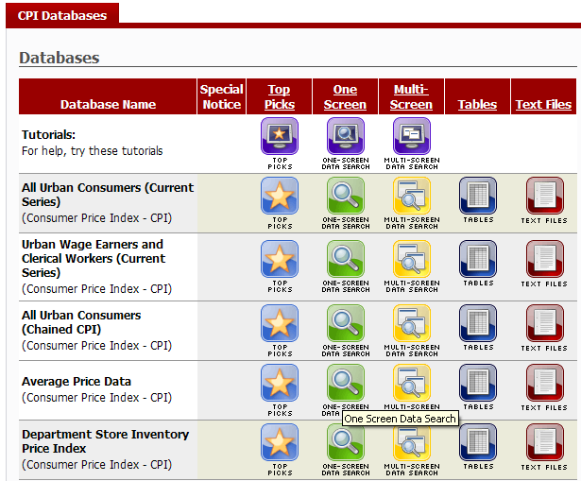

Now select the U.S. city average for the area, and Ground beef, 100% beef, per lb. (453.6 gm) option for the item.

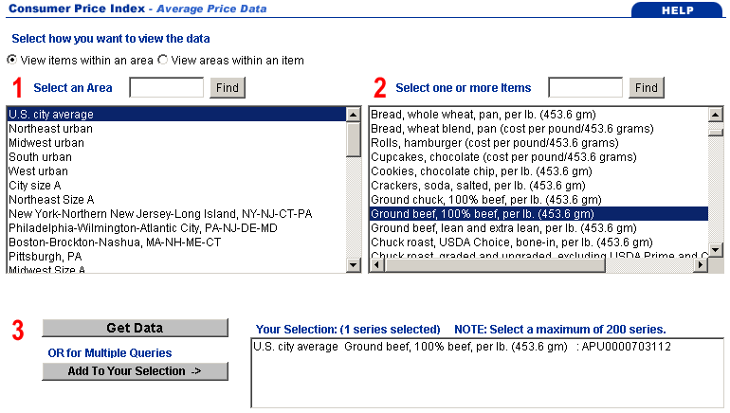
Next, you are going to hit the Add To Your Selection button. Then, hit the Get Data button to take you to a new web page.

Select 10 years of data (2000-2010) by scrolling through the drop-down that state from and to which dates. Then click the GO button to get the data.
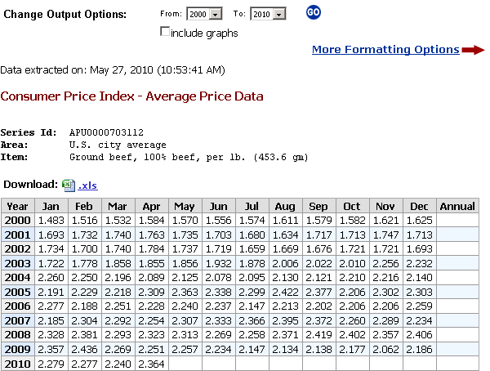

Q25) Provide an explanation of the observed movement in ground beef prices (from the data obtained). In your explanation, use the supply and demand analysis that we have worked on in this lab.

Enter your answer in this box.

Congratulations! You have finished your first lab.

Save this document and print it.

You can save a lot of paper and ink by starting from the top of this document and cutting everything out of the final, printed version except the questions and your answers. You should also confirm that you have answered every question.

