Name:
Introductory Economics Lab http://www.depauw.edu/learn/introeconlab
Excel Workbooks: EconomicGrowth.xls

Economic Growth Lab

Introduction

This lab is devoted to the issue of economic growth. It concentrates on Real GDP per person as a measure of economic performance. We take a long run view, ignoring the many ups and downs, booms and recessions, that dominate the news. A simple graph shows what we’re interested in examining:
It may seem like growth was slow and then sped up, but a curve like the thick, smooth line can be generated by a constant growth rate. The power of compounding eventually produces huge increases, even the though the growth rate is unchanged.
Real GDP per capita
time
The thick, smooth line is the long run path of an economy. For advanced economies, the path is often surprisingly stable. Each country has its own path—everyone knows that countries do not grow at the same rate.

The thin, squiggly line captures the actual movement of the economy. It sometimes rises above the thick line, when the economy is booming, but eventually peaks and turns back down, only to take off again.

This division between long run path and short run business cycle divides macroeconomics into two parts. Both views are important. Both are filled with interesting questions.

From the long run perspective, economists have pondered such questions as: Why do some countries grow faster than others? Do slowpokes catch up? What can be done to increase the rate of growth?

Those who concentrate on the short run have focused on questions like: What triggers upturns and downswings? Is there any pattern to the cyclical behavior? What can be done when the economy turns sour?

This lab is not going to answer any of these questions either because they are too complicated or because we simply do not know the answers. Instead, we will concentrate on understanding how we measure economic growth. This might seem mundane, but if we hope to ever understand growth, we first must establish clear, consistent definitions and measurements.
Source

All of the data for the lab come from a downloadable Excel workbook, horizontal-file.xls, created by Angus Maddison and available at www.eco.rug.nl/~Maddison/ .

The Doc sheet has detailed documentation of the data.

Definitions

In the workbook, GDP stands for Real GDP.

Maddison uses something called Geary-Khamis dollars to correct for the effect of varying price levels over time. This approach incorporates foreign exchange prices. The details are unimportant for our purposes. What matters is that prices are constant over time so the comparison of GDP over time is valid.

Per Capita GDP is the same thing as GDP per person and since GDP is actually Real GDP, it’s the same thing as Real GDP per person.

Open EconomicGrowth.xls and read the Intro sheet. Proceed to the Population sheet. Below is a picture of the top left corner of the sheet.

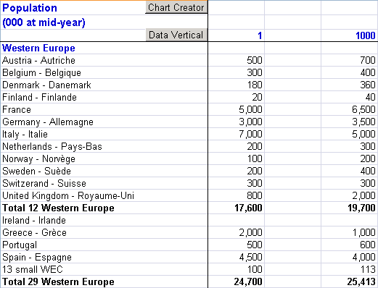

The sheet contains data on the number of people, in thousands, at mid-year in a country. Some countries have data all the way back to 1 AD! The sheet tells us that there were 7 million people in present-day Italy in 1 AD. Rome was a huge city of over a million people. After the fall of the Roman Empire, no European city would be that big until after the Renaissance.

As you explore the sheet, you will find blank cells. Blank cells are not zero. Blanks indicate missing values—either the data was not available or the country did not exist.
One problem with the sheet is the overwhelming size of the data.

Scroll right and down to see what’s available. Find the population of Cuba in 1900. It’s 1.658 million people (not 1,658 people). The Panes are frozen (search Help for “Freezing Panes” if you want to learn more about this nice feature) so that column A with the countries and row 3 with the years are always visible. That helps, but it’s still hard to analyze the data by simply scrolling through it.

Take, for example, a comparison of the population of France and Italy. Starting at 1 AD and scrolling right through the numbers is a poor way to do this comparison.

A graph is much better. But creating graphs is cumbersome. You have to select the years in row 3, then hold down the Ctrl key in order to select the appropriate years for a particular country.

The  button in cell A1 makes drawing graphs a breeze.

Use the button to make a chart that compares France and Italy’s population.

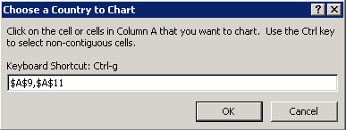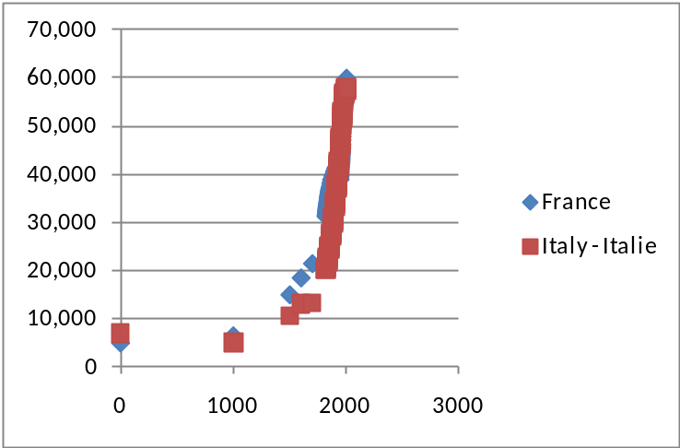

The chart shows that the populations of both countries rocketed within the last few hundred years, but we can’t see very clearly exactly when this happened.

The chart, however, is alive. It’s a regular Scatter Excel chart. You can title it, add x and y axes labels, and format it as you wish.

One especially important feature that you can control is the x axis. By right-clicking on the x axis (in Excel 2007 or greater, double-click the x axis in earlier versions), you can change a variety of characteristics.

Q1) Change the x axis scale so that the minimum value is 1800. Take a picture of your chart (select the chart, click the Home tab, then arrow under Paste, then select As Picture → Copy As Picture) and paste (Ctrl-V) it in the text box below.

Paste your picture in this box.

Q2) What story does your chart tell about the differences in the populations of France and Italy from 1800 to the present? In other words, describe how the populations of these two countries have behaved differently over time.

Enter your answer in this box.

Proceed to the GDP sheet. Below is a picture of the top left corner of the sheet.
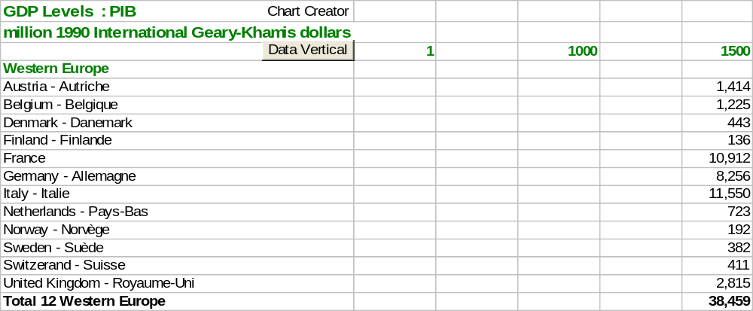

We are now looking at the Gross Domestic Product, measured in millions of 1990 International Geary-Khamis dollars.

Key Concept
Q3) Find the definitions of “Nominal GDP” and “Real GDP” in your textbook. In your own words, what is the difference between these two terms? Which is one is better? Why?

Enter your answer in this box.

Q4) The GDP sheet has Real GDP data because it is measured in constant 1990 International Geary-Khamis dollars. Thus, the effect of changing price levels has been removed. Suppose we had nominal GDP data in the year 2000. How would the numbers compare to the values in the GDP sheet for the year 2000?

Enter your answer in this box.

Real GDP is our best measure of the total output produced by the economy. Like all measurements, Real GDP is not perfect. It has some flaws. One of the problems with GDP is that it doesn’t count everything. Your textbook undoubtedly has at least one example of this. It might be in a discussion of the underground economy or an example of the weaknesses of GDP.

Q5) Find an example of a flaw in the measurement of GDP in your textbook and quote it (by typing in the text in the box below). Document your quotation, including the author’s name, title of the textbook, edition, year of publication, and page number.

Enter your answer in this box.

Q6-A) Which country had the biggest economy in the world in 1 AD, according to Maddison’s GDP data? How big was it?

Enter your answer in this box.

Q6-B) Which country had the biggest economy in the world in 1500 AD, according to Maddison’s GDP data? How big was it?

Enter your answer in this box.

Q6-C) Which country had the biggest economy in the world in 2000 AD, according to Maddison’s GDP data? How big was it?

Enter your answer in this box.

The button in the GDP sheet works the same way as in the Population sheet.

Q7) Create a chart of the GDP of the three countries you identified in the three parts of the previous question. Does the chart suggest that output has been climbing steadily for two thousand years? If not, when does it look like it took off?

Enter your answer in this box.

Q8) Change both the x and y scales to focus in on when the biggest economy in the world in 2000 AD passed the other two countries. Take a picture of your chart and paste it in the text box below.

Paste your picture in this box.

Answer the next question based solely on the data in the workbook. Do not consider other factors such as culture, politics, or climate.

Key Concept
Q9-A) Compare China and Japan in 2000 AD. China’s economy is bigger. Would you rather be born in China or Japan? Explain.

Enter your answer in this box.

Q9-B) Same question with different countries. Compare Mexico and Switzerland in 2000 AD. Mexico’s economy is almost five times bigger. Would you rather be born in Mexico or Switzerland? Explain.

Enter your answer in this box.

While Real GDP measures the output of an entire nation, it does not factor in the number of people in the country. Economists would choose to be born in Japan or Switzerland over China or Mexico because it is Real GDP per person that reflects the standard of living in a country. China is the most populous country in the world today. With over a billion people, you know they will have a large GDP.

But then the resulting output has to be divided among all of those people. The average slice going to each person in China is smaller than the average slice someone gets in Japan. The same holds true for Switzerland versus Mexico. This is why the preferred measure of comparison is Real GDP per person. The computation is simple: 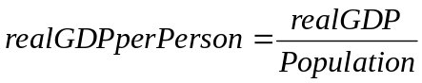.

This equation reveals an inherent weakness in the use of Real GDP per person as a measure of the standard of living. We are computing the average Real GDP, but there is no guarantee that it is actually distributed this way. In other words, what if a country’s GDP was really unevenly distributed? Maybe just a few people get almost all of the output and the rest live in abject poverty. You probably wouldn’t want to be born in such a country (perhaps unless you could guarantee to be born rich) even if Real GDP per person was quite high.

This is a serious, important issue in the use of Real GDP per person as a measure of the standard of living and as our preferred yardstick for comparison of economic performance. Unfortunately, the methods used to study the distribution of income are quite complicated and beyond our scope for this lab. If you are interested in this issue, a good place to start is to learn about the Gini Coefficient. A web search of this term should get you going.

Another problem with using Real GDP per person is that it does not directly measure satisfaction, welfare, or happiness. However, Real GDP per person does tell us the average (per person) value of all final goods and services produced by the economy in a given time period. The argument is that this is highly correlated with satisfaction and well-being. After all, higher Real GDP per person may not automatically mean greater welfare, but it does mean people are able to buy more health care, education, and other things that increase well-being.

The remainder of this lab will focus on Real GDP per person as the primary means of comparing economic performance. There are critics of this approach. You should know that Real GDP per person suffers from measurement flaws, ignores issues of distribution, and assumes that wealth is correlated with satisfaction. In spite of these problems, as a practical matter, Real GDP per person remains the most important variable in all of macroeconomics.

We are ready to move on to the next sheet in the workbook, PerCapita GDP. Below is a picture of the top left corner of the sheet.
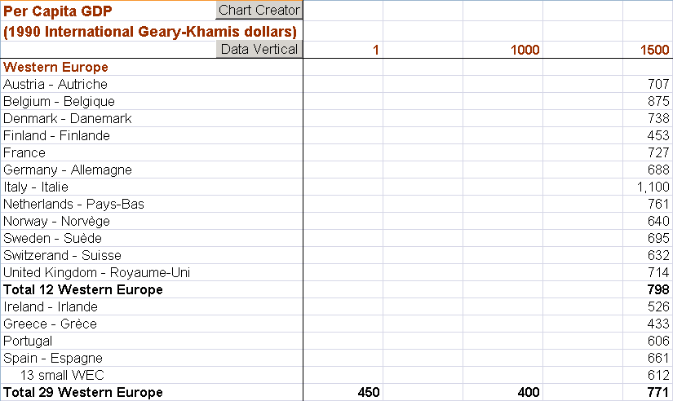

Q10) Presumably, the PerCapita GDP sheet is simply the value in the GDP sheet (for a given country and year) divided by the corresponding value in the Population sheet. Let’s confirm this. In cell GS5 of the PerCapita GDP sheet, enter a formula that computes the Real GDP per person for the year 2008 for Austria. Fill your formula down for all of the countries. Take a picture of range GS5:GS17 and paste it in the text box below. Were you able to replicate the numbers in column GR?
Hint: Pay close attention to the units of the GDP and Population sheets. You want 1990 G-K dollars per person.

Paste your picture in this box.

Q11) Create a chart of the Real GDP per person of Ireland and Portugal. Change the x scale to start in 1970. What do you conclude about the economic performance of these two countries since 1970?

Enter your answer in this box.

Q12) Create a chart of the Real GDP per person of Argentina and Japan. Change the x scale to start in 1950. What do you conclude about the economic performance of these two countries since 1950?

Enter your answer in this box.

The Lesson of Questions 11 and 12
From the Intro sheet:

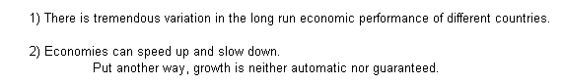

Maybe it isn’t surprising that countries as different as Ireland and Portugal or Argentina and Japan would exhibit such vast differences in economic growth. Let’s look at particular regions of the world.

We will use the Compare sheet to make charting and comparing a snap.

Proceed to the Compare sheet. It has a list box with the countries, below that a place where you choose which variable to chart, and an empty graph.

Click on a country in the list box. Excel displays it on the chart.

Click on another country and Excel adds it to the chart. It really is a snap to compare countries.

Below the chart are easy ways to control the min and max values for the years plotted.

Click the  button to wipe the chart clean.

The Compare sheet offers a powerful, easy way to compare performance.

Q13) In 1990, the former Yugoslavia was split into five countries: Bosnia, Croatia, Macedonia, Slovenia, and Serbia/Montenegro/Kosovo. Are their economies about the same or is one performing better than the others? Describe your procedure for answering this question. In other words, how did you arrive at your answer?

Enter your answer in this box.

Q14) The Central American countries are Honduras, Guatemala, El Salvador, Nicaragua, and Costa Rica. (Panama is not usually grouped with these five because of its long association with the US, including using the American dollar as the national currency.) Are their economies about the same or is one performing better than the others? Describe your procedure for answering this question. In other words, how did you arrive at your answer?

Enter your answer in this box.

The Lesson of Questions 13 and 14:
Questions 13 and 14 make clear that the tremendous variation in economic performance cannot be explained by simply different cultures or languages. In fact, we do not have a good explanation. Put another way, we cannot predict, fifty or one hundred years out, who will grow rapidly and who will sink.

Return to the PerCapitaGDP sheet, where we will work with the  button.

In addition to charting Real GDP per person in order to see the evolution of an economy over time, economists also compute the percentage change in Real GDP per person from one time period to another as a measure of the rate of growth.

Like any percentage change, the percentage change in Real GDP per person is the change (or difference) from one time period to the next divided by the initial value. The percentage change in Real GDP per person from 1999 to 2000 is,

.

Since the data are organized with time horizontally and countries vertically it’s a bit awkward to compute percentage changes. Sure, you could insert a row, then enter the formula, and then fill right, but the button makes this work a little easier. Like the chart creator button, you can select one or more countries when prompted. Clicking OK inserts the data from your chosen country or countries in a new worksheet and organizes it vertically, with time in column A.

Let’s see how percentage change in Real GDP per person is used to measure the rate of growth.

Click the button in the PerCapitaGDP sheet and select Norway and Sweden. Compute the percentage change in Real GDP per person for each country in columns D and E. Use the first row for data labels, %ChangeNorway and %ChangeSweden. Of course, for the first few observations you can’t compute a change from year to year because you don’t have the data. Norway’s annual series starts in 1830, so your first formula should be entered for the percentage change from 1830 to 1831 in the row corresponding to the year 1831. Fill down to compute the percentage changes from year to year until the last available year.

Q15) Report the percentage change in Real GDP per person for Norway and Sweden from 2000 to 2001.

Enter your answer in this box.

Q16) Use Excel’s AVERAGE function to find the average percentage change in Real GDP per person for Norway and Sweden from 1830 to 2008.

Enter your answer in this box.

Although higher is better, economists consider a 2% per year rate of growth in Real GDP per person to be quite good. At 2% per year, the Rule of 70 tells us that output per person should double approximately every 35 years because 70/2 = 35. That means output would double roughly every generation. 2% per year growth in Real GDP per capita is like batting .300 in baseball or shooting 50% from the field in basketball or getting a B+ in Introductory Economics. It’s not necessarily awesome and higher is undoubtedly better, but 2% per year over a long period time is certainly respectable and quite commendable. Both the Swedes and Norwegians pulled it off, but there are many countries that don’t even come close.

Let’s test the Rule of 70 with Sweden and Norway. Since its average percentage change in Real GDP per person was about 2% per year. Sweden’s output per person in 2008 was just over 24,400. Half of that is about 12,200. If the Rule of 70 works, Sweden should have had a Real GDP per person of 12,200 around 1974 (35 years earlier, starting from 1974 as the first year).

Difficult
Q17) How well does the Rule of 70 work for Sweden and Norway? What explains the difference in the time it takes to double for these countries? Explain your procedure and give a complete answer.

Enter your answer in this box.

Norway’s growth rate (like Sweden’s and every other country) is not constant. In other words, it does not steadily march forward at a constant rate per year. In fact, you can see that it fluctuates and, sometimes, quite wildly.

Excel has two functions, MIN(cell range) and MAX(cell range), that report the smallest and biggest numbers in a cell range. These functions can help you easily answer the next question.

Q18) Identify Norway and Sweden’s single best year and single worst year. Report the years and the corresponding percentage changes in Real GDP per person.

Enter your answer in this box.

The final point to make about percentage changes is that seemingly small differences can have big effects when long time periods are involved. (And this point applies to Q17 above so you might want to revisit that question after you finish this work.) We’ll use Sweden as an example. Suppose Sweden had grown every year at 2.1%, Norway’s average percentage change, instead of its actual 1.9% growth rate. What would have happened by 2008?

To run this what-if, go the sheet with the vertical data for Norway and Sweden and enter the following formula in cell F23: =C22*1.021
The formula increases Sweden’s actual output per person in 1830 (cell C22) by 2.1% so that the Swedes produce 888.2274 instead of the actual 868.0464 real GDP per person.

In cell F24, enter the formula =F23*1.021. This way, we get 2.1% increases on top of the previous “made up” values.

Now, fill the formula in cell F24 down to the end of the data set.

Q19-A) After following the steps above, what is Sweden’s hypothetical output per person in 2008, assuming a 2.1% rate of growth since 1830?

Enter your answer in this box.

Q19-B) Compare your answer in part A to Sweden’s actual output per person in 2008. How much better did our hypothetical Sweden do?

Enter your answer in this box.

Q19-C) Compare your answer in part A to the actual output per person for the countries in 2008 in the PerCapita GDP sheet. How does our hypothetical Sweden stack up?

Enter your answer in this box.

The lesson should be crystal clear: seemingly small changes in rates of growth can have HUGE effects when allowed to compound over a long period of time.

We’ll end this lab on a sad, frustrating note. We’ve been looking at the winners—countries with high rates of growth and high Real GDP per person. But what about the poor?

Return to the PerCapita GDP sheet.

Click on cell A3, then scroll down and right until cell GR194 is visible. Hold down the Shift key and click cell GR194. This selects all of the cells from A3 to GR194.

With cell range A3:GR194 selected, execute Data: Sort.

In the Sort dialog box, click the “My data has headers” box and then select the 2008 year to Sort By. You want to sort in ascending order. Your Sort dialog box should look like this.

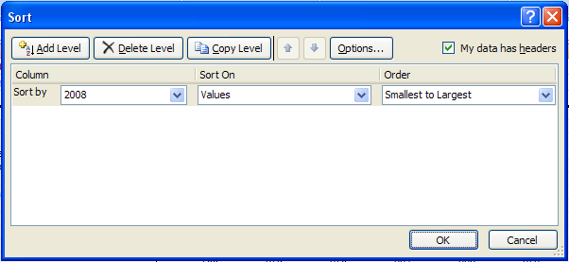

Click OK. You’ve sorted the entire data set by the values in column 2008. Scroll right to see 2008.

If you need to, you can always recover the original organization of the data by undoing the sort: Ctrl-z.

Q20-A) Which country is the poorest country in the world in 2008?

Enter your answer in this box.

Q20-B) Make a chart of the Real GDP per person of this country. Change the x scale so that the minimum is 1950. Describe what you see.

Enter your answer in this box.

The point of this lab can be summarized by the 1995 winner of the Nobel Prize in Economics:

The diversity across countries in measured per capita income levels is literally too great to be believed. [p. 3]

Within the advanced countries, growth rates tend to be very stable over long periods of time, provided one averages over periods long enough to eliminate business cycle effects (or corrects for short-term fluctuations in some other way. For poorer countries, however, there are many examples of sudden, large changes in growth rates, both up and down. [p. 4]

I do not see how one can look at figures like these without seeing them as representing possibilities. Is there some action a government of India could take that would lead India’s economy to grow like Indonesia’s or Egypt’s? If so, what, exactly? If not, what is it about ‘the nature of India’ that makes it so? The consequences for human welfare involved in questions like these are simply staggering: Once one starts to think about them, it is hard to think about anything else. [p. 5]

Robert Lucas, “On the Mechanics of Economic Development,” Journal of Monetary Economics, 22 (1988), pp. 3-42.

Congratulations! You have finished the economic growth lab.

Save this document and print it.

You can save a lot of paper and ink by cutting everything out of the final, printed version except the questions and your answers.

