Name:
Introductory Economics Lab http://www.depauw.edu/learn/introeconlab
Excel Workbook: CPI.xls

CPI Lab

Introduction

This lab has three goals:

- To show how the CPI is constructed.
- To explore a sub-index of the CPI on college tuition and fees.
- To compare US and Mexico’s CPI.

Open the CPI.xls workbook and read the Intro sheet.

If you haven’t already, you should read the chapter or chapters in your textbook on the CPI. Read about the BLS and the monthly survey they conduct to find prices for a particular basket of goods. Make sure you understand that one way to measure inflation is by calculating the percentage change in the CPI from one time period to another. Your textbook may have graphs or tables of the CPI or inflation rate over time.

Proceed to the SDPI sheet. The sheet shows how a fixed basket price index is constructed by creating a price index for a spaghetti dinner. For the spaghetti dinner, we need to buy spaghetti, hamburger meat, tomatoes, bread, and dessert. We’ll ignore various spices, drinks, and non-food items (plates, stove, etc.) for the sake of brevity. This is a barebones spaghetti dinner.

The SDPI sheet does not contain data for a dessert. You’ll have to go get this information. Proceed to the BLS web site at http://www.bls.gov/cpi/home.htm and use the Average Price Data query to get US City Average price data on ice cream. Cell B7 has a convenient link for you to use to go directly to the data. The exact series information is
Your browser must be Java-enabled and allow pop ups.
Series Id: APU0000710411
Area: U.S. city average
Item: Ice cream, prepackaged, bulk, regular, per 1/2 gal. (1.9 lit)
Get your data in column format (using the More Formatting Options link) so you can easily copy and paste it into column F of the SDPI sheet. Copy the data and paste it an empty area of the sheet, then move the ice cream data into its place in column F. Make sure the dates are correctly aligned.

Q1) Create a well-labeled chart of the price of ice cream over time. Copy the graph as a picture and paste it in the box below.

Paste your picture in this box.

Q2) Compute the percentage change over the entire ten-year period from April-2000 to April-2010 in the price of each of the five products in the spaghetti dinner. Which product had the lowest percentage change and how much was it? Which product has the highest percentage change and how much was it?
Note: This requires a single calculation for each item of the percentage change in price from April-2000 to April-2010, not the monthly percentage change during this period.

Enter your answer here.

Let’s turn to the construction of the Spaghetti Dinner Price Index. The SDPI is like the CPI in that we need to determine the cost of a fixed basket of goods, but we don’t simply average the prices of the goods in the basket. Instead, we have to appropriately weight the contribution of each good to the total. The CPI does this by careful analysis of consumer spending patterns. For the SDPI, we’ll arbitrarily assign weights, like this:

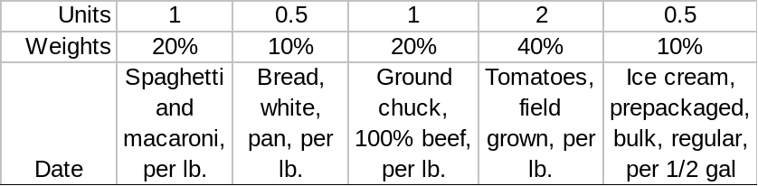

In other words, for our dinner, we use one pound each of spaghetti and hamburger meat, half a loaf of bread, a quarter of a pound of ice cream, and two pounds of tomatoes. The weights are then determined by the proportion of each item to the total. The formulas in the cells in row 11 make this clear.

Click on the formulas in the cell range B11:F11 to see how the weights are determined.

With the price data and weights, we are ready to construct the price index. We proceed in two steps. For the first step, in cell H13, enter the formula for the Weighted Basket Value. You will definitely want to use absolute references for the weights. In Excel, dollar signs are used to indicate absolute references. Also, hitting the F4 button while the cell is selected will make the cell an absolute reference. A formula that refers to cell A123 with dollar signs, $A$123, will continue to refer to that cell if the formula is moved or copied. Thus, your formula should begin like this for the spaghetti and macaroni item: =B13*$B$11. This way, when you fill down the formula, it will always use B11 as the cell for the weight. Of course, you need to finish the formula to include the other four goods, before you do the fill down. Remember to use the $ absolute reference for each of the weights.

Q3-A) Report the value of the Weighted Basket Value for Apr-2000.

Enter your answer in this box.

Q3-B) Is the value of the Weighted Basket Value for Apr-2000 the actual cost of the spaghetti dinner for that month? Why or why not?

Enter your answer in this box.

Use column I to compute the annual percentage change for the Weighted Basket Value that is in column H. Be careful here. Starting in cell I25, you want the percentage change from the same month in the previous year. For example, you want to calculate the percentage change in the Weighted Basket Value from Jan-94 to Jan-95. Fill down your formula. Each cell will compute the percentage change from that month a year before. We’ll use this work in a later question.

Once we have the Weighted Basket Value, we can proceed to the second step in constructing the SDPI: make each Weighted Basket Value relative to a base year. Let’s use Jan-2000 as the base year. In cell J13, enter the following formula, =100*H13/$H$85, then fill down.
Pause to consider what you have done. You took each Weighted Basket Value and made it relative to the Jan-2000 Weighted Basket Value. Of course, Jan-2000’s value is exactly 100 because it is divided by itself. Values less than 100 indicate time periods when it was cheaper to buy the spaghetti dinner and values greater than 100 mean the spaghetti dinner is more expensive.

Q4-A) Report the value of the SDPI for Jan-1994.

Enter your answer in this box.

Q4-B) Is the value of the SDPI for Jan-1994 the cost of the spaghetti dinner for that month? Why or why not?

Enter your answer in this box.

Q4-C) What does the value of the SDPI for Jan-1994 tell you about the price of our spaghetti dinner in Jan-1994 compared to Jan-2000?

Enter your answer in this box.

Q5) Create a chart of the SDPI over time. Copy the graph as a picture and paste it in the box below.

Paste your picture in this box.

Q6-A) Does your chart in Q5 support the argument that a spaghetti dinner has been increasing in price? Explain.

Enter your answer in this box.

Q6-B) Add a Trendline to the chart created inQ5, and display its equation. Paste your chart below. Does the equation support your answer Q6-A, why or why not?

Paste your picture in this box.

Add you text answer below it.

Q7) Does your chart in Q5 support the argument that a spaghetti dinner has been increasing in price at a steady, constant rate? Explain.

Enter your answer in this box.

In column K, compute the annual percentage change in the SDPI starting in Jan-1995. Note that this is easily done by simply copying the formula in cell I25, pasting it in cell K25, and then filling down. This is a good example of working smartly with Excel. You don’t need to retype the formula in this case.

Q8) Compare the values in columns I and K. What do you notice?

Enter your answer in this box.

In columns L and M, compute the SDPI for a different base time period than Jan-2000. You choose the time period, compute the SDPI, and compute the annual percentage change in the SDPI.

Q9) Report the value of the SDPI for Jan-1994 and include the base time period you used.

Enter your answer in this box.

Difficult
Q10) Your friend notices that the values of the SDPI for your base (in column L) are different from the values of the SDPI for the Jan-2000 base (in column J). He concludes that, “The SDPI is sensitive to the base time period chosen. This is a weakness.” Do you agree or disagree? Explain.

Enter your answer in this box.

Proceed to the CPICategories sheet.

The SDPI is a mini-version of the CPI. Instead of five products, several hundred goods and services are incorporated into the CPI. Each month, they are priced all over the country (over 80,000 individual products are priced each month) and the CPI is computed. The annual percentage change (from the same month a year ago) is reported and is a common measure of the annual inflation rate.

The typical news release reads like this:

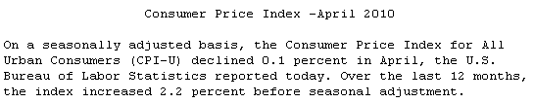

The CPICategories sheet has the eight major expenditure categories and the weights from each category. Housing is by far the largest item of the typical urban consumer’s budget.

Q11) Make a pie chart of the CPI categories that reflects the weights of each of the major categories in the CPI. To make a pie chart, in Excel 2007 or greater, click the Insert tab and choose the Pie chart. In earlier versions of Excel, use the Chart Wizard. Copy the chart as a picture and paste it in the box below.
Note: Be careful with the legend text. Make sure it is meaningful. A list of Series 1, Series 2, etc. is not meaningful.

Paste your picture in this box.

One of the categories contains education. The explanatory note in the sheet shows that college tuition is one of the sub-categories. Can we get data from the BLS that reflects price changes in college tuition? You bet we can.

Proceed to the CollegeTuition sheet. Return to the CPI’s home page at http://www.bls.gov/cpi/home.htm and click the All Urban Consumers (Current Series) link under the area with the heading “CPI Databases.” Click on the “One-Screen Data Search” button that is located to the right of the All Urban Consumers text. Cell B7 has a convenient link for you to use to go directly to the data. Make sure you select US City Average and College tuition and fees as shown in the picture below, and then click the Get Data button.

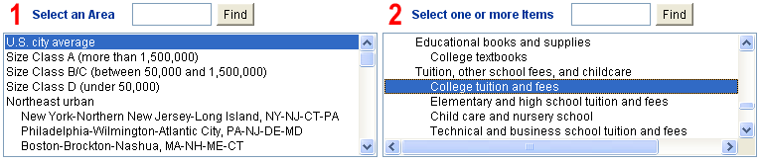
OK, so now you know where the data in the CollegeTuition sheet came from, but what exactly are these numbers? You need to learn more about the data. Fortunately, there’s a nice fact sheet on this series at the bottom of the CPI’s home page. Return to http://www.bls.gov/cpi/home.htm and click on How BLS Measures Price Change for College Tuition and Fees in the Consumer Price Index. Read the page, then answer questions 12 to 14.

Q12) What exactly does the 1.493 number for the College tuition and fees mean?

In case you are confused, the BLS documentation helps us here:

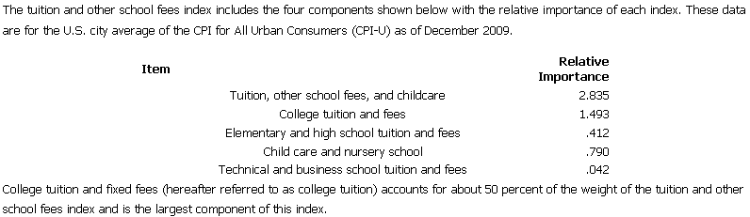
Q12 is asking, “What is this number?”

Enter your answer here.

Q13) Is the College tuition and fees value used in the CPI a price for attending a particular college? Explain.

Enter your answer in this box.

Q14) How would financial aid impact the measurement of the College tuition and fees series?

Enter your answer in this box.

Before we actually crunch the college tuition and fees numbers, let’s examine the issue of seasonal adjustment.

Proceed to the SeasonalAdj sheet. This sheet has a download of College tuition and fees from 1980 to 2010. It has both the unadjusted and seasonally adjusted series.
The first graph, titled Seasonally Adjusted versus Not, is a poor graph because you can’t tell what’s going on. The two series are very close to each other so it doesn’t help us understand what’s happening in the data.

The second graph, Figuring Out Seasonal Adjustment, is much better in showing what seasonal adjustment is doing. By zooming in on just two years worth of data, we can see what’s going on. Use it to answer questions 15 to 17. Unfortunately, the chart has several other problems that you must fix.

Q15) The second graph is better than the first one, but it needs a description of which series is which. Add a legend to the chart and make other improvements, and then copy the graph as a picture and paste it in the box below.

Note: Do not be satisfied with the dreaded Series 1 and Series 2 legend text. That conveys zero information. The legend must be informative.

Note: Do not simply put down a text box. Figure out how to manipulate the legend text.

If you are unsure of what to do, see the ExcelBasics.doc file available at http://www.depauw.edu/learn/introeconlab/lab0.htm for instructions on how to control the legend text in a chart.

Paste your picture in this box.

Q16) In which month does the unadjusted College tuition and fees series jump up?

Enter your answer in this box.
Q17) Refer to the Figuring Out Seasonal Adjustment graph to explain what the BLS does to seasonally adjust the College tuition and fees series.

Enter your answer in this box.

Now that you understand the data, we are ready to analyze it.

Return to the CollegeTuition sheet. We conveniently created a table for you that has the September values of the overall CPI and the unadjusted College tuition and fees series. This way, we can compare the behavior of an overall measure of inflation versus inflation in college costs.

Q18) Create a chart of the two series. Title the chart and add a legend, and then copy the graph as a picture and paste it in the box below.
Note: Do not be satisfied with a chart that goes from the early 1900s with lots of blank space. Change the x axis to create a visually appealing, informative chart.

Paste your picture in this box.

Q19) In columns D and E, compute the annual percentage changes in the two indexes. Report the average annual percentage change for the two series.

Enter your answer in this box.

Q20) Everyone knows that a college education has been getting more and more expensive, but what does your analysis in the previous two questions show? In other words, use the work you did earlier to comment on the magnitude of the price increases in college tuition and fees versus overall price increases.

Enter your answer in this box.

We’ll conclude this lab by taking a look at some international data on prices.

Proceed to the USMexicoCPI sheet. The sheet has Mexican and US CPI from Jan-1980 to Apr-2010. It also computes monthly and annual inflation (as percentage changes, of course) for the two countries and has a few charts.

Q21-A) Can we argue that the US has enjoyed price stability since 1980? Explain.

Enter your answer in this box.

Q21-B) Can you find evidence of deflation in the US since 1980? If so, when?

Enter your answer in this box.

Q22) While we do not have data on GDP or unemployment, do you think the US inflationary episode in the early 1980s was bad for the economy? Why?

Enter your answer in this box.

Q23) Your friend notices that the first few observations in the data set have very small values for Mexico’s CPI versus the US CPI. She argues that this is good news for Mexican consumers since it means prices were very low. What do you think of this argument?

Enter your answer in this box.

Q24-A) Find a definition for hyperinflation in your textbook (or online) and quote it. Document your quotation, including the author’s name, title of the textbook, edition, year of publication, and page number or the web site’s address.

Enter your answer in this box.

Q24-B) Can you find evidence of hyperinflation in the USMexicoCPI sheet? Explain.

Enter your answer in this box.

Compare the two Annual %Change CPI graphs in the USMexicoCPI sheet. At first glance, they look quite similar. But pay close to attention to the y axis. This is a misleading comparison.

Q25-A) Change the y axis scale of the US Annual %Change CPI graph to match that of the Mexican Annual %Change CPI graph. Copy the graph as a picture and paste it in the box below.

Paste your picture in this box.

Q25-B) Is the behavior or the US and Mexican price level since 1980 roughly the same or quite different?

Enter your answer in this box.

Congratulations! You have finished the CPI lab.

Save this document and print it.

You can save a lot of paper and ink by cutting everything out of the final, printed version except the questions and your answers.

