Name:
Introductory Economics Lab http://www.depauw.edu/learn/introeconlab
Excel Workbook: MonetaryPolicy.xls

Monetary Policy Lab

Introduction

This lab is designed to help you understand monetary policy and how the central bank can influence the economy in the short run. The explanation is complicated and along the way you will learn about an important distinction between nominal and real interest rates. You will also have the opportunity to explore data on interest rates in the US over the second half of the 20th century.

Key Concept

If you haven’t already, you should read the chapter or chapters in your textbook on money. Your textbook should explain that money is anything generally accepted as a means of payment. Most books explain how money evolved to facilitate exchange. Things get a little more difficult, and so you should read more carefully, when your book explains the money market. Money demand is usually presented as a portfolio choice problem. As the interest rate rises, ceteris paribus, money demand falls because it is more expensive to hold wealth as money. The Fed determines the money supply. Your book should review the tools available to the Fed for affecting the money supply, including the discount rate, reserve requirement, and open-market operations. This last instrument is especially important. How and why the purchase of bonds by the Fed would increase the money supply, while selling bonds decreases the money supply is worth a thorough read. This lab assumes you have a working knowledge of these concepts.

Open the MonetaryPolicy.xls workbook and read the Intro sheet.

Q1-A) Click the 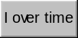 button in the Intro sheet. What is the main point of the Investment graph, compared to the other two graphs?

Enter your answer in this box. The box expands as you type in text.

Q1-B) Follow the download steps in the CIG sheet to update the Investment graph with data up to the present. Copy and paste your Investment graph in the box below and comment on whether or not the recent behavior of Investment supports your answer to part A above.

If you are unsure of how to make a chart, see the ExcelBasics.doc file available at http://www.depauw.edu/learn/introeconlab/lab0.htm for instructions.

In Excel 2007 and greater, copy the chart by selecting the chart, clicking the arrow under Paste (in the Home tab) and select As Picture→: Copy as Picture. In earlier versions of Excel, you can right-click the chart to accomplish the same thing.

Enter your answer in this box. The box expands as you type in text.

Play around a bit with the three policy tool scroll bars in the Intro sheet. Click the  button when you are finished exploring and answer the questions below.

Q2) As you increase G, Y rises, because Y = C + I + G. But did you notice that the size of the letter Y (which is meant to reflect the value of Y) grows faster than G grows? If G increases by $100 billion, why would Y increase by more than $100 billion?

Enter your answer in this box.

Q3-A) If Y = C + I + G, how can T affect Y? Put another way, there’s no T in the equation for Y so how does T influence Y?

Enter your answer in this box.

Q3-B) How do tax increases affect unemployment? Explain.
Hint: Macroeconomics emphasizes “domino explanations:” x causes y which causes z. Practice this style here. Don’t just say, “Higher taxes increase unemployment.” What are the steps?

Enter your answer in this box.

Q4) If the economy were doing badly and the Fed wanted to stimulate it with monetary policy, what should the Fed do? How would the Fed’s move affect the economy? Explain.
(Reminder: please include the steps in your answer.)

Enter your answer in this box.

We now turn to a more careful examination of exactly how monetary policy works.

Proceed to the MoneyMarket sheet.

The MoneyMarket sheet is designed to give you practice understanding how the Fed can manipulate the money supply to influence interest rates, which affects Investment and finally GDP and unemployment.

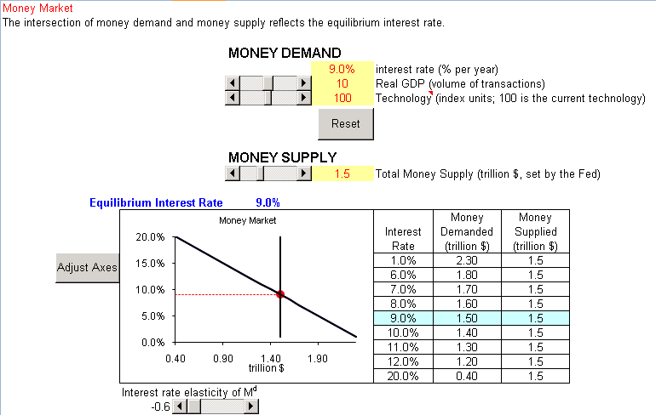

The sheet opens with a money supply of $1.5 trillion interacting with money demand to pin down the equilibrium interest rate at 9% per year.

Since the interest rate is on the y axis, changes in the interest rate result in a movement along the money demand curve (which is actually a straight line here for simplicity’s sake).

You will use the scroll bars to change the variables in cell F6 and F7. This will cause the money demand curve to shift.

Monetary policy is controlled by the scroll bar that changes cell F12.

Let’s begin.

Play around with the Real GDP (volume of transactions) scroll bar.

Q5) How does Real GDP affect money demand?

Enter your answer in this box.

Click the 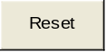 button to return the variables to their initial values.

Use the scroll bar to increase the technology variable to 120. Money demand falls, shifting left.

Take a picture of the money market chart (see Q1-B for instructions if needed).

Q6) Paste the money market chart in the box below.

Paste your picture in this box.

Q7) In conventional supply and demand curves, technology is a shift parameter for the supply curve and increases in technology increase supply, shifting it right. For money demand, however, increases in technology decrease demand. Why?
Hint: What kind of technology are we talking about here?

Enter your answer in this box.

Having explored the properties of the money demand function, we are ready to turn to the monetary policy tool.

Click the button.

Q8-A) Suppose the Fed wanted to decrease the interest rate to 7% per year. What should the Fed do to the money supply? Use the money supply scroll bar and describe your procedure in answering this question.

Enter your answer in this box.

Q8-B) Suppose the Fed wanted to increase the money supply in order to decrease the interest rate to 7% per year. Describe what open market operations the Fed would execute and why this would increase the money supply.

Enter your answer in this box.

Q8-C) Under what economic circumstances would the Fed take measures to decrease interest rates?
Enter your answer in this box.

Q9-A) Using your general knowledge of how elasticity is calculated, come up with a definition and an equation for the interest rate elasticity of money demand.

Enter your answer in this box.

Q9-B) When you first open the workbook, the interest rate elasticity of demand is
-0.6. Is this elastic or inelastic? How do you know?

Enter your answer in this box.

Difficult
Q10) When money demand becomes more interest rate elastic, does this help or hinder the Fed’s ability to influence the economy? Describe your procedure.
Hint: Use the interest rate elasticity of money demand scroll bar to experiment.

Enter your answer in this box.

Q11) When the Fed decreases the interest rate, which of the three components of GDP is immediately impacted? How precisely is this variable affected by a decrease in the interest rate?

Enter your answer in this box.

It’s time to move beyond the money market and to a more careful exploration of the next step in the monetary transmission mechanism: the relationship between the interest rate and investment.

In Q11, you pointed out that decreases in the interest rate lead to increases in Investment. As you know, increases in Investment will stimulate the economy since Y = C + I + G.

The tie between the interest rate and Investment has a complication that involves the distinction between nominal and real interest rates.

Nominal interest rates are the interest rates observed in the real-world. The nominal interest rate tells you how much you will be paid (or you have to pay, if you are borrowing).

A real interest rate goes one step further, it figures how much you get (or have to pay) in real terms. In other words, it factors in the effect of rising prices over time.

Before we go to work with Excel, consider a simple example. You borrow $1,000 today at 10% per year and you pay it back in one year. How much do you pay back? That’s easy, the principal that you borrowed, $1000, plus the interest of $100.

But a year has gone by and, presumably, prices have risen. By how much? Say 5%. It stands to reason that your true, real interest rate is not 10% because when you pay back the $1,100, one year later, that money isn’t worth what $1,100 is worth today because of the inflation. Well, how much is $1,100 worth if prices have risen 5% in a year? Let’s find out.

Proceed to the InterestRate sheet. Here is the basic setup.

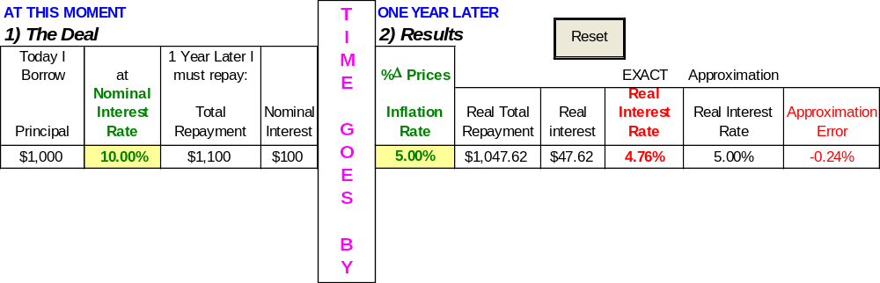

As you can see, the sheet implements the example in Excel. You borrow $1,000 now at 10% per year, but when you pay the $1,100 back one year later, since prices have risen by 5%, your Real Total Repayment is only $1,047.82. In other words, you are paying back $1,100 that can buy only $1,047.82 worth of goods. Thus, your real interest rate is only 4.76%, not 10%. You are happy. Your lender is sad. More on this in a moment.

Q12) Click on the Real Total Repayment number in cell G7. Explain the formula—why is the Total Repayment divided by (1 + InflationRate)?

Enter your answer in this box.

Q13) Increase the inflation rate to 8%. Report the exact real interest rate and explain why it fell.

Enter your answer in this box.

Q14) Is it possible for the real interest rate be negative? If so, demonstrate via an example. Describe your procedure.

Enter your answer in this box.

Difficult
Q15) While there are two interest rates, nominal and real, Investment depends on the real interest rate. Why?

Enter your answer in this box.

Next, you will learn that there’s an easier way to compute the real interest rate than the tedious Total Repayment/(1 + InflationRate) approach. It’s easier, but not exact. However, it works well for small numbers, like interest and inflation rates usually are (although many economies have experienced high rates and then the approximation does badly).

The Real Interest Rate Approximation says that

Real Interest Rate = Nominal Interest Rate – Inflation Rate

Let’s see how it works.

Click the button. Note how cell J7 implements the Real Interest Rate Approximation. Cell K7 reports the approximation error.

Q16) Your friend says, “I’m confused. There are two real interest rates, one in cell I7 and another in cell J7, and they are different. Which one is the right one?” Help your friend out by explaining what’s going on here.

Enter your answer in this box.

Q17) Demonstrate that the Real Interest Rate Approximation is better the smaller the inflation rate. Describe your procedure.

Enter your answer in this box.

Q18) Find the two values of the inflation rate where the Real Interest Rate Approximation works perfectly—i.e., the exact real interest rate is the same as the approximation’s real interest rate so the approximation error is zero. Describe your procedure.

Enter your answer in this box.

Q19) Does the Real Interest Rate Approximation work when there is deflation—that is, negative percentage changes in the price level? Describe your procedure in answering this question.

Enter your answer in this box.

Our work on nominal and real interest rates enables us to make a crucial point: inflation affects the nominal interest rate. Here’s why.

Q20) When the rate of inflation unexpectedly increases, are borrowers happy? How about lenders? In each case, explain your answer.

Enter your answer in this box.

Suppose you were a lender and you wanted a real return of 5% per year. How would you set your nominal interest rate?

You could do a little algebra on the Real Interest Rate Approximation, like this:

Real Interest Rate = Nominal Interest Rate – Inflation Rate

Real Interest Rate + Inflation Rate = Nominal Interest Rate

When the Real Interest Rate Approximation is used to determine the Nominal Interest Rate we have what is called the Fisher Effect. It says that higher inflation rates lead to higher nominal interest rates, which makes sense since lenders know that higher inflation means the money paid back in the future has less purchasing power.

Irving Fisher was a US economist in the first half of the 20th century. You can learn more about him at http://cepa.newschool.edu/het/profiles/fisher.htm.
Q21) Change the rate of inflation to 8% in cell F7. Suppose the lender wanted a real interest rate of 5%. What nominal interest rate would she charge? Why?
Note: You may use the Real Interest Rate Approximation.

Enter your answer in this box.

There’s one BIG problem, however. You have to know the inflation rate in the future. You have to guess or predict this inflation rate. So, the equation turns into something a little more complicated:

Nominal Interest Rate = Real Interest Rate + Expected Inflation Rate

Proceed to the FisherEffect sheet. Here is the basic setup.

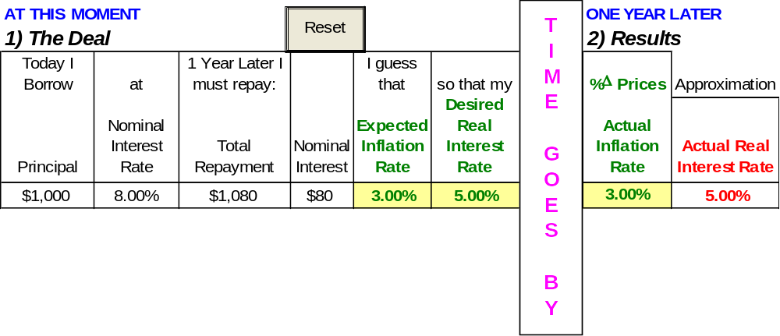

It looks similar to the previous sheet, but look carefully—there are important differences. In this sheet, you are aware that your final, actual real interest rate depends on the inflation rate. Thus, you predict an expected inflation rate and a desired real interest rate and this gives a nominal interest rate.

Of course, your prediction may not be exactly on target.

Q22-A) Increase the actual inflation rate so that is higher than the expected inflation rate. Take a picture of cell range A5:I7 and paste it in the box below.

To take a picture of a group of cells in Excel 2007 or greater, select the cells, then click the down arrow under the Paste button and choose As Picture → Copy as Picture. In older versions of Excel, select the cell range, then hold down the Shift key and you right-click the selected cell range and select Copy as Picture.

Paste your picture in this box.

Q22-B) If your expected inflation rate is lower than the actual inflation rate, in other words, prices rose more than predicted, who’s happy, you or the lender? Why?

Enter your answer in this box.

It may seem that as long as expected and actual inflation is the same, all will be well. That’s true, but the problem is that the task of predicting inflation is different in low versus high inflation situations. It turns out that high inflation is variable inflation. There’s no theoretical reason for this to be true, but historical experience does confirm that this is true. Thus, if prices are reasonably stable, with inflation of 1 or 2 percentage points per year, then it is much easier to forecast inflation than if prices are galloping along at double digit rates of inflation. If inflation over several years is 8% per year, then 14% per year, and 12% per year, it stands to reason that next year’s inflation is much harder to guess than if inflation had been 1.2%, 1.8% and 1.6%.

In his best-selling Intermediate Macroeconomics textbook, the President’s chief economic advisor (at that time), N. Gregory Mankiw, writes: “Finally, in thinking about the costs of inflation, it is important to note a widely documented but little understood fact: high inflation is variable inflation. That is, countries with high average inflation also tend to have inflation rates that change greatly from year to year.”

Q23-A) Suppose inflation was expected to be 15% next year and a lender wanted a 5% real return. How would the lender set the nominal interest rate using the usual equation?
Note: You may use the Real Interest Rate Approximation with the expected inflation rate. Show your work.

Enter your answer in this box.

Q23-B) Same as question 23, except that the lender knows that high inflation is variable inflation. How does this affect the lender’s decision on the nominal interest rate?

Enter your answer in this box.

We conclude this lab by taking a quick look at some data.

Proceed to the Data sheet.

Q24-A) Make a chart of the nominal interest and inflation rate data over time. Take a picture of your chart and paste it in the box below.

Paste your picture in this box.

Q24-B) Does your chart provide evidence that the nominal interest rate and the inflation rate move together? Explain.

Enter your answer in this box.

The last question in the lab asks you to visit the excellent Fred web site at:

http://research.stlouisfed.org/fred2/

As you can see, there is a wealth of information available.

Click on the “Interest Rates” link.

Click on the “Prime Bank Loan Rate” link.

Click on the DPRIME variable. “Prime” stands for the rate that is provided to best (i.e., lowest risk) customers and “D” is for “daily.”

Fred displays a chart of the Daily Bank Prime Loan Rate (which is what DPRIME stands for). The chart includes gray “recession” bars that indicate when the US economy was performing poorly.

You can easily see that interest rates during the early 1980s were quite high. Remember that inflation was quite high also during this time period. This is a clear demonstration of the fact that nominal interest rates (such as DPRIME) are affected by inflation.

Click Download Data.

Download the DPRIME.xls workbook (click Open when prompted).

Q25-A) Make a chart of the daily Prime Bank Loan Rate over time. Carefully title the chart, create a reasonable x axis, and avoid the dreaded “Series 1” legend text. Take a picture of your chart and paste it in the box below.

Paste your picture in this box.

Obviously, your chart should look like the one created by Fred. This question is meant to give you practice with downloading data and charting in Excel.

Q25-B) On July 1, 1998, the Prime Bank Loan Rate was 8.5%, yet the nominal interest rate in the Data sheet for 1998 was 4.82%. If there are many interest rates and they deviate from each other this wildly, how does it make sense to talk about the Fed affecting “the” interest rate?

Enter your answer in this box.

Congratulations! You have finished the monetary policy lab.

Save this document and print it.

You can save a lot of paper and ink by cutting everything out of the final, printed version except the questions and your answers.

