Name:
Introductory Economics Lab http://www.depauw.edu/learn/introeconlab
Excel Workbook: InternationalTrade.xls

International Trade Lab

Introduction

This lab has two goals:

- To explain why countries trade and
- To explore some US trade data.

Open the InternationalTrade.xls workbook and read the Intro sheet.

If you haven’t already, you should read the chapter or chapters in your textbook on international trade. Many introductory Econ textbooks cover the fundamentals of trade in a basic way in an early chapter, and then do a more in-depth chapter on trade well into the text. Since this lab is concerned with the simple, fundamental question of why countries trade, you will want to read the material in your book that reviews the basics of trade, usually with the aid of something called a production possibilities frontier, or PPF, graph, which is reviewed below. Your book will explain that trade enables countries to reach consumption possibilities unattainable by simply producing all goods and services domestically. In a nutshell, this is why countries trade.

As mentioned above, the primary tool that you need to understand for this lab is the concept of a production possibility frontier. The PPF is a graph that shows the different production outcomes that come about from a society deploying its resources in different ways. It is a simply model of scarcity that demonstrates the tradeoffs that a country faces when it chooses to use its scarce resources differently across different industries. Another useful way to interpret the PPF is as a visual display of the set of attainable production outcomes for a country given its resources and technology.

For example, suppose that a country has 1000 units of labor (its only resource) and can produce only two goods, bread and steel. If a unit of bread requires one unit of labor, then devoting all of its resources to bread yields 1000 loaves of bread and no steel. If on the other hand, steel requires 100 units of labor per ton, then devoting all of its resources to steel would yield 10 tons of steel and no bread. Drawing a straight line connecting these two points yields a simple PPF that describes this economy’s choices for various amounts of bread and steel.

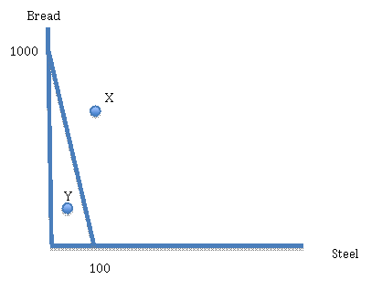

Any combination of bread and steel on that line will use all of society’s resources. Any point X outside the line is unattainable, while any point Y on the interior is inefficient, since it is possible to have more of both goods by using resources more wisely.

Your textbook will probably show a curved PPF, reflecting increasing opportunity cost of specializing in one good. All the ideas in this lab would work equally well with a curved, more realistic PPF, but the numbers are harder to crunch. Therefore, this lab uses a linear PPF like the one above.

Proceed to the WhyTrade sheet. The sheet shows a severely simplified trade situation. The essentials are captured by the table below:
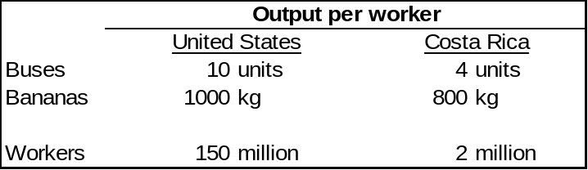
Use this table to answer questions 1, 2 and 3.

Q1) What is the opportunity cost of a bus in the US? Explain how you arrived at your answer.

Enter your answer in this box.

Q2) Which country has an absolute advantage in the production of both buses and bananas? How do you know?

Enter your answer in this box.

Q3) Which country has a comparative advantage in the production of buses? How do you know?

Enter your answer in this box.

Now let’s turn to the PPF graphs, which look like this:

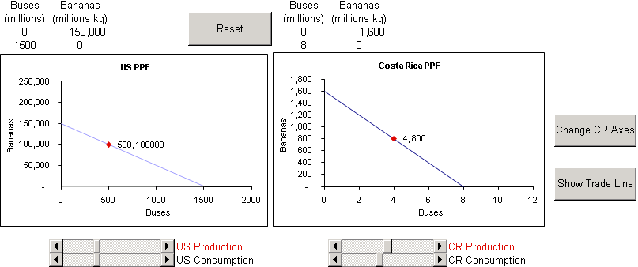

The two PPF graphs represent each country’s production possibilities. Although it looks the Costa Rican economy has more production choices, look carefully at the y axes.
Q4) Click on the 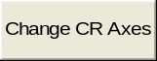 button. What happened to the Costa Rican PPF and why?

Enter your answer in this box.

Q5) Click on the US Production scroll bar to move the production choice along the PPF. Why do we ignore the points inside the PPF?

Enter your answer in this box.

Q6) Let’s suppose US consumers like buses much more than bananas. Choose a production point that reflects these preferences. Copy the US PPF graph as a picture and paste it in the box below.

Paste your picture in this box.

Q7-A) Costa Ricans, on the other hand, prefer bananas to buses. Use the CR Production scroll bar to set the production choice to 2 buses and 1200 bananas. Copy the CR PPF graph as a picture and paste it in the box below.

Paste your picture in this box.

Q7-B) Use Word’s drawing functionality (execute Insert: Shapes: Oval) to place a point (a circle filled in with a color) at 2 buses and 1400 bananas in the picture you just pasted above.

Q8) While the (2,1400) point is currently unattainable, would Costa Ricans prefer this point over the (2,1200) point? Explain why.

Enter your answer in this box.

International Trade

We are now ready to introduce trade between the US and Costa Rica.

Suppose, at their current production choices, that the US and Costa Rica could trade with each other. A crucial variable is the price at which buses and bananas are exchanged. This is often called the terms of trade. Scroll down a bit, if needed, to see the terms of trade in cell F40. We presume that the US and Costa Rica have negotiated a price of 150. In other words, 1 bus can be bought with 150 kg of bananas. (This seems like a ridiculously cheap bus, but then again, the whole example is, shall we say, highly stylized.)

Click the  button to see the world of new CONSUMPTION possibilities opened up by international trade. The pink lines represent new consumption choices for the US and Costa Rica.

Use the US and CR Consumption scroll bars to explore the consumption possibilities for the two countries. Notice that the consumption choice moves along the PPF part of the time, and along the pink, Trade Line at other times.

Q9) Use the CR Consumption scroll bar to choose a consumption point with 8 buses. Your friend is very confused, “How can Costa Rica have 8 buses and some bananas when the only way they can produce 8 buses is by devoting all of their labor force to bus production?” How would you explain to your friend how Costa Rica is pulling off this remarkable feat?

Enter your answer in this box.

Q10) Change the terms of trade (in cell F40) to 110. Has the price of buses gone up or down? Who’s helped and who’s hurt by this? Why?

Enter your answer in this box.

Click the 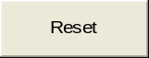 and then the buttons.

Q11) Change the terms of trade (in cell F40) to 80. The pink Trade Line now lies within the US PPF. What does this mean?

Enter your answer in this box.

Q12) What is the range of feasible terms of trade values? Why are values outside of this range not feasible?

Enter your answer in this box.

Q13) In fact, in order to maximize the gains from trade, the US and Costa Rica will specialize in the production of a single good. Use the US and CR Production scroll bars to show which goods the two countries will specialize in. When you are finished, copy the US and CR PPF graphs and paste them in the box below.

Paste your picture in this box.

Note: The complete specialization scenario is only of three possible outcomes for a two-country, linear PPF model. The other two outcomes involve complete specialization by one of the two countries. Which outcome obtains depends on the structure of world demand.

Q14) Your friend, poor thing, is confused again. “This doesn’t look like a very good solution for these two countries. The US is stuck with 1500 busses and no bananas while the Costa Ricans are up to their ears in bananas and have to walk everywhere. What’s so great about international trade?” How would you help your friend understand the powerful advantages of international trade?

Enter your answer in this box.

Q15) Suppose that US specializes in buses but they decide to consume at the point (500, 150,000). Given this situation, what would be the volume of exports and imports for the US? Describe your calculations for each answer.

Enter your answer in this box.

THE POINT ABOUT INTERNATIONAL TRADE:
The reason why international trade is good is that it allows countries access to consumption possibilities beyond the PPF. The expanded consumption choices enabled by trade increase the standard of living.

Stephen Landsburg gives a clear, clean exposition of why countries trade in an essay titled “The Iowa Crop” (see The Armchair Economist, 1993). Landsburg credits David Friedman with the idea, but mentions that it might not be original to Friedman.

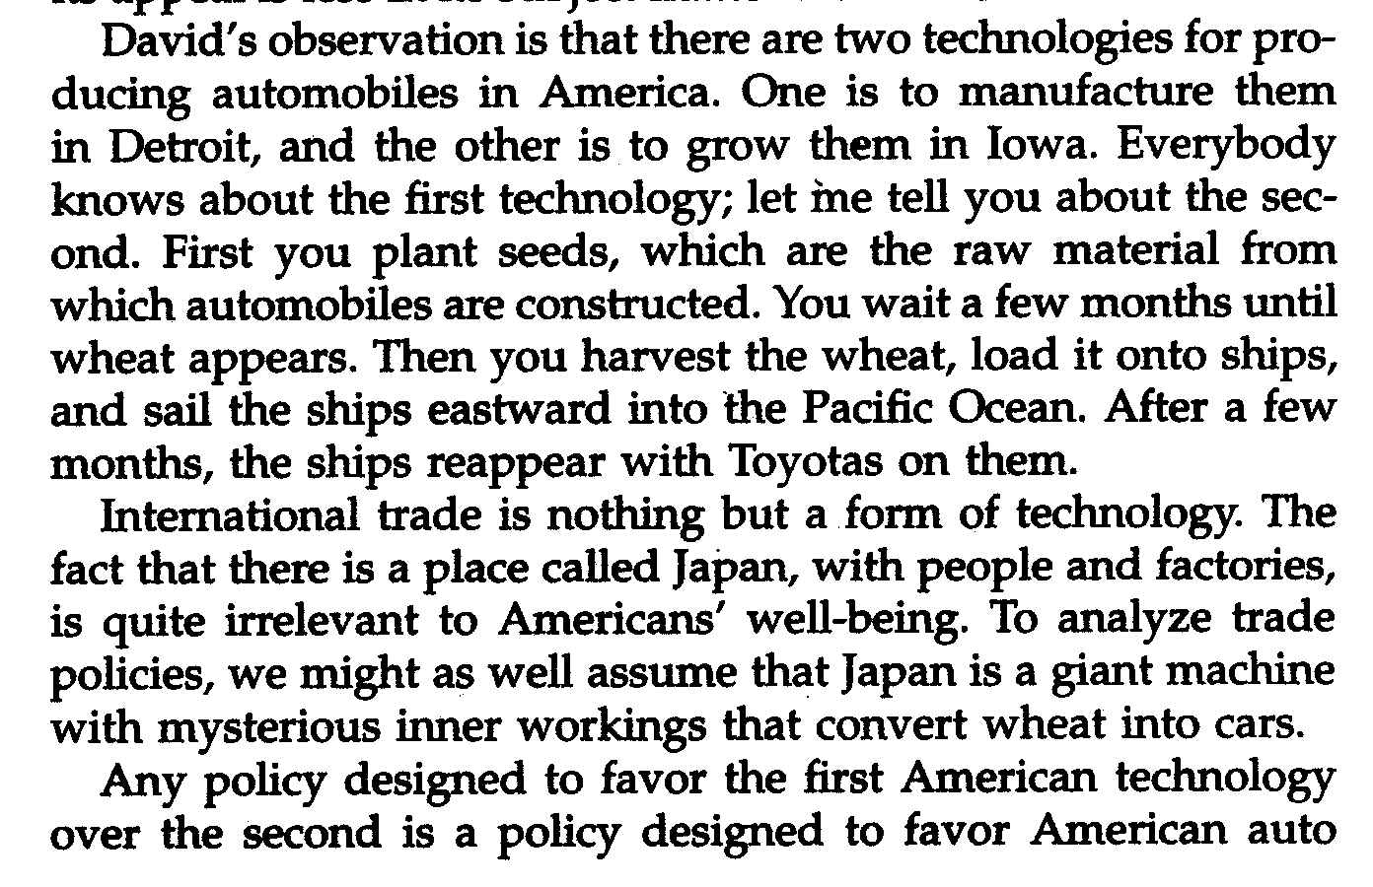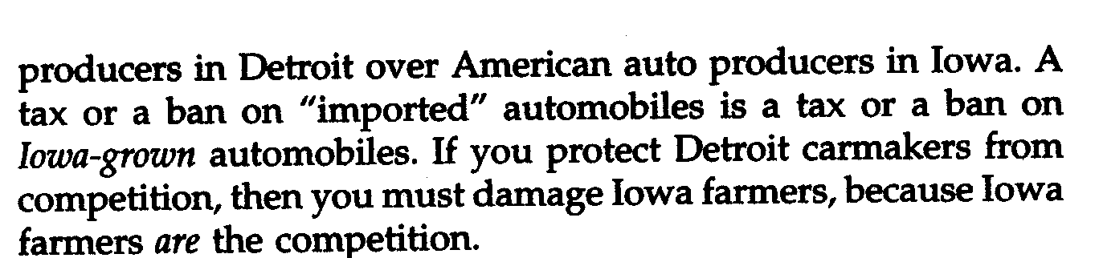

Landsburg ends the essay by reminding the reader of the long history of free trade in economics.

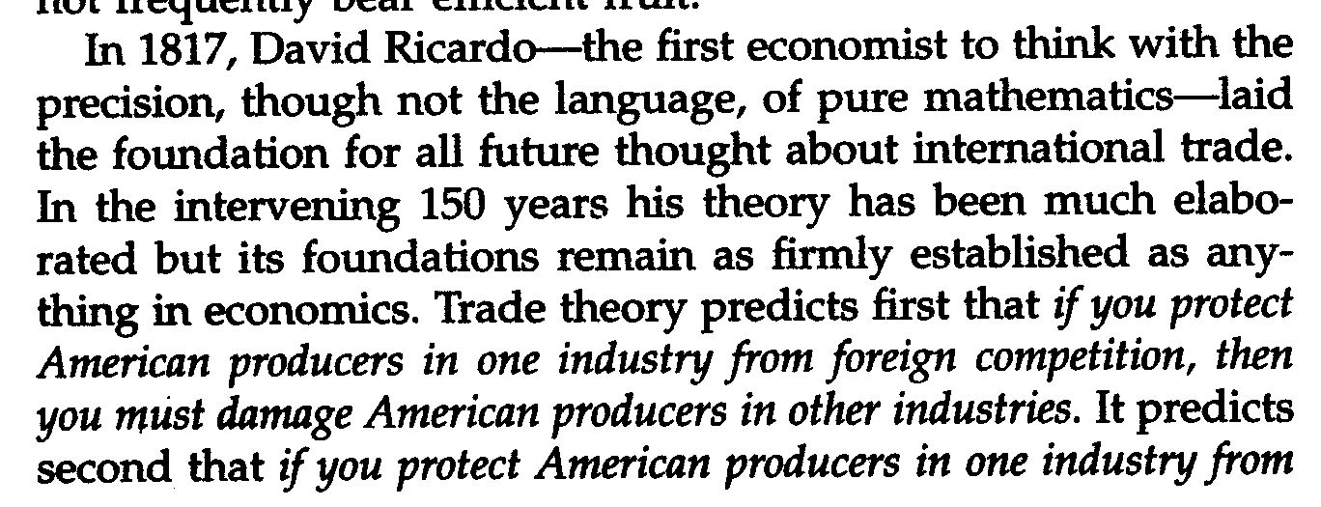
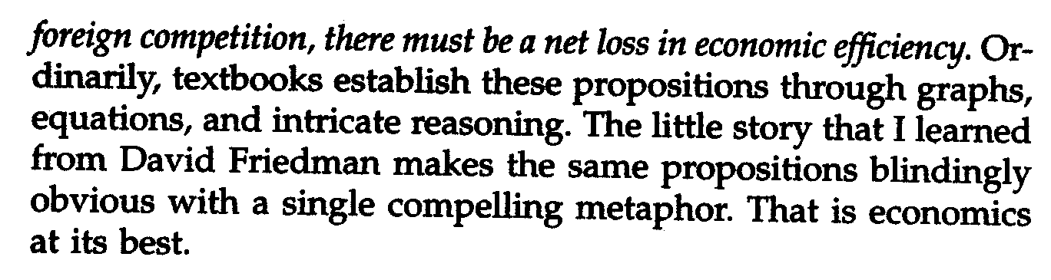

In fact, the point about specialization applies not only to international trade, but to our daily lives.

Consider the following scenario: Peter and Bert bake bread and brew beer.

Change the names and the values in the table on the first page to reflect a new situation: the productivity of Peter and Bert making beer and bread. You may use whatever numbers you want, but make sure that one has a comparative advantage in one good and the other in the other good. Make sure you set the number of workers to 1 (in cells C12 and E12) and change the units in the table as needed.

Q16) Take a picture of your completed table (range B7:F12) and paste it in the box below.

Paste your picture in this box.

Q17) If neither Peter nor Bert had a comparative advantage in bread or beer, would their productivities have to be exactly the same? Explain.

Enter your answer in this box.
Q18) Use your table to explain who would specialize in producing bread. Why does this happen?

Enter your answer in this box.

We’ll end this lab by taking a quick look at some real-world US trade data.

Proceed to the Data sheet and click on the first link, to get US trade data on fresh bananas. Notice that the US imports fresh bananas from several countries, including Costa Rica. Follow the Steps very carefully in this sheet.

The resulting map is quite informative. You can explore other goods such as oil and computers.

Q19) What is the dollar volume of banana imports from Costa Rica? Click on the “View HS-0803 Exports” link located on the top right of the webpage. What is the dollar volume of banana exports TO Costa Rica for the same time period? What’s going on here?

Enter your answer in this box.

Return to the Trade Stats Express – National Trade Data web page and locate the most recent year’s bus imports from Costa Rica.. See the screenshot on the Data sheet for the exact product description you need to locate. Not surprisingly, the US imports no buses from Costa Rica. Bananas yes, buses no.

Q20) What is the dollar volume of bus exports to Costa Rica from the US? What’s going on here?

Enter your answer in this box.

Congratulations! You have finished the International Trade lab.

Save this document and print it.

You can save a lot of paper and ink by cutting everything out of the final, printed version except the questions and your answers.

