Name:
Introductory Economics Lab http://www.depauw.edu/learn/introeconlab
Excel Workbook: Elasticity.xls

Elasticity Lab

Introduction

This lab is divided into two parts: theory and data.
- The theory part is a discovery exercise. You pepper a buyer with questions in order to elicit her demand curve. Then you compute elasticities at particular points.
- The data part has you surf the web for estimates of the price elasticity of cigarettes and then offers data on cigarette smoking for you to work with.

Theory

Q1) Find the definition of the price elasticity of demand in your textbook and quote it (by typing in the text in the box below). Document your quotation, including the author’s name, title of the textbook, edition, year of publication, and page number.

Enter your answer in this box. The box expands as you type in text.

Open Elasticity.xls, read the Intro sheet and proceed to the Theory sheet.

The Theory sheet is designed to give you practice understanding demand curves and elasticities.

Click the  button and enter a price in the form that pops up:
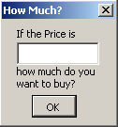

The buyer will respond with a quantity demanded at that price. The result will be posted in columns A and B and the chart will be updated.

Click the  button to clear all of the entries in columns A and B and the chart. This is useful if you make a mistake and want to start over.

The workbook uses a random number generator to give you your own personal, unknown demand curve. Your job is to figure out the buyer’s demand curve and use it to answer a few questions.

Let’s begin.

Q2) Offer five different prices. Make the first price 1 dollar per unit, the second 2 dollars per unit, and the third 3 dollars per unit. Make the fourth price 5 and the last price 10 dollars per unit. Take a picture of the chart and paste it in the box below.
Hint: To take a picture, select the chart, and click the arrow under the Paste button and select As Picture and Copy as Picture. In earlier versions of Excel, right-click the chart, then hold down the Shift key and click copy.

Paste your picture in this box.

Q3) In cell C7, enter a formula that computes the change in quantity divided by the change in price from the first data point to the second. Formulas in Excel always start with an “=” sign and you have to use parentheses carefully. The formula in cell C7 should look exactly like this:
=(B7-B6)/(A7-A6)
This ratio tells you how much quantity demanded changes for a given change in the price. Report your ratio in the box below.

Enter your answer in this box.
Q4) Fill Down your formula in cell C7 for all of the other data points. What do you notice about the change in quantity given a change in price?
Note: Do NOT reenter the formula by hand in every cell. Use Excel’s powerful Fill Down feature (search “Fill Down” in Help) to quickly do this task. Help is found by clicking on the blue question mark located at the top right of Excel, or by clicking F1.

Enter your answer in this box.

Now that you’ve determined the change in quantity demanded for a given change in price of your virtual buyer’s (obviously linear) demand curve, let’s work on the elasticity.

We haven’t paid much attention to units, but the ratio you computed in Q3 and Q4 has units. The change in quantity demanded might be a weight (bushels, pounds, tons and so on) or maybe the good is sold in six-packs or by the month (like cable or satellite TV). We don’t know the units of this generic good, but it has to have some units.

Q5) Use cell D7 to compute the price elasticity of demand from P=$1/unit to P=$2/unit. Proper use of parentheses is crucial. Your formula must compute the percentage change in quantity in the numerator which is then divided by the percentage change in price. Report your elasticity in the box below.
Hint: Unlike Q3 where you were told exactly what to type, this question asks you to come up with the formula on your own. Click the  button if you are totally stuck.

Enter your answer in this box.

Q6) What are the units of the elasticity you computed in Q5? Explain.

Enter your answer in this box.

Q7) Fill Down your formula in cell D7 for all of the other data points. What can you conclude the elasticities of demand along a linear demand curve? Explain.

Enter your answer in this box.
Q8) Identify the price with the smallest elasticity (in absolute value). Without doing any calculations, at this price, would this buyer’s total expenditure (price times quantity) rise, fall, or remain the same if price rose by 1 dollar per unit? Explain why.

Enter your answer in this box.

You can use Excel like a calculator, but Excel is much more than an adding machine. Most users know that Excel can create charts, but it also has some powerful charting tools. Here is an example.

Right-click on the points that make up your demand curve (on the chart) and select Add Trendline . . . from the pop up menu, like this:
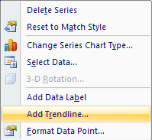

Accept the Linear (default) fit, but click on the Options tab and check off the option to display the equation on the chart, then click OK.
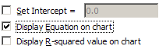

Excel fits a line to your points and displays the equation on the chart in the usual mathematical form of the equation of a line, y = mx + b. Of course, m is the slope and b is the y-intercept. It’s not smart enough to put your variable names in for y and x, but you can directly edit the equation.

Q9) Click on the displayed equation on your chart so it is highlighted, then change the y to a P and the x to a Q. Take a picture of your chart.

Paste your picture in this box.

Q10) The slope reported by the equation of the fitted line, m, is not the same as change in quantity given the change in price that you computed in Q3 and Q4 (in column C). How is the slope of the fitted line, m, related to the computations in questions 3 and 4?

Enter your answer in this box.

ASIDE: Alfred Marshall Draws a Demand Curve and Everyone Does it His Way

Everybody knows that if the price goes up, people buy less. But, believe it or not, it wasn’t until the 1600s that this idea was first written down. Even more unbelievable is the fact that it wasn’t until the late 1800s that a graph was used to depict a demand curve.

The story gets even wackier at this point. It turns out that the person who made modern supply and demand analysis popular, Alfred Marshall, chose to put Price on the y axis and Quantity on the x axis. For Marshall, this wasn’t a mistake because he was interested in how price responded to forces in the market and eventually settled down to its equilibrium value.

In France, Leon Walras, was telling a different story. Walras argued that quantities demanded and supplied responded to price. Modern economics usually adopts the Walrasian view and, thus, Price should be on the x axis and Quantity Demanded or Supplied, the dependent variable, should be on the y axis.

Quantity
Price
Marshall’s
Demand
Quantity
Price
Walras’
Demand

However, Marshall’s way stuck. The explanation is complicated, but a key factor is the fact that Marshall wrote in prose (“plain English”) while Walras was a mathematician who remained incomprehensible to many “literary economists.” At any rate, today, all introductory textbooks rely on supply and demand analysis and the vast majority put Price on the y axis.

Economists, being the accommodating folks that we are, just learn to live with this rather confusing state of affairs. Beyond the introductory level, we call Marshall’s backwards demand the inverse demand curve. This is mathematical terminology. If the demand function, 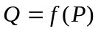, has an inverse, it is 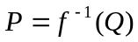and one can show that, graphically, you can invert a function just by switching the axes.

The only reason why you need to know about all of this is that when we compute changes in quantity demanded given changes in the price, or the slope of the demand function, that is different than the slope of the conventional, Marshallian demand curve with P on the y axis. In fact, in your answer to Q10, you should have said that one is the reciprocal of the other (and if you didn’t say that, now is a good time to correct your answer!).

You should remember that quantities demanded and supplied respond to price and that the conventional demand and supply curves, with Price on the y axis, are, strictly speaking, drawn backwards.

Click the  button. Excel inserts a new sheet, called NewDemand, with the same prices that you used earlier to establish the demand curve, but the quantities demanded are different because this is a different demand curve.

Let’s compare the two demand curves.

Q11) The new demand curve has at least one point on the P axis. What does this mean?

Enter your answer in this box.

Difficult
Q12) The downward sloping part of the new demand curve has the same slope as the original demand curve, yet it is not the same curve. How was the new demand curve obtained from the original demand curve? Explain your procedure in arriving at an answer to this question.

Enter your answer in this box.

Q13) Give THREE reasons that could have caused the original demand curve to become the new demand curve.

Enter your answer in this box.

Q14) Compare the price elasticity of demand from P=1 to P=2 for the original and new demand curves. Which demand curve is more price sensitive to this change in price?

Enter your answer in this box.

Q15) Without doing any computations, if price rises by 1% from P=1, which demand curve, the original or the new one, will have a greater increase in total revenue? How do you know this?

Enter your answer in this box.

Data

Let’s use our knowledge of elasticity to study a real-world example. We will focus on cigarettes.

You should know that cigarette smoking has decreased tremendously in the US over the last decades. The figure below tells the story for the entire century.
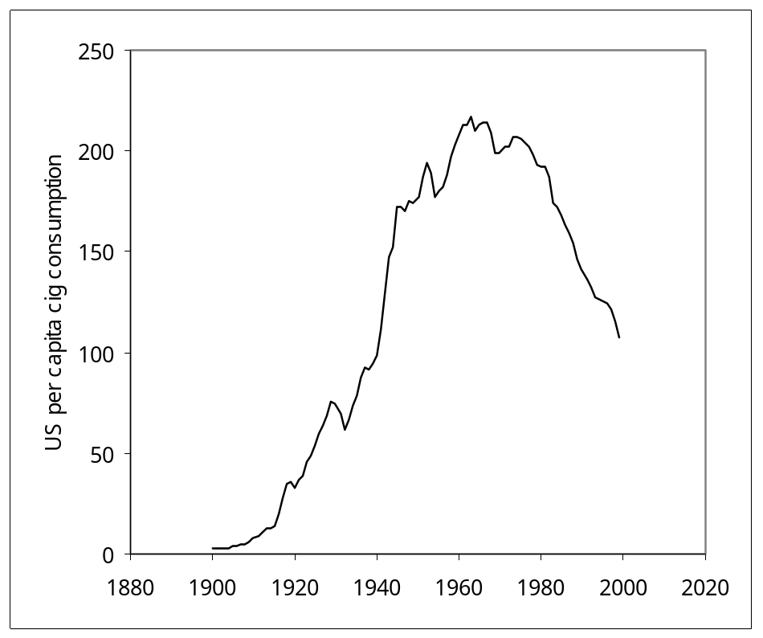
United States per capita consumption of cigarettes for persons 18 and over, 1900-1999. Source: Click the 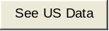 button in the Data sheet.

In this lab, we are interested in measuring the price of elasticity of demand of cigarettes.

Q16) Launch a browser and use your favorite web search engine to find an estimate for the price elasticity of demand for cigarettes. Report the numerical value and the address (URL) of the web page where you found it.

Enter your answer in this box.

Now, proceed to the Data sheet in the Elasticity.xls workbook in order to see data on Price and Quantity for cigarettes across states. The price is in cents per pack and includes all taxes (local, state, and federal) charged. The quantity is number of packs sold per person. There are 20 cigarettes in a pack.

Q17) Create a chart with Price on the y axis and Quantity on the x axis. Fit a line to the scatter plot (using the Add Trendline approach that you used earlier) and display the equation of the line on the chart. Take a picture of your chart.

Paste your picture in this box.

Q18) Compute the price elasticity of demand for cigarettes from a 10 cent price increase from the average price (223.4 cents). Report your result.
To help with the calculations, we computed the quantity demanded at the given price using the intercept and slope from the fitted line.

Price | Quantity
223.4 | 88.9
233.4 | 75.6

Enter your answer in this box.

Q19) Given what you know about cigarettes, your answer to the previous questions (Q17 and Q18) should cause some concern. Why?

Enter your answer in this box.

In fact, you should realize that estimating a demand curve is not easy. Demand curves exist, but they are hidden and uncovering them is extremely complicated. The primary obstacle is that a demand curve is concerned with how much would be demanded, at a specific point in time, for a whole array of prices, but all we see at a specific moment is one price.

Of course, as time as goes by, we see other prices, but then we may be in serious violation of the ceteris paribus requirement. In the cigarette data, we have prices for a particular point in time (1999), but there are many other things different across the states that must be held constant in order to accurately estimate demand for cigarettes.

The crucial point here is that you cannot simply fit a line to price and quantity data and, voila, you have the demand curve. The area of economics devoted to the quantitative and statistical analysis of data is called econometrics.

Q20) Now that you know that estimating demand is mighty complicated, evaluate the quality of the price elasticity of demand for cigarettes that you obtained in Q16. Is the data and method used to obtain the estimate explained? Does it make sense?

Enter your answer in this box.

Congratulations! You have finished the elasticity lab.

Save this document and print it.

You can save a lot of paper and ink by cutting everything out of the final, printed version except the questions and your answers.

