Name:
Introductory Economics Lab http://www.depauw.edu/learn/introeconlab
Excel Workbook: GovIntervention.xls

Ceilings, Floors, and Taxes Lab

Introduction

This lab is divided into three parts: price ceilings, price floors, and taxes.

Open CeilingsFloorsTaxen.xls and read the Intro sheet. It explains a few basic concepts and shows graphs of how price ceilings, price floors, and taxes are analyzed via supply and demand analysis. Proceed to the PriceCeiling sheet after you have finished reading the Intro sheet.

Part 1) Price Ceilings

The sheet opens with a price ceiling of 50 dollars:
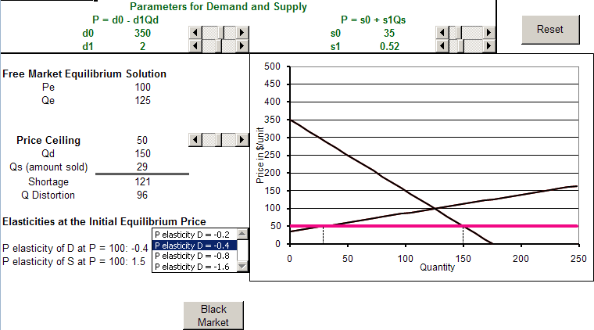

The display shows that the price ceiling generates a quantity demanded of 150 units and a quantity supplied of 29 units, which results in a persistent shortage of 121 units of the good. The Free Market Equilibrium Solution, price of 100 dollars and quantity of 125 units, is also shown.

By comparing the free market’s equilibrium quantity to the quantity supplied with the price ceiling, we obtain a measure of the distortion caused by the price ceiling, 96 units.

Price Ceiling Basics

Q1) Why is the shortage “persistent”? In other words, how are shortages usually eliminated by markets, and why can’t the market work its usual magic in this case?

Enter your answer in this box. The box expands as you type in text.

Key Concept
Q2) So the price ceiling prevents the market from getting rid of the shortage, but so what? What is bad about price ceilings?

Enter your answer in this box.

Use the scroll bar in cell C15 to adjust the price ceiling. Make the price ceiling be 80 dollars.

Q3) Is a price ceiling of 80 dollars better than the original price ceiling of 50 dollars? Why?
HINT: Your answer to Q2 (assuming it is correct) applies again here.

Enter your answer in this box.

Click the  button to return the price ceiling to its original value of 50 dollars.

Price Ceilings and Elasticity

One of the fundamental lessons of price ceilings is that the size of the shortage depends on the price elasticities of demand and supply for the good.
Q4) Use the ability to set the price elasticity of demand to demonstrate that the more price elastic the demand, the greater the shortage. Take a picture of the graph and use it to explain this fundamental lesson.

Paste your picture in this box and provide your answer below the picture.

Like demand, the responsiveness of supply to changes in price affects the shortage.
Q5) What is the relationship between the price elasticity of supply and the size of the shortage?
NOTE: The workbook does not have a convenient list box that can be used to set the price elasticity of supply, but you should be able to figure out how a more or less elastic supply affects the shortage, given your work with demand in the previous question.

Enter your answer in this box.

Click the button to return the price ceiling to its original value of 50 dollars.

Price Ceilings and Black Markets

Another important aspect of price ceilings that can be demonstrated via supply and demand analysis is the fact that price ceilings must be actively policed. Sellers have an incentive to cheat because they can make more money by selling at prices above the legally prescribed maximum. Less obvious is the fact that those buyers who are unable to acquire the good at the legal price also have an incentive to violate the law because this may be the only way they can buy the product. With buyers and sellers made better off by illegally trading at above the legally set price, it’s no surprise that government is going to have to spend resources to enforce the price ceiling.

A black market exists whenever goods or services are traded illegally. Some goods, like cocaine and marijuana, cannot be sold at any price (so their price ceiling is set at zero). Yet we know these goods are bought and sold illegally in what we call black markets or the underground economy.

We have been using the demand curve to report the quantity demanded given a price, but we can invert the question and ask how much buyers are willing to pay for a given quantity. This approach has us read off the price from the demand curve for a given quantity:

Q
P
1) Given
this
Q
2) This is the max P buyers will pay
D

Since the amount available for sale has been choked off by the price ceiling, the price buyers are willing to pay for the available quantity supplied is higher than the price ceiling and even higher than the equilibrium price in the free market.

In fact, the amount that buyers are willing to pay for the quantity supplied at the price ceiling is called the black market price.

Q
P
Black Market Price
D
S
Qss

As you can see, the black market price is illegal because it is above the price ceiling, and quite high (compared to the ceiling and free market equilibrium price).

Make sure you are working with the initial values of the parameters (by clicking the button if needed), then click on the 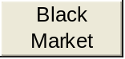 button in order to see the black market price displayed on the sheet and in the graph.

Q6) Compute the difference between the Price Ceiling value and the Black Market Price and the corresponding percentage difference. Report your results.

Enter your answer in this box.

Q7) Compute the extra revenue gained by sellers if they all cheated and sold all of the quantity supplied at the Black Market Price.

Enter your answer in this box.

Like the size of the shortage, the Black Market Price and the gains from cheating are functions of the elasticities of demand and supply.

Q8) Use the ability to set the price elasticity of demand to demonstrate that the more price inelastic the demand, the greater the Black Market Price. Take a picture of the graph and use it to explain this fundamental lesson.

Paste your picture in this box and provide your answer below the picture.

Q9) What is the relationship between the price elasticity of supply and the Black Market Price?
Hint: You need to be able to imagine a more inelastic (or more elastic) supply curve and then determine what effect that would have on the Black Market Price. If your imagination is not that good, you can manipulate the supply intercept and slope coefficients (s0 and s1) in order to create a new, red S curve. If you do this, make sure you force the new S curve through the initial equilibrium solution. This ensures that you new S curve, if steeper, is more inelastic.

Enter your answer in this box.

Part 2) Price Floors

Proceed to the PriceFloor sheet.

The sheet opens with a price floor of 125 dollars:
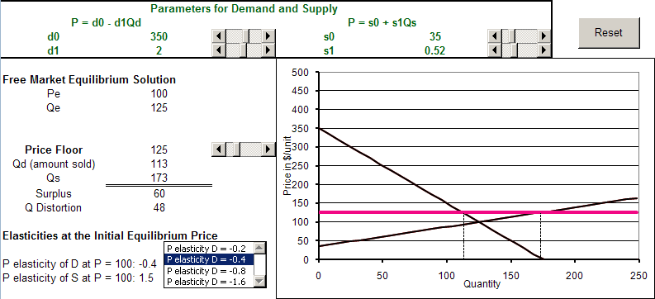

The display shows that the price floor generates a quantity demanded of 113 units and a quantity supplied of 173 units, which results in a persistent surplus of 60 units of the good. The Free Market Equilibrium Solution, price of 100 dollars and quantity of 125 units, is also shown.

By comparing the free market’s equilibrium quantity to the quantity supplied with the price floor, we obtain a measure of the distortion caused by the price ceiling, 48 units.

Price Floor Basics

Q10) Why is the surplus “persistent”? In other words, how are surpluses usually eliminated by markets, and why can’t the market work its usual magic in this case?

Enter your answer in this box. The box expands as you type in text.

Key Concept
Q11) So the price floor prevents the market from getting rid of the surplus, but so what? What is bad about price floors?

Enter your answer in this box.

Use the scroll bar in cell C15 to adjust the price floor. Make the price floor be 150 dollars.

Q12) Is a price floor of 150 dollars better than the original price floor of 125 dollars? Why?
HINT: Your answer to Q11 (assuming it is correct) applies again here.

Enter your answer in this box.

Click the button to return the price floor to its original value of 125 dollars.

Price Floors and Elasticity

One of the fundamental lessons of price floors is that the size of the surplus depends on the price elasticities of demand and supply for the good.

Q13) Use the ability to set the price elasticity of demand to demonstrate that the more price elastic the demand, the greater the surplus. Take a picture of the graph and use it to explain this fundamental lesson.

Paste your picture in this box and provide your answer below the picture.

Like demand, the responsiveness of supply to changes in price affects the surplus.

Q14) What is the relationship between the price elasticity of supply and the size of the surplus?
NOTE: The workbook does not have a convenient list box that can be used to set the price elasticity of supply, but you should be able to figure out how supply affects the surplus, given your work with demand in the previous question.

Enter your answer in this box.

Click the button to return the price floor to its original value of 125 dollars.

Supporting Price Floors

Unlike price ceilings, where the government spends resources catching cheaters, the main role played by government in the case of price floors is figuring out how prop up the floor and preventing it from collapsing.

There are various ways to support a price floor, but we will analyze only one: direct purchase of the surplus by the government.

The idea is quite simple: let buyers willing to pay the legally set minimum price buy as much they want and then have the government buy the rest.

Let’s see how this method works with the PriceFloor sheet.

Q15) Return to the original problem (click the button if needed) and compute the total revenue earned by the sellers, the amount paid by the buyers, and the amount which the government had to purchase.

Enter your answer in this box.

Q16) You should expect that the price elasticities of demand and supply would affect the total cost borne by the government. Is it better for the government, in terms of the total cost of the amount purchased, for the price elasticity of demand to be more elastic? Explain your procedure in arriving at your answer to this question. Take a picture of the graph to help explain your answer.

Paste your picture in this box and provide your answer below the picture.

Part 3) Per Unit Taxes

Proceed to the Taxes sheet and use the scroll bar in cell C14 to set a tax of 50 dollars per unit on this good.
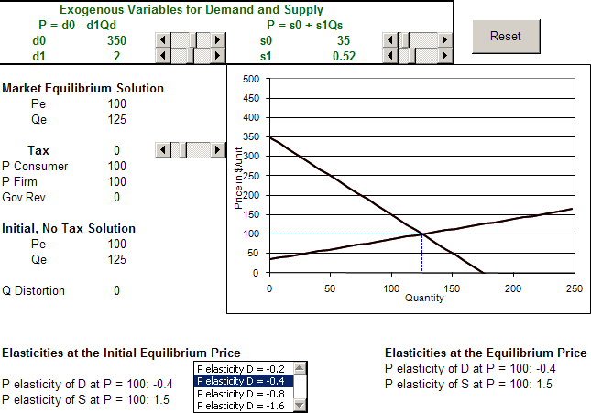

The suppliers, who are responsible for collecting the tax (when they sell the good), must now receive 50 dollars more per unit for any given quantity in order to be willing to produce and sell that given quantity. This is why the supply curve shifts UP (not left) to the new, red supply curve.

The market then re-equilibrates at the intersection of the new supply and original demand curve.
Tax Basics

Q17) While the new equilibrium solution is, in fact, given by the intersection of the new supply and original demand curves, the market does not actually operate this way. Describe the forces that push the market to its new equilibrium after the supply curve shifts up.

Enter your answer in this box.

Key Concept
Q18) So the buyers and sellers aren’t especially happy about the fact that a tax has been imposed on this product, but so what? What is bad about per unit taxes?

Enter your answer in this box.

In addition to the effect taxes have on the quantity produced, we are also interested in how the buyers and sellers divide the burden of the tax.

The sheet displays information that can be used to easily answer this question. The price paid by the buyers, price received by the seller, and the revenue generated for the government are displayed on the sheet.

The consumer is obviously paying $139.68, which is the observed market price for the good, but the seller is only receiving $89.68 for each unit sold. This is because the seller has to send the government 50 dollars for each unit sold.

The revenue generated for the government is easy to calculate (and the formula can be seen by clicking in cell B17): tax times quantity sold. With a tax of 50 dollars per unit and with 105.16 units sold, the government makes 5,258 dollars.

Q19) So, would you say the buyer or seller is bearing the greater burden of the tax? How are you measuring who bears the greater burden?

Enter your answer in this box.

Taxes and Elasticity

The price elasticities of demand and supply play an important role in determining the effects and incidence of a tax.

Q20) With a tax of 50 dollars, change the price elasticity of demand at P=100 to
-1.6. Is the distortionary effect of the per unit tax greater now than compared to the initial situation? What do you conclude about the effect of the price elasticity of demand on the distortion created by per unit taxes?

Enter your answer in this box.

Q21) Compare the -0.4 and -1.6 elasticities of demand with respect to the effect on government revenue. Report the tax revenue generated by the 50 dollar tax in each case.

Enter your answer in this box.

Q22) For a government interested in maximizing tax revenue, is it better to apply per unit taxes to more price inelastic goods? Explain.

Enter your answer in this box.

The price elasticity of demand also affects the tax incidence.

Q23) With a tax of 50 dollars, compare the tax incidence (the shares paid by buyers and sellers) when the price elasticity of demand at P=100 is -0.4 versus -1.6. What do you conclude about how the price elasticity of demand affects the tax incidence?

Enter your answer in this box.

Taxes in the Real World

In the US, cigarettes are taxed by local, state, and federal governments. The map below shows state tax rates in September of 2009:
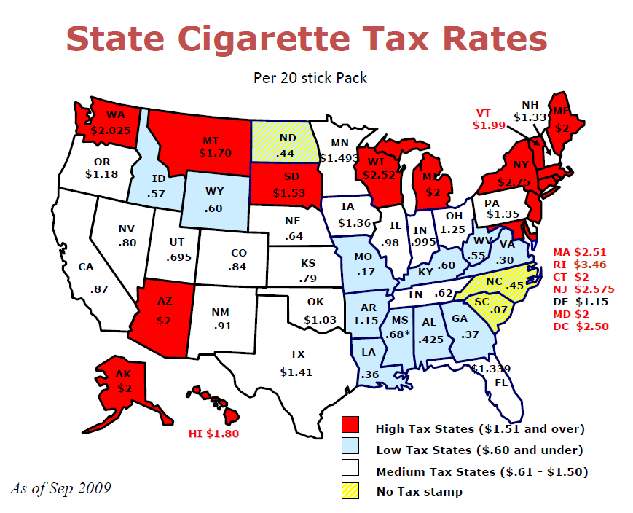
Source: http://www.atf.gov/ (Filename: cigtaxmap011604.ppt)

Q24) Use your favorite Internet search engine to find the United States Federal government’s excise (per unit) tax rate on cigarettes. Report your answer, along with the date and the web address where you found it.

Enter your answer in this box.

In a previous lab, you searched for the Internet for estimates of the price elasticity of demand for cigarettes. Let’s suppose that the price elasticity of demand for cigarettes is actually -0.6.

Q25) With a price elasticity of demand of -0.6, who do you think bears most of the burden of the taxes on cigarettes – buyers or sellers? Explain.

Enter your answer in this box.

Congratulations! You have finished the government intervention lab.

Save this document and print it.

You can save a lot of paper and ink by cutting everything out of the final, printed version except the questions and your answers.

