Name:
Introductory Economics Lab http://www.depauw.edu/learn/introeconlab
Excel Workbook: PerfectCompetition.xls

Perfect Competition Lab

Introduction

This lab is designed to help you understand how perfectly competitive firms choose the amount of output to produce to maximize profits. It will also explain why the short run supply curve is the marginal cost curve where P > AVC.

Open the PerfectCompetition.xls workbook and read the Intro sheet.

If you haven’t already, you should read the chapter or chapters in your textbook on perfect competition. Read about diminishing marginal productivity and the cost structure of a firm. You need to understand the family of cost curves, including marginal cost, average total cost, and average variable cost. Read about how the firm will produce where MR = MC in order to maximize profits, but if the Price falls below AVC, the firm will shutdown. Finally, read about the supply curve and why it is the marginal cost curve.

Q1) Find the definition of “price taking” or being a “price taker” in your textbook and quote it (by typing in the text in the box below). Document your quotation, including the author’s name, title of the textbook, edition, year of publication, and page number.

Enter your answer in this box. The box expands as you type in text.

Proceed to the Graphs sheet.

The Graphs sheet is designed to give you practice understanding the firm’s profit maximization problem.

The sheet is built around a perfectly competitive firm that has a cost function given by the following equation:
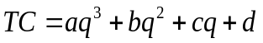
The cost function parameters in the sheet are:

The variable costs are aq³ + bq² + cq, and the fixed cost is d.

You will use the drop-down control on top of the four graphs as well as the q and Price sliders in the middle of the graph to select different prices and put the firm in different profit positions.
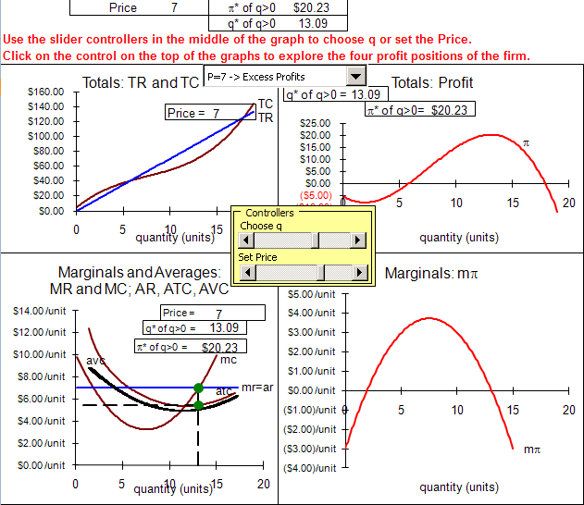

The sheet opens with the firm earning excess, or positive, economic profits. At a Price = $7/unit, the display shows that the firm will produce 13.09 units of output and make $20.23 of profits.

Q2) Find the definition of “fixed costs” in your textbook and quote it (by typing in the text in the box below). Document your quotation, including the page number.

Enter your answer in this box.

Q3) What is the value of fixed costs facing the firm in the Graphs sheet?

Enter your answer in this box.

Q4) Explain, using the bottom left graph, why the firm will not produce more than 13.09 units of output. In other words, use the logic of marginalism in your answer.

Enter your answer in this box.

Profits are total revenue minus total costs. A little algebra shows that we can compute profits from average revenue and average costs at any level of q:
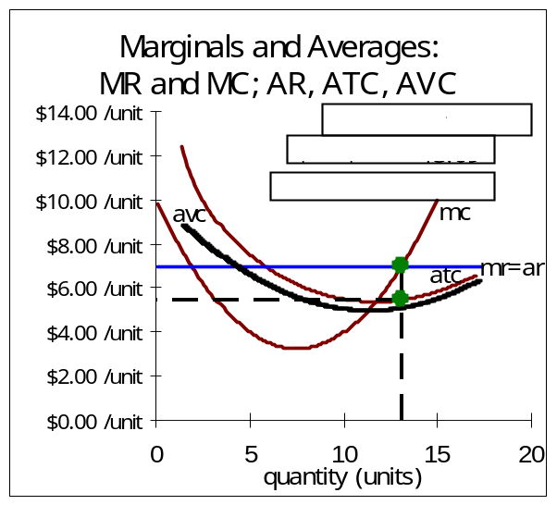
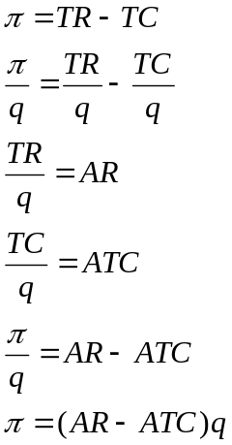

The equation says that we take average revenue minus average total cost (that’s profit per unit) and multiply times the number of units to get profits.

In the graph, this computation is simply the area of the shaded rectangle.

Q5) Use the bottom left graph to compute the profits at q=13.09. ATC at 13.09 is $5.455/unit. Show your work along with your final answer.

Enter your answer in this box.

Proceed to the OptimalChoice sheet. It has the same cost function parameters as the Graphs sheet and it is organized to enable you to use Excel’s Solver to find the optimal solution.

Q6) Click on the Data tab in Excel. In the Analysis group of the Data tab, Solver is found; click on the Solver button. Solver needs a Target Cell, an objective (Max, Min, or Value of), and a Changing Cell. Click Solve when you are ready and click OK to accept Solver’s solution. Copy Solver’s optimal quantity and paste the value in the text box below.

Enter your answer in this box.

Q7) Is Solver’s answer better than the q=13.09 answer from the Graphs sheet. Explain your procedure in answering this question. (Hint: Think about what the objective of the firm is.)

Enter your answer in this box.

Return to the Graphs sheet. We want to explore what happens to the optimal quantity as the price falls. There are four profit positions in which the firm can find itself in the short run. Click on the drop down control at the top of the graphs and select the Zero Profits choice, like this:
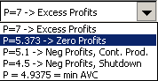

Q8) The Zero Profits case occurs when Price = 5.373. In response to the price drop, the firm changes its chosen level of output to 11.71. Why doesn’t the firm continue to produce q=13.09 when the price falls?

Enter your answer in this box.

Q9) Find the definition of “economic profit” in your textbook and quote it (by typing in the text in the box below). Document your quotation, by providing the page number.

Enter your answer in this box.

Q10) When economic profits are zero, is it true that the firm isn’t making any money?

Enter your answer in this box.

So far we’ve seen two profit positions for the firm, Excess Economic Profits and Zero Economic Profits.

Let’s proceed to the third profit position: Negative Profits, but Continuing Production.

Use the drop down control to set the Price at $5.10/unit.

Q11) At the optimal level of output (q=11.43), the firm experiences negative economic profits, yet it decides to continue production. Why?

Enter your answer in this box.

The fourth, and final, profit position is: Negative Profits, Shutdown.

Use the drop down control to set the Price at $4.50/unit.

Q12) Economic profits remain negative, but this time the firm decides to shutdown and produce no output at all. Explain why.

Enter your answer in this box.

Key Concept
Q13) In deciding whether to produce or shutdown in the face of negative profits, the firm can use a simple decision rule: if P < AVC, shut down. Explain why this rule works.
HINT: Consider using the information from questions 9 and 10 as an example in your explanation.

Enter your answer in this box.

Q14-A) Here are two pictures of the total profit function:

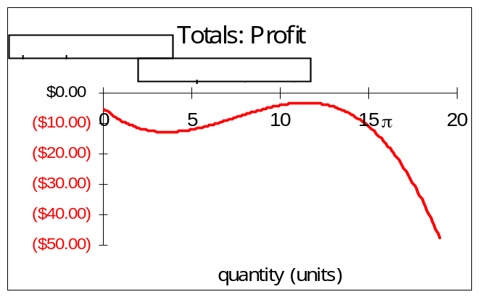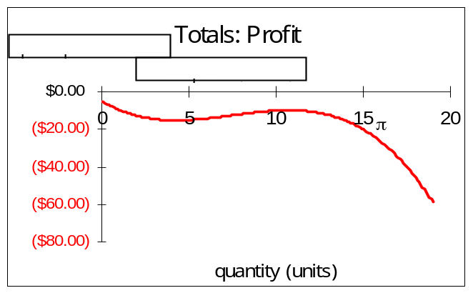
P=5.1 P=4.5

In which situation, the right or the left, should the firm shutdown? Use the graphs to explain why.

Enter your answer in this box.

Q14-B) Do these graphs agree with the “if P < AVC, shutdown” decision rule? Explain.

Enter your answer in this box.

DERIVING SUPPLY

A fundamental result from the theory of the profit maximizing firm is that we can derive the firm’s supply curve. We can offer the firm different prices and see how much they would be willing to produce. The resulting price-quantity pairs are points on the supply curve.

Fill in the quantity values in the table in Column X. In other words, find the optimal q for the given prices.

Q15) Draw a graph (an XYScatter chart) with Price on the y axis and optimal q on the x axis. Do not connect the points. Title your chart and label the axes. Copy your chart and paste it in the text box below.

Paste your picture in this box.

Q16) Compute the price elasticity of supply from P=5.1 to P=5.373. Report your answer.

Enter your answer in this box.

Q17-A) A friend tried to do the question above and he got 1.026. What common mistake did he make?

Enter your answer in this box.

Q17-B) Another friend tried to do Q16 and she got 2.2. What common mistake did she make?

Enter your answer in this box.

You can try the 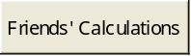 button to see the formulas they used. The answers will be the same as what your friends got only if you have the correct quantities for P=5.1 and P=5.373.

Advanced Thinking

These problems are more difficult. Good luck!

Q18) Set the drop down controller to the P=7 -> Excess Profits case. Look closely at the bottom left graph. There are TWO points where MR = MC, but the firm will ignore the one where q ≈ 2 (it’s actually 1.91) and select the optimal q at 13.09. Look at the marginal profit graph (the bottom right graph). The same phenomenon is happening there. The marginal profit function intersects the x axis in TWO separate places. We know that q = 13.09 is the optimal solution, but what is happening at the other point where MR = MC?

HINT: Look at the total profit function.

Enter your answer in this box.

Q19) Set the drop down controller to the P=5.1 -> Neg Profits, Cont Prod case. Note that the optimal value of q is 11.43 and the firm stays in business. Scroll left in the Graphs sheet to reveal the data that underlie the four graphs. Change the fixed cost, cell E5, to 20 (from 5). What effect does this have on the firm’s optimal q and decision to continue production in the face of negative economic profits? Explain.

Enter your answer in this box.

Proceed to the OptimalChoice sheet. Change the Price from 7 to 4 (in cell B12). Run Solver.

Q20-A) Report Solver’s answer in the textbox below.

Enter your answer in this box.

Q20-B) Is Solver’s answer correct? Explain.

Enter your answer in this box.

Congratulations! You have finished the profit maximization under perfect competition lab.

Save this document and print it.

You can save a lot of paper and ink by cutting everything out of the final, printed version except the questions and your answers.

