Name:
Introductory Economics Lab http://www.depauw.edu/learn/introeconlab
Excel Workbook: Monopoly.xls

Monopoly Lab

Introduction

This lab is designed to help you understand how a monopolist chooses the amount of output to produce to maximize profits, the price at which to the sell the product, and the profits generated.

Open the Monopoly.xls workbook and read the Intro sheet.

If you haven’t already, you should read the chapter or sections in your textbook on monopoly. Read about the differences between perfectly competitive firms and monopolies. Focus on the explanation of the MR curve and how it is different from the demand curve. Read about how a monopolist will produce where MR = MC in order to maximize profits, then compute the appropriate price from the demand curve. Finally, read about how profits are computed as the area given by the difference between Average Revenue (Price) and Average Total Cost times the optimal quantity.

Q1) Find the definition of a “monopoly” in your textbook and quote it (by typing in the text in the box below). Document your quotation, including the author’s name, title of the textbook, edition, year of publication, and page number.

Enter your answer in this box. The box expands as you type in text.

Q2) How are monopolies and perfectly competitive firms different with respect to barriers to entry?

Enter your answer in this box.

The cost structure of a monopolist does not differ from a perfect competitor. Total cost remains the sum of total variable cost and total fixed cost. Marginal cost intersects average variable cost and average total cost at the minimum of each curve.

It’s on the revenue side that a monopolist differs from a perfectly competitive firm. Unlike a price taker, which faces a horizontal demand curve and, therefore, P=MR, a monopolist faces the market demand curve. Since market demand is downward sloping, marginal revenue diverges from demand.

Proceed to the MRandD sheet. Use Excel’s Zoom feature to make sure you can see both graphs and the Quantity information at the bottom of the graphs.

The MRandD sheet is designed to help you understand the relationship between marginal revenue and its associated demand curve.

The demand curve is given by the equation of the line, Price = Price_Int - Price_Slope*Q. The intercept and slope parameters are named cells on the sheet. The sheet opens with the Price_Slope coefficient (cell B2) equal to zero. Thus, the demand curve is horizontal, P=MR, and TR is a straight line. This is the situation facing a perfectly competitive firm. But we are dealing with a monopolist, so we know it faces the downward sloping market demand curve.

Click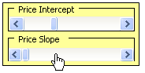 in the center of the Price Slope slider bar FOUR times as shown in the picture above. As you click on the control, watch the two graphs. The demand curve becomes negatively sloped and the TR line becomes a curve.

Q3) As you clicked on the Price Slope control, MR split from D. Explain why Marginal Revenue diverges from the Demand curve for a monopolist.
Hint: Your textbook should be helpful. If you quote it, be sure to cite your source.

Enter your answer in this box.

Q4) With the Price Slope parameter set at 0.4, use the Choose Q slider control at the bottom of the graphs to find the level of output that maximizes total revenue. Report your procedure and answer in the text box below.

Hint: This question is about visualization, using the graphs, rather than computation, calculating an exact number.

Enter your answer in this box.

Proceed to the Graphs sheet. Once again, use the Zoom feature to make sure you can see all of the graphs and the Quantity information at the bottom of the graphs.

The Graphs sheet is designed to give you practice understanding the monopolist’s profit maximization problem.

Note that this is different from the total revenue maximization that you just explored in the previous question. Like any firm, the monopolist is interested in maximizing the difference between revenue and costs, not simply maximizing revenue.

The sheet is built around a monopolist that has a cost function given by the following equation:
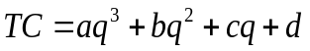
The cost function parameters in the sheet are:
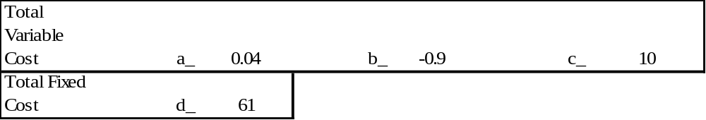
The variable costs are aq³ + bq² + cq and the fixed cost is d.

The revenue side is given the following Price Intercept and Price Slope parameter values:

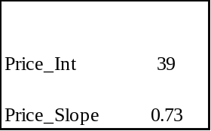

The sheet opens like this:

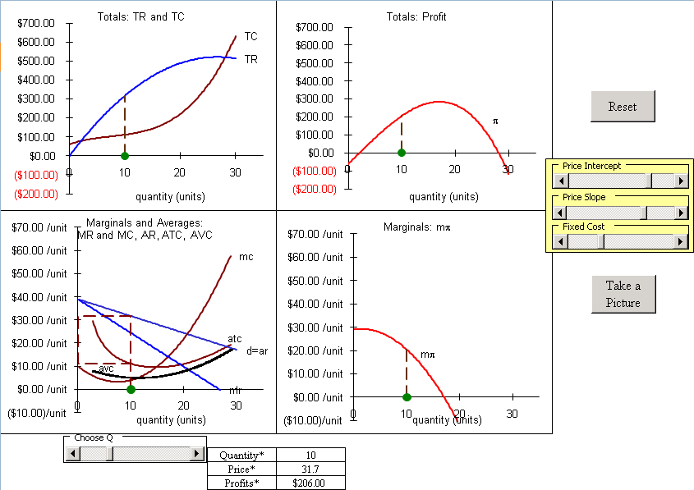

The sheet opens with the firm earning excess, or positive, economic profits. This monopolist has decided to produce 10 units, sell at a price of $31.70/unit, and thus it makes $206 of profits.

Q5) Use the logic of marginalism to explain that this is not the optimal solution for the monopolist. In other words, at Q=10, use the bottom left hand graph to explain why you know the monopolist is not maximizing profits.

Enter your answer in this box.

Q6) Use the quantity slider control (at the bottom of the graphs) to find the optimal quantity, price combination for the monopolist and resulting maximum profits. Report all three variables: optimal quantity, optimal price, and maximum profits. Explain your procedure, including the part of the display you were most focused on.

Enter your answer in this box.
Notice that your profit-maximizing output does not maximize total revenue. The total-revenue maximizing output occurs at MR = 0, rather than at MR = MC.

Q7) Use the bottom left graph to compute the profits at q=17. ATC at 17 units is $9.85/unit. Show your work along with your final answer.

Enter your answer in this box.

Proceed to the OptimalChoice sheet. It has the same demand and cost function parameters as the Graphs sheet and it is organized to enable you to use Excel’s Solver to find the optimal solution.

Q8) Execute Solver by clicking the Data tab and then clicking the Solver button under the Analysis section. Solver needs a Target Cell, an objective (Max, Min, or Value of), and a Changing Cell. Click Solve when you are ready and click OK to accept Solver’s solution. Copy Solver’s optimal quantity and paste the value in the text box below.

Hint: In this case, the target cell contains the value that the monopolist wants to maximize. The changing cell contains the variable that the monopolist can manipulate to achieve its objective. See Solver.doc in Lab 4 for additional detail.

Enter your answer in this box.

Q9) Is Solver’s answer better than the q=17 answer from the Graphs sheet. Explain your procedure in answering this question.

Enter your answer in this box.

Return to the Graphs sheet.

Click the 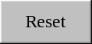 button.

Q10) Use the slider controls to the right of the graphs to explore the monopolist’s response to a decrease in demand. Explain your procedure and your results.
Note that when you use the slider controls to the right of the graphs, the optimal quantity and price are immediately displayed at the bottom of the graphs. That’s convenient!

Enter your answer in this box.

Difficult
Q11) Use the slider controls to put this monopolist in a zero economic profit situation. Let’s call a profit position within $1 of zero close enough to zero profits. Click the 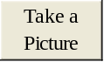 button to take a picture of the display, then paste the picture in the text box below.
Note that there are many combinations of the slider controls that can be used to answer this question. Your picture will be used to determine if your answer is correct.

Paste your picture in this box.

Click the button.

Q12-A) Scroll left in the Graphs sheet in order to see the revenue and cost parameters. Change cell I1 from 10 to 35. Does this affect variable or fixed costs? Explain.

Enter your answer in this box.

Q12-B) Scroll right, back to the four graphs. Describe the effect that changing cell I1 had on the bottom left graph.

Enter your answer in this box.

Q13) With cell I1=35, the monopolist is suffering negative profits. Will this monopolist continue production or shut down? Explain.

Enter your answer in this box.

Click the button.

Q14) If this monopolist were to be broken up into many small firms so that the market became competitive, approximately what would be the equilibrium price and quantity? Explain how you arrived at your answer.

Enter your answer in this box.

Key Concept
Q15) Most people don’t like monopoly because they charge high prices, but this is not the primary reason why economists are critical of monopolists. Why do economists complain about monopolies?
Hint: Use your answer to the previous question as a point of comparison.

Enter your answer in this box.

Congratulations! You have finished the monopoly profit maximization lab.

Save this document and print it.

You can save a lot of paper and ink by cutting everything out of the final, printed version except the questions and your answers.

