Name:
Introductory Economics Lab http://www.depauw.edu/learn/introeconlab
Excel Workbook: PresentValue.xls

Present Value Lab

Introduction

This lab is devoted to explaining the concept of present value and showing how to determine if an investment is worth it.

Open PresentValue.xls and read the Intro sheet.

Q1) Find the definition of “present value” in your textbook and quote it (by typing in the text in the box below). Document your quotation, including the author’s name, title of the textbook, edition, year of publication, and page number.

Enter your answer in this box. The box expands as you type in text.

Proceed to the PresentValue sheet.

Click on any cell in the PresentValue sheet. It displays the present value of the amount (at the given interest rate and number of years in the future).

Whenever you change a cell in this sheet, the sheet automatically updates. Questions 2 through 8 will be answered using this sheet.

Let’s take a tour of the display. The sheet opens with the following:
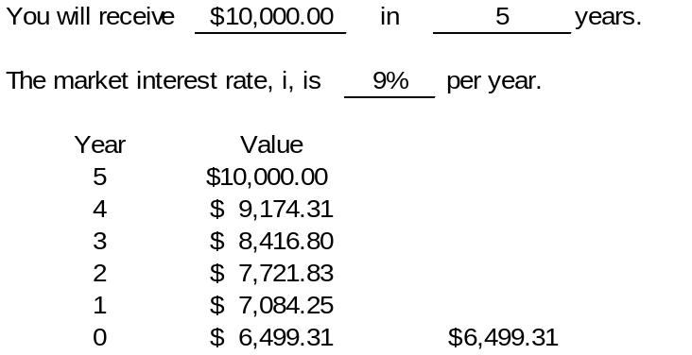
Note that the years are in backwards order as we bring the future back down to the present.

The market interest rate tells you the return on money invested today. The higher this number, the faster money will grow over time.

Column B shows how the present value can be computed by a year-by-year computation of the amount needed to become a given amount the next year.

Q2) Click on cell B12 (the second cell in the table) and note that the formula in the cell is “=B11/(1+$C$8).” Describe what this formula is doing.

Enter your answer in this box.

Q3) Cells B16 and D16 display the same number, the present value, but they have different formulas. How is cell D16 coming up with same number as cell B16?

Enter your answer in this box.

Terminology: Because money in the future is worth less viewed from today, we often say that a future sum is discounted in order to obtain its present value. Discounting is just another way of saying that we convert the future sum into the present by computing the amount it has to be reduced in order to grow into the future amount.

Q4) Change cell B6 to $20,000. What happens to its present value?

Enter your answer in this box.

Click the 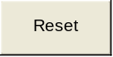 button.

Q5-A) Change cell D6 to 10 years. What happens to its present value?

Enter your answer in this box.

Q5-B) Change cell D6 to 20 years. What happens to its present value?

Enter your answer in this box.

Q5-C) What is the relationship between the present value of a dollar amount and number of years in the future in which the money is received? Provide an explanation for the relationship.

Enter your answer in this box.

Click the button.

Q6-A) Change cell C8 to 20%. What happens to the present value?

Enter your answer in this box.

Q6-B) Change cell C8 to 50%. What happens to the present value?

Enter your answer in this box.

Q6-C) What is the relationship between the present value and interest rate? Use Word’s Equation Editor (execute Insert: Object, then select Microsoft Equation 3.0, or your version) to type in the formula for present value. Use the formula to explain the relationship between PV and i.
Hint: Get Help by searching for “equation editor” if needed.

Enter your answer in this box.

Click the button.

Q7) What is the present value of $8,000 received 90 years from now at an interest rate of 7%?

Enter your answer in this box.

Q8-A) Would you prefer to have $100,000 four years from now given an interest rate of 8% or $75,000 right now? Explain your procedure in answering this question

Enter your answer in this box.

Q8-B) What would the interest rate have to be to make you indifferent between having $100,000 four years from now versus $75,000 right now? Explain your procedure in answering this question

Enter your answer in this box.

Proceed to the Stream sheet.

This sheet is used to answer questions 9 to 14.

This sheet shows a hypothetical stream of income over a person’s working lifetime. The shaded cells are parameters that you can change. The situation you’ll see when you open the sheet shows a person who works for 41 years at a job that requires 1 year of training. Columns J, K, and L show the payments received each year. Payment for the first year, year 0, is zero because this job requires one year of training. During the training year, you don’t get paid.

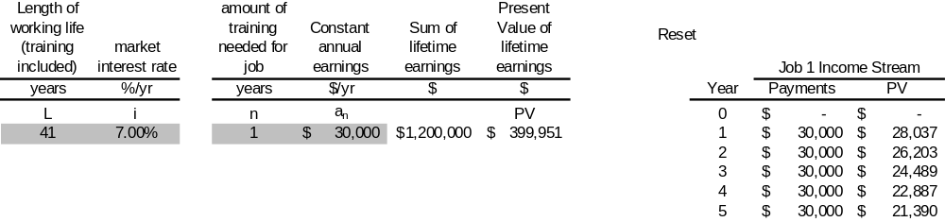

To keep things simple, we assume the person is paid the same amount year after year. We could make salaries rise to make it more realistic, but since it wouldn’t change the analysis we’ll just keep it simple.

Q9) This person gets paid $30,000/year for 41 years and, therefore, has a total lifetime earnings of $1.2 million. In a way, this $1.2 million number is meaningless. Explain why.

Enter your answer in this box.

Of course, we already know that the $30,000 earned 41 years from now is worth a lot less than the $30,000 earned the first year on the job after training. The PV column (Column L) computes the present value of each $30,000 salary.
Q10) Create a chart that plots the Payments (that is, the salary received each year) and PV of each of those payments over the person’s working life (that is, as a function of time). Label the axes and title the chart. (Hint: The horizontal axis will be time in years and the vertical axis will be dollars). Copy and paste your chart in the text box below. (To get help on creating well-designed charts, see ExcelBasics.doc, available at http://www.depauw.edu/learn/introeconlab/lab0.htm.)

Paste your chart in this box.

Q11) In your chart, the payment (salary) remains the same, but the present value of the payment falls over time. Why does this happen?

Enter your answer in this box.

Q12-A) If the interest rate rises, what happens to the present value of lifetime earnings?

Enter your answer in this box.

Q12-B) If the person’s working lifetime increases, what happens to the present value of lifetime earnings?

Enter your answer in this box.

Q12-C) If the amount of training needed for the job rises, what happens to the present value of lifetime earnings?

Enter your answer in this box.

Difficult
Q13) Lotteries advertise huge jackpots, but if you read the fine print, you will see that they pay out over many years. So, say you win a $1,000,000 lottery and then you find out that it’s actually $50,000 per year for 20 years. Suppose that you get the first $50,000 installment immediately. How much have you actually won? Explain your procedure.
Hint: Alter the parameters in the Stream sheet to reflect this problem.

Enter your answer in this box.

Click the button.

Q14) Would you prefer a job with 1 year of training and an annual salary of $30,000 or one with 3 years of training and an annual salary of $34,000? Explain your procedure and how you arrived at your answer.

Enter your answer in this box.

Proceed to the TwoJobs sheet.

This sheet is used to answer the remaining questions in this lab.

The sheet is an extension of the Stream sheet, comparing two jobs instead of just one. Let’s take a quick tour of the sheet. A second row (in range C12:G12) has been added for the second job. This job has a higher annual salary, $34,000, but it takes 3 years of training (during which you aren’t paid) to get the job.

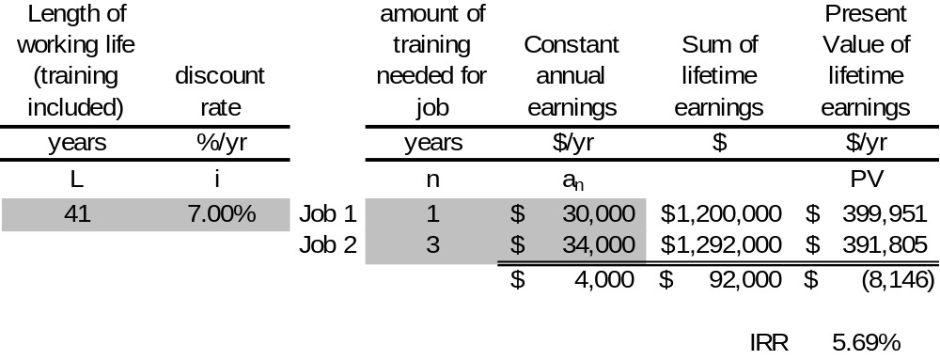

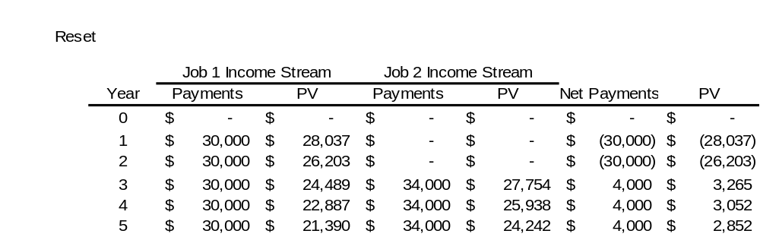

The stream data shows three years of zero values for Job 2 (while in training) and only 1 year of zero earnings for Job 1.

The Net Payments columns (O and P) are simply the payments from Job 2 minus the payments from Job 1.

Job 2 can be seen as an investment project. You invest $30,000 in years 1 and 2 in order to get $4,000 each year for the next 38 years. We want to figure out if the project is worth undertaking.

Q15) Would you agree that it is better to take Job 2 because you will make $92,000 more over your lifetime? Explain.

Enter your answer in this box.

Key Concept
Q16) Which job would you take, Job 1 or Job 2? Why?

Enter your answer in this box.

In fact, new entrants into the labor market will make the same decision as you did. Adam Smith argued that markets would establish an equilibrium salary gap between the two jobs.

“The whole of the advantages and disadvantages of the different employments of labour and stock must, in the same neighbourhood, be either perfectly equal or continually tending to equality. If in the same neighbourhood, there was any employment evidently either more or less advantageous than the rest, so many people would crowd into it in the one case, and so many would desert it in the other, that its advantages would soon return to the level of other employments. This at least would be the case in a society where things were left to follow their natural course, where there was perfect liberty, and where every man was perfectly free both to chuse what occupation he thought proper, and to change it as often as he thought proper. Every man's interest would prompt him to seek the advantageous, and to shun the disadvantageous employment.”

This is the first paragraph of Book I, Chapter X of Adam Smith, An Inquiry into the Nature and Causes of the Wealth of Nations, 1776. An excellent online source is http://www.econlib.org/library/Smith/smWN.html.

Q17) According to Adam Smith, what’s going to happen on the TwoJobs sheet?
Hint: Read the quote again carefully and remember that wages are determined by supply and demand for labor.

Enter your answer in this box.

Smith did not use graphs (because graphs weren’t invented in his day), but we can draw the equilibrium salary differential story. The two supply and demand graphs below are connected via dashed lines that represent the current salary differential in the two jobs.

Job 1
Number of Workers
Salary ($/yr)
D
S
Job 2
Number of Workers
Salary ($/yr)
D
S
Current
Salary Differential

In addition to the equilibrium forces within each market driving salaries to the intersection of supply and demand, there’s another equilibrium force affecting the salary gap between the two jobs. We imagine a cohort of new workers getting ready to enter the labor force. They will choose Job 1 over Job 2.

Q18) As workers pour into Job 1, what happens in the supply and demand graphs above? Why?

Enter your answer in this box.

Q19) Suppose Job 2’s salary rose to $38,000 per year and Job 1’s salary remained at $30,000 per year. Which job would you take now, Job 1 or Job 2? Why?

Enter your answer in this box.

So, at $34,000 per year, new entrants shun Job 2, but at $38,000 a year, they flood into Job 2. This leads to an obvious question, “At what salary are the two jobs in equilibrium?” Hunting and pecking (repeatedly changing cell E12) is one way to answer this question, but it’s a lot easier to use Excel’s Solver. Of course, you need to figure out how to configure the Solver dialog box. The changing cell should be easy enough, cell E12. Job 2’s salary is bouncing depending on the decisions of the new entrants into the labor market. But what’s the target? We are neither maximizing nor minimizing. We seek a value of cell E12 that does what? Answer this and you will find the answer to the question below.

Q20) At what salary are the two jobs in equilibrium?

Enter your answer in this box.

If you correctly answered Q20, you should notice that the IRR (cell G15) is now 7%. It’s time to define and understand the IRR.

Excel’s actually has a function called IRR and we used it in cell G15: =IRR(O10:O60).

Q21) Access Excel’s Help, search for “IRR”, and read the Help file for IRR. Copy and paste Excel’s definition in the text below.

Enter your answer in this box.

Excel Help’s definition of the IRR isn’t very clear. Here’s a better definition, the internal rate of return, IRR, is that interest rate that sets the present values of the two streams equal to each other. In other words, it’s the interest rate that makes you indifferent between making the investment (in the two jobs example, taking Job 2) or not. You find the IRR by solving the equation below for IRR.

This equation has no analytical solution. In its Help on IRR, Excel describes how it uses an iterative procedure.

Notice that we are not using the market interest rate, but some other interest rate that we are solving for that sets the net present value to equal zero.

We can see how IRR actually works via an example.
Click the button.

Click Solver in the Data tab in Excel 2007 or greater (execute Tools: Solver in earlier versions). Configure the Solver dialog box exactly like this:

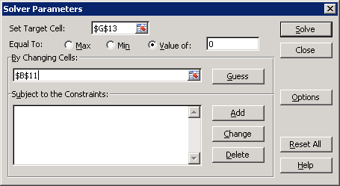

You are choosing the interest rate that will set the net present value to zero. That’s exactly the definition of the IRR. Click Solve.

Q22) What do you notice about the value of the interest rate generated by Solver when compared to the IRR?

Enter your answer in this box.

Click the button.

Copy cell G15, then click on cell B11 and execute Home: arrow under Paste: Paste Special: Values. This is the way you transfer a number displayed by Excel that is actually a cell formula. If you simply copy and paste, you end up pasting the formula. Paste Special, Values enables you to paste only the numerical value, not the formula of the cell. This is a handy trick to remember.

Q23) What happened to cell G13?

Enter your answer in this box.

Questions 22 and 23 show that the IRR is an interest rate that makes the net present value equal to zero, but how do you use it?

To use the IRR, you follow a simple rule:

When the IRR < interest rate, do not make the investment.
When the IRR > interest rate, make the investment.

For this reason, the IRR is sometimes called the hurdle rate. The investment’s IRR must hurdle, or jump over, the market interest rate in order for the project to be undertaken.

You can think of it like this: If the IRR is higher than the prevailing interest rate, then you do better by putting your money into this project than in the bank at the prevailing interest rate.

Click the button.

Q24) Use the IRR method to explain why you would choose Job 1.

Enter your answer in this box.

NOTE: The IRR method is known to fail if the investment project is complicated, with positive and negative flows mixed over time. For simple projects (with costs up front and returns in the future), the IRR method is a convenient way to express the desirability of a project. The more the IRR exceeds the market interest rate, the more profitable the project.

Q25) Studies of the rate of return to education show that the IRR to a college degree is around 10-15%. Is college a good investment? Explain.

Enter your answer in this box.

Congratulations! You have finished the present value lab.

Save this document and print it.

You can save a lot of paper and ink by cutting everything out of the final, printed version except the questions and your answers.

