Name:
Introductory Economics Lab
Excel Workbooks: GameTheory.xls, RockPaperScissors.xls

Game Theory Lab

Introduction

This lab is devoted to introducing game theory as a tool for analyzing market structures in between perfect competition and monopoly. This is a large and growing part of economics that incorporates the notion of interdependence into optimal decision-making. There are many types of games and a variety of situations have been modeled with game-theoretic principles. We will apply game theory to profit-maximizing firms.

Under the extremes of perfect competition or monopoly, firms make decisions in isolation. They optimize (choosing output to set MC=MR) and ignore the behavior of other firms. We know, however, that most firms are neither perfect competitors nor monopolists. Most firms are engaged in a competitive battle over market share where decisions impact others and the behavior of rivals is carefully monitored. Game theory seeks to model this environment in the form of a game. The idea is that strategy and tactics are needed to win.

Our simple application will pit two firms against each other. The duopoly market structure has several assumptions.
- Each firm produces an identical product. There is no brand loyalty by consumers.
- There is no possibility of entry by other firms.
- The market demand is exactly known by both firms.
- The two firms choose the level of output to produce at the same time. Thus, this called a simultaneous move game.

The two people most influential in developing and analyzing this particular game are Augustin Cournot (pronounced coor-NO) and John Nash. Both made important contributions as mathematicians and economists. Below are web links if you are interested in learning more about them.

From an Economics perspective, see
http://cepa.newschool.edu/het/profiles/cournot.htm
http://cepa.newschool.edu/het/profiles/nash.htm
http://nobelprize.org/economics/laureates/1994/index.html
In 1994, Nash shared the Nobel Prize in Economics with John Harsanyi and Richard Shelton "for their pioneering analysis of equilibria in the theory of non-cooperative games."

From a Mathematics perspective, check out:
http://www.gap-system.org/~history/Mathematicians/Cournot.html
http://www.gap-system.org/~history/Mathematicians/Nash.html
Open GameTheory.xls and read the Intro sheet.

Proceed to the Parameters sheet.

Q1) The Parameters sheet contains a description of the firm’s total cost function. Given the parameter values in cells B24:B27, what is this firm’s fixed cost? How do you know?

Enter your answer in this box. The box expands as you type in text.

Q2) Compute the Average Total Cost of producing 10,000 kwh.
Note: The units of the total cost function are in cents.

Enter your answer in this box.
Q3) The Marginal Cost is constant at 5 cents per kwh. What does this mean in plain English?

Enter your answer in this box.

Proceed to the PerfectCompetition sheet and read it.

Q4) How much profit does each firm make under the perfectly competitive market structure? Explain your reasoning.

Enter your answer in this box.

Proceed to the Monopoly sheet.

Q5) The Monopoly sheet opens with the monopolist producing the perfectly competitive output of 15,000 kwh and selling at a price of 5 cents per kwh. Using the logic of marginalism, why will the monopolist not produce this amount of electricity?

Enter your answer in this box.

Q6) Use the Choose Q control under the graph to find the profit-maximizing level of output and price for the monopolist. Take a picture of the graph (Right-click execute Copy while holding the Shift key) and paste it (Ctrl-V) in the text box below.
Hint: If you can’t tell exactly where MR equals MC, keep you eye on the profit in cell B18. This is quite the strong demonstration of the effectiveness of marginalism—there’s no doubt that profits are maximized where MR=MC.

Paste your picture in this box.

Click the 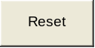 button.

Q7) Now use Excel’s Solver to find the monopolist’s profit-maximizing solution. Report the optimal quantity and price.
Remember that the monopolist is trying to maximize profits by choosing output. It determines the optimal price from the demand curve after getting the optimal level of output.

Enter your answer in this box.

It’s comforting that Excel’s Solver and the graph (equating MR and MC) give the same answer. (If they did not, then you made a mistake in the applying one of the methods.) It’s always good—when it’s important to get the answer right—to have alternative ways of getting the answer because you’ve got a built-in checking procedure.

Proceed to the ResidualDemand sheet. The text in the first few rows of the sheet describes the set up of the Duopoly Game. Firm 1’s optimal decision depends upon Firm 2’s choice of output. Given a level of output by Firm 2, Firm 1 has the rest of the market and act as a monopolist with remaining, residual, demand for the product.

Q8) The ResidualDemand sheet opens with Conjectured Q2 = 0. This effectively makes Firm 1 a monopolist and the optimal output of 7,500 kwh is displayed. A friend says, “We’re done. Firm 1 should choose to make Firm 2 produce nothing and then Firm 1 can rock.” What’s wrong with your friend’s logic?

Enter your answer in this box.

Q9) Click  in the center of the slider bar TEN times as shown in the picture above. As you click on the control, watch the graph. You’ve set Conjectured Q2 to 10,000 kwh. What are the two red lines?

Enter your answer in this box.

Key Concept
Q10) With Conjectured Q2 equal 10,000 kwh, use the Choose Q control under the graph to find the profit-maximizing level of output and price for Firm 1. Take a picture of the graph (Right-click execute Copy while holding the Shift key) and paste it (Ctrl-V) in the text box below.

Paste your picture in this box.

Bring up Solver by clicking the Data tab and then clicking the Solver button under the Analysis section. Solver needs a Target Cell, an objective (Max, Min, or Value of), and a Changing Cell. In this case, the target cell contains the value that the firm wants to maximize. The changing cell contains the variable that the firm can manipulate to achieve its objective. See Solver.doc in Lab 4 for additional detail.

Q11) Now use Excel’s Solver to find the duopolist’s profit-maximizing solution. Report the optimal quantity and price.
Remember that the duopolist is trying to maximize profits by choosing output. It determines the optimal price from its residual demand curve after getting the optimal level of output.

Enter your answer in this box.

Q12) Your friend says, “So, if Firm 1 optimizes when it has monopoly power and it optimizes when Firm 2 produces 10,000 kwh, then Firm 1 doesn’t care what Firm 2 does. Either way, Firm 1 is optimizing so there is no difference.” Can this be right? Explain.

Enter your answer in this box.

Key Concept
Q13) Fill in the table (starting in row 37) with the optimal output and price for the given Conjectured Q2. Select the cell range A37:C44, then take a picture of this range (Execute Home: arrow under Paste: As Picture: Copy As Picture) and paste it (Ctrl-V) in the text box below.

Paste your picture in this box.

Q14) The last entry in the table, when Conjectured Q2 = 15000, deserves a closer look. Why won’t Firm 1 produce anything when Firm 2 produces 15,000 kwh?

Enter your answer in this box.

You have seen that Firm 1 changes its optimal output depending on the conjectured output of Firm 2. The relationship between Firm 1’s optimal output and Firm 2’s conjectured output is called Firm 1’s reaction or best-response function.

Q15) Create a chart of Firm 1’s Reaction function. Although it makes more sense to put Conjectured Q2 on the x axis (after all, Firm 1’s output responds to the given Conjectured Q2), force your chart to put Conjectured Q2 on the y axis and Firm 1’s output on the x axis. Make sure chart connects the points with a line (that is, use the Scatter chart option with data points connected by lines) and check that the axes are properly labeled.
Take a picture of your chart (select it, then click the Home tab, then the arrow under Paste: As Picture: Copy As Picture) and paste it (Ctrl-V) in the text box below.

Paste your picture in this box.

Key Concept
Q16-A) What if Conjectured Q2 was 0, so Firm 1 produced 7,500 kwh, but then Firm 2 actually produced 5,000 units. Would Firm 1 regret its choice of producing 7,500? If so, what would Firm 1 had wished it would have played (i.e., produced)?

Enter your answer in this box.

Q16-B) How does Firm 1’s Reaction function in the chart you created in Q14 clearly show where the regretted decisions lie?

Enter your answer in this box.

Of course, Firm 2 is in the exact same position as Firm 1. Firm 2 also has a Residual Demand curve and a Reaction function that is obtained in the same way as Firm 1.

Thus, we are ready to take the final step in our analysis of the Duopoly Game.

Proceed to the Duopoly sheet.

Let’s take a tour of this sheet.
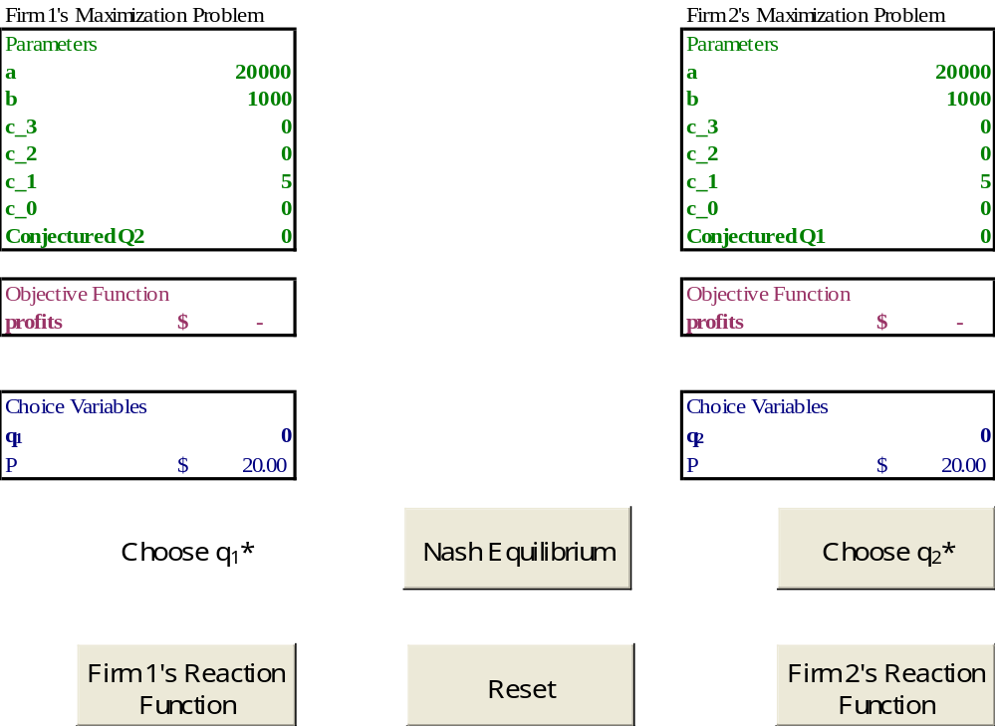

On the left is Firm 1’s view of the game, while Firm 2 plays from the right side.

Click the 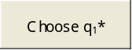 button to find Firm 1’s optimal solution given that ConjecturedQ2 is zero. If Firm 2 happened to play zero (producing no output), Firm 1 would be very happy. But what about Firm 2? It would regret that choice of zero output.

Click the 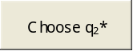 button to find Firm 2’s optimal solution given that ConjecturedQ1 is 7,500. If Firm 1 happened to play 7,500 kwh, Firm 2 would be happy with its choice. Now it’s Firm 1’s turn to be unhappy. Firm 1 would regret its choice.

Click the and buttons in order a few more times. You can see that each time one of the two firms regrets the decision made. As long as one of the two firms regrets a decision, we can’t be in equilibrium because equilibrium is defined as no tendency to change. Clearly, given the opportunity, one of the firms would change its decision and that would trigger the other one to change and we wouldn’t be in equilibrium because there’s a lot of change going on!

The Reaction, or best response, functions capture this phenomenon well.

Click the 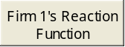 button. Excel will calculate points on Firm 1’s Reaction function, display them in a table, and draw a chart of the Reaction function.

Click the 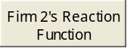 button. The same procedure is applied to Firm 2’s Reaction function.

Q17) The Reaction functions show that if Firm 1 guessed that Firm 2 would produce 3,000 kwh, Firm 1 would produce 6,000 kwh. Firm 2 would regret a choice of 3,000 kwh which led Firm 1 to produce 6,000 kwh. If Firm 1 produced 6,000 kwh, what does the Reaction function data tell you that Firm 2 would have wished it would have produced?

Enter your answer in this box.

Is there any position in this crazy game where the two firms are happy with their choices given the other firm’s choice? In fact, there is such a position and it is called a Nash Equilibrium.

Click the 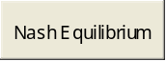 button to display the solution to the duopoly problem.

Key Concept
A crucial characteristic of the Nash Equilibrium is that there are no regrets by either firm, so they don’t wish they would have played a different level of output. This is the heart of the idea of a Nash Equilibrium.

Q18) Take a picture of the Both Reaction Functions chart (Execute Home: arrow under Paste: As Picture: Copy As Picture) and paste it (Ctrl-V) in the text box below. Use Word’s Drawing Tools (execute Insert: Shapes and select the circle tool) to put a circle around the Nash Equilibrium position.

Paste your picture in this box.

Difficult
Q19-A) So a Nash Equilibrium is a no regrets position for both firms, but it is not the best possible, mutually acceptable solution for both firms. What would be the best possible, mutually acceptable solution for both firms? Report optimal q1, optimal q2, and the profit made by each firm. Explain why this solution is preferred by both firms to the Nash Equilibrium solution.

Enter your answer in this box.

Q19-B) If your answer to Q19-A is preferred by both firms, why don’t the firms reach this solution?

Enter your answer in this box.

Proceed to the Summary sheet. The sheet sums up the work you’ve done in this lab. Use the summary data to answer the last question in this lab.

Q20) From society’s viewpoint, is Monopoly or Duopoly better? Why?

Enter your answer in this box.

Just for Fun

Go to http://www.depauw.edu/learn/introeconlab/lab9.htm and download the RockPaperScissors.xls workbook. Open it and play a bit. What is the Nash equilibrium solution for this game? (Scroll to the end of this document to see the answer.)

Congratulations! You have finished the game theory lab.

Save this document and print it.

You can save a lot of paper and ink by cutting everything out of the final, printed version except the questions and your answers.
The child’s game Rock, Paper, Scissors has no Nash equilibrium! Either you or your opponent will have regret—one of you could have done something different that would have given a win.

