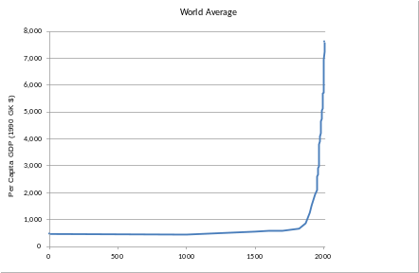
Barreto
Econ 210: History of Economic Thought
Spring 2023 DePauw University

CONCLUSION
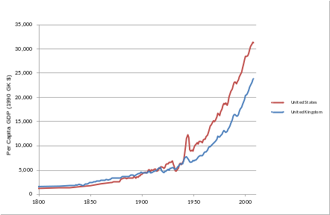

What have we done here?
I. Introduction

II. Pre-Smithian Economics

III. Adam Smith
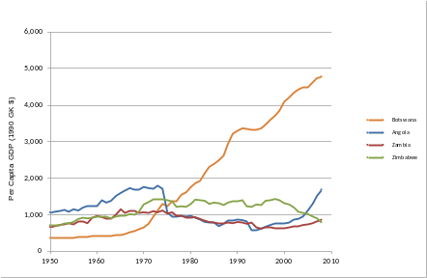
IV. David Ricardo

V. Karl Marx

VI. Neoclassical (Orthodox) Economics

VII. John Maynard Keynes

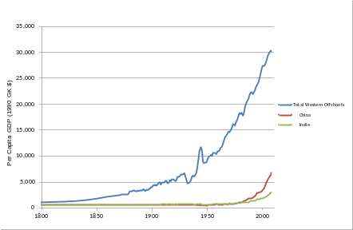
VIII. Joseph Schumpeter

IX. Frank Knight

X. The Entrepreneur

XI. Conclusion

One thing few people know about each economist

Is there a cumulative progression of knowledge in economics?

Physics
Hawking (2018)
Einstein (1920)
Newton (1600)
Copernicus (1500)
Ptolemy (140 AD)
Economics
Keynes, Knight &
Schumpeter (1920s~50s)
Marx (1870)
Ricardo (1820)
Smith (1780)
Music
_______ (today)
Presley (1960)
Brahms (1860)
Mozart (1780)

