Barreto
Hist Econ

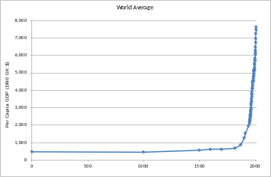
The Entrepreneur in the History of Economic Thought

Types of Entrepreneurship in Economics
Schumpeter: Innovator
The Theory of Economic Development (1911; 1934, English translation)
“The essence of successful enterprise lies in creative imagination and initiative.” David Landes

Knight: Uncertainty-bearer and responsible decision-maker
Risk, Uncertainty and Profit (1921)
http://www.econlib.org/library/Knight/knRUP.html
Finley (1973, 147) cites the story, “repeated by a number of Roman writers, that a man— characteristically unnamed— invented unbreakable glass and demonstrated it to Tiberius in anticipation of a great reward. The emperor asked the inventor whether anyone shared his secret and was assured that there was no one else; whereupon his head was promptly removed, lest, said Tiberius, gold be reduced to the value of mud… neither the elder Pliny nor Petronius nor the historian Dio Cassius was troubled by the point that the inventor turned to the emperor for a reward, instead of turning to an investor for capital with which to put his invention into production.”
Hudson, p. 19, in Landes, Mokyr, Baumol, eds., (2010), The Invention of Enterprise.
Say: Coordinator
A Treatise on Political Economy (1803)
http://www.econlib.org/library/Say/sayT.html

Kirzner: Arbitrageur
Discovery and the Capitalist Process (1985)

Timeline
Marginal Revolution
Classical
???
Smith
Say
Kirzner
Schumpeter
Knight
Walras
Jevons
Menger
Marshall
RicardoMalthus
Mill
Marx
Keynes
Veblen

Key Turning Points in Economics
Smith (1776) → Classical School
Walras, Jevons, and Menger (1870s) → Marginal Revolution (which underlies modern, orthodox economics)

