Introduction

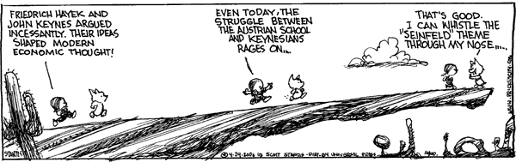
www.gocomics.com/calvinandhobbes/

Definition
Economic History
v.
History of Economics (aka History of Economic Thought)

“Economic history—the story of what happened—is intimately related to the history of economic thought—the story of what economists thought had happened and was still happening. Sometimes economists got it right and sometimes they got it wrong.”
Mark Blaug, Economic History and the History of Economics, 1986, p. vii.

Why Study the History of Economics?

AC Pigou’s reaction when asked to review a book about Adam Smith:
“These antiquarian researches have no great attraction for one who finds it difficult enough to read what is now thought on economic problems, without spending time in studying confessedly inadequate solutions that were offered centuries ago.”

E-mail in 1996 from Peter Boettke formerly at NYU, now at George Mason:
“NYU just abolished History of Economic Thought as a requirement for the PhD. We have quite a number of faculty who teach in the area or related areas ... Bruno Stein, James Becker, Israel Kirzner, Mario Rizzo and myself. Nevertheless, NYU was one of the last remaining PhD programs to retain the history of thought requirement ... now it is gone. The main arguments offered were: (1) the opportunity cost of studying the history of doctrine is too high and (2) all the good ideas from the past are incorporated already in the present. Thus, history of thought is a hobby, but not a worthy vocation. That is our problem I would conjecture professionally—as this is the common idea.”

So, why does DePauw University offer Eco 210: History of Economic Thought???

