Barreto
Hist of Econ Thought

JOHN MAYNARD KEYNES
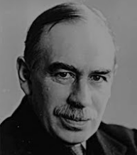

I) Background
A) Biography

B) Major Works

II) Influences
A) Historical Period: THE GREAT DEPRESSION

B) Classical and Neoclassical Economics

III) Problem Orientation
A) Practical

B) Theoretical

IV) Unemployment and Business Cycles

A) The Classical Explanation of Unemployment

B) The Keynesian Attack
i) "Money Illusion"
ii) Unemployment Equilibrium

C) The Keynesian Solution for Unemployment and Business Cycles

V) Capitalism and Inequality

VI) Demography

VII) The Future Prospects for Capitalism

VIII) Conclusions
I) Background
A) Biography

B) Major Works

II) Influences
- Historical Period: THE GREAT DEPRESSION

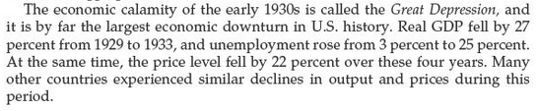
Greg Mankiw, Brief Principles of Economics, 6th ed., p. 344.

“Bert?” Yes? “¿Por qué paso?”
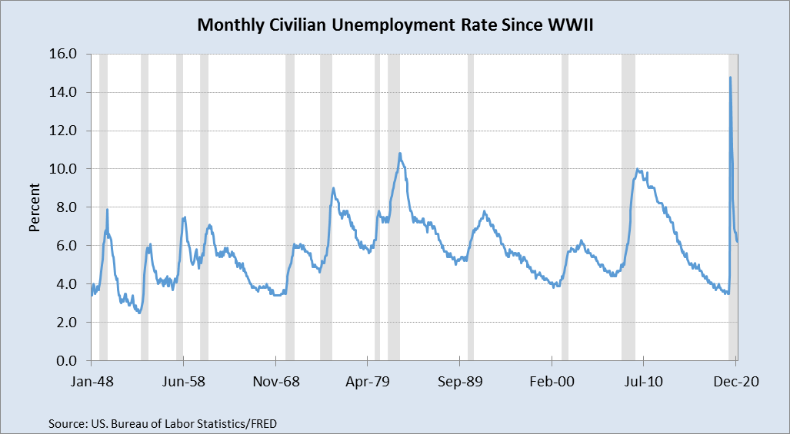

Let’s Zoom in on the Great Depression:

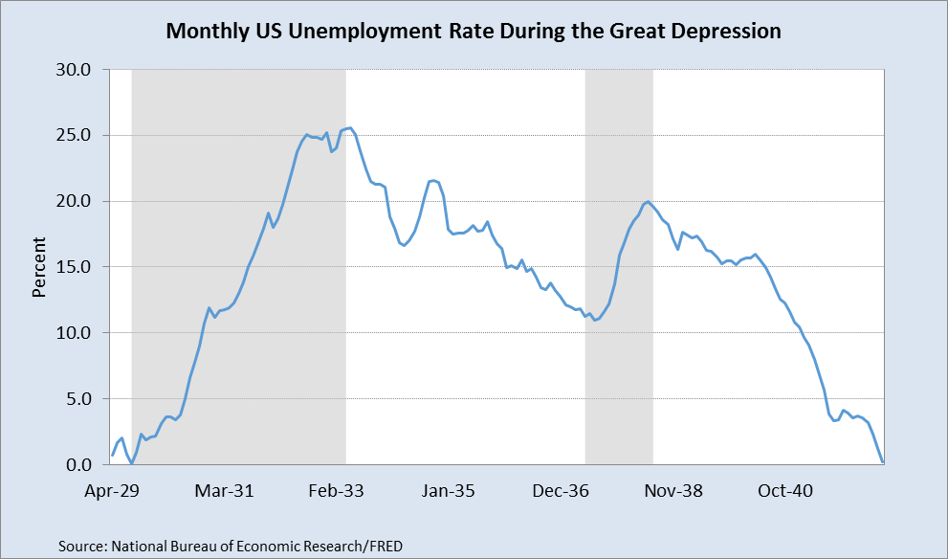

Understanding the Unbelievable Severity of what happened:

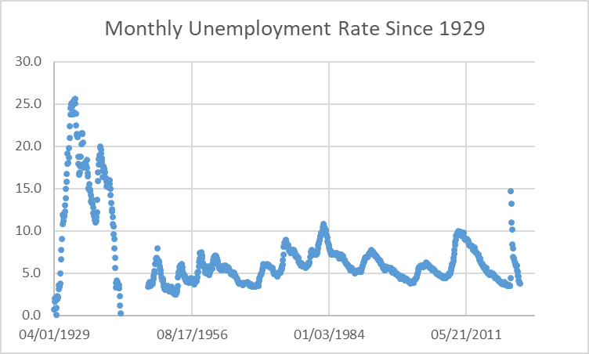

B) Classical and Neoclassical Economics
As defined by Keynes, he just lumps everyone before him, from Ricardo and Mill to Marshall and Pigou, as classical. No one else uses classical like this.

What about Marx? What does Keynes think of him?

III) Problem Orientation
Chap 1: The General Theory
A) Practical

B) Theoretical

