Barreto
Hist of Econ Thought

Understanding the Great Depression

Stylized Graph

Great Depression Data

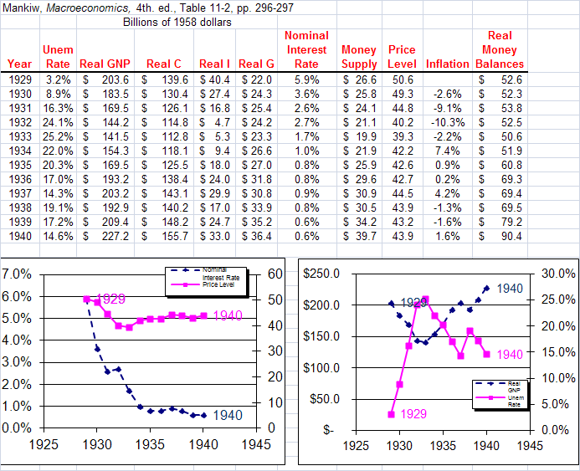

________________________________________

Question 4A:
 | Acceptable | Unfair
Class
KKT
Executives

Question 4B:
 | Acceptable | Unfair
Class
KKT
Executives

Question 5A:
 | Acceptable | Unfair
Class
KKT
Executives

Question 5B:
 | Acceptable | Unfair
Class
KKT
Executives

Question 6A:
 | Acceptable | Unfair
Class
KKT
Executives

Question 6B:
 | Acceptable | Unfair
Class
KKT
Executives

KKT: “Fairness as a Constraint on Profit Seeking: Entitlements in the Market” by Daniel Kahneman, Jack L. Knetsch, and Richard Thaler, The American Economic Review, Vol. 76, No. 4 (Sep., 1986), pp. 728-741. Stable URL: http://www.jstor.org/stable/1806070

“Fairness as a Constraint on Profit Seeking: Comment” by Raymond F. Gorman and James B. Kehr, The American Economic Review, Vol. 82, No. 1 (Mar., 1992), pp. 355-358. Stable URL: http://www.jstor.org/stable/2117622
Delete before printing and send via email after class
Money Illusion

Sample sizes are all around 100 to 125.

Question 4A: A company is making a small profit. It is located in a community experiencing a recession with substantial unemployment, but no inflation. There are many workers anxious to work at the company. The company decides to decreases wages 7% this year.
 | Acceptable | Unfair
KKT | 38% | 62%
Executives | 51% | 49%

Question 4B: A company is making a small profit. It is located in a community experiencing a recession with substantial unemployment and inflation of 12%. There are many workers anxious to work at the company. The company decides to increase wages only 5% this year.
 | Acceptable | Unfair
KKT | 78% | 22%
Executives | 98% | 2%

Question 5A: A shortage has developed for a popular model of automobile and customers must now wait two months for delivery. A dealer has been selling these cars at list price. Now the dealer prices this model at $200 above list price.
 | Acceptable | Unfair
KKT | 29% | 71%
Executives | 70% | 30%

Question 5B: A shortage has developed for a popular model of automobile and customers must now wait two months for delivery. A dealer has been selling these cars at a discount of $200 below list price. Now the dealer sells this model only at list price.
 | Acceptable | Unfair
KKT | 58% | 42%
Executives | 97% | 3%

Question 6A: A small company employs several people. The workers’ incomes have been about average for the community. In recent months, business for the company has not increased as it had before. The owners reduce the workers’ wages by 10% for the next year.
 | Acceptable | Unfair
KKT | 39% | 61%
Executives | 37% | 63%

Question 6B: A small company employs several people. The workers have been receiving a 10% annual bonus and their total incomes have been about average for the community. In recent months, business for the company has not increased as it had before. The owners eliminate the workers’ bonus for next year.
 | Acceptable | Unfair
KKT | 80% | 20%
Executives | 91% | 9%

