Barreto
Hist of Econ Thought

FRANK HYNEMAN KNIGHT
(Another Brick in the Wall, Pink Floyd)

I) Background
A) Biography
B) Major Works

II) Influences
A) The Chicago School
"There is no God, but Frank Knight is his prophet."
B) Skepticism

III) Problem Orientation

IV) Solving the Problem of Externality
A) Definition and Examples
B) The Problem of Externality
i) Pigou's Original Problem—traffic congestion
ii) Pigou's (read “Orthodox, Neoclassical") Solution
iii) Knight's Solution—and Understanding the Coase Theorem

V) Entrepreneurship
From Risk, Uncertainty and Profit
A) Decision Making Under Uncertainty
B) Function of the Entrepreneur
C) Profit Theory

VII) The Future of the Enterprise Economy

VIII) Conclusion
I) Background
A) Biography

B) Major Works

II) Influences
A) The Chicago School
"There is no God, but Frank Knight is His prophet."

B) Skepticism and Iconoclasm

From Knight’s 1950 AEA Presidential Address, quoted in The Academic Scribblers (by William Breit and Roger Ransom) as “the best succinct statement of Knight's philosophical view of social reform, a view that is dominant in the thinking of those who followed Knight's lead and whom we regard as members of the new neoclassicism.” p.198.

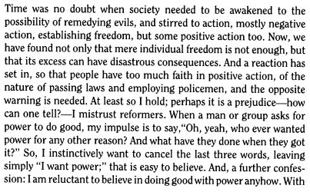
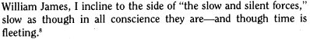

III) Problem Orientation
“The Fire of Truth: A Remembrance of Law and Economics at Chicago, 1932-1970” Edmund W. Kitch, Journal of Law and Economics, Vol. 26, No. 1. (Apr., 1983), pp. 163-234.

Coase:
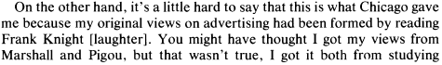
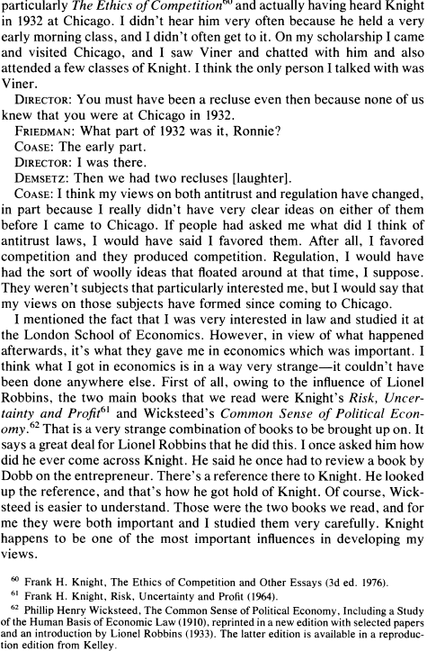
p.215:
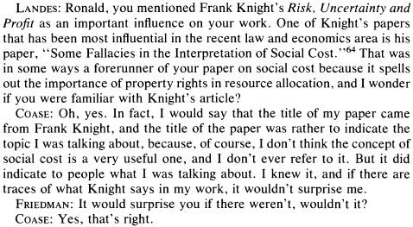

IV) Solving the Problem of Externality
A) Definition and Examples

Barreto
Hist of Econ Thought

The Problem of Externality

I) PIGOU'S PROBLEM:
Two roads connect two different cities.
Broad, Poor Road — One road is broad and can accommodate all traffic without any decrease in speed as traffic increases. Unfortunately, it is poorly graded and has potholes.
Narrow, Good Road — The other road is in excellent shape. Unfortunately,
vehicles are forced to slow down as traffic increases.

The following table gives the productivity (total, marginal and average) of the two roads in terms of the output generated per unit of time.
• The broad, poor road can handle any number of trucks, but they must travel slowly. Hence, the productivity index is constant at 20 units per additional truck.
• The narrow, good road data shows that productivity is a function of the number of trucks hauling cargo on the road. When there is only one truck on the road, the truck has a total productivity of 35 because it can carry the cargo quickly. As more trucks use the narrow, good road, however, the productivity of every truck falls. For example, if 3 trucks were on the road, the resulting traffic would lower the productivity of each truck to 25 units per truck (yielding a total productivity of 75 units).

BROAD, POOR ROAD NARROW, GOOD ROAD
Trucks TP MP AP Trucks TP MP AP
0 0 -- -- 0 0 -- --
1 20 20 20 1 35 30 35
2 40 20 20 2 60 20 30
3 60 20 20 3 75 10 25
4 80 20 20 4 80 0 20
5 100 20 20 5 75 -10 15
6 120 20 20 6 60 -20 10
7 140 20 20 7 35 -30 5

TP_{BP} = 20T TP_{NG} = 40T - 5T²
MP_{BP} = 20 MP_{NG} = 40 - 10T
AP_{BP} = 20 AP_{NG} = 40 - 5T
Suppose there were 7 trucks that needed to go from one city to the other.

How many trucks will travel on each road???

Upon coming to the, ahem, fork in the road, each truck driver will decide — individually — whether it’s better to take the BP or the NG road.

Let’s see how each truck driver decides:
Each truck driver gets paid according to productivity — individual productivity. If truck #1 generates 25 units of productivity, the truck driver gets $25. We assume self-interest — i.e., each truck driver is trying to get as much money as possible.

So, let’s see how the trucks get allocated:

Truck | Broad, Poor Road | Narrow, Good Road
Truck #1
Truck #2
Truck#3
Truck #4
Truck #5
Truck #6
Truck #7
TOTAL

Thus, according to Pigou, the “individual seeking to max self-interest” or “market” solution yields a total productivity of:

How many trucks should travel on each road???

Number of Trucks on BP:

Number of Trucks on NG:

Total Productivity:

What is Pigou's Problem?

A graphical exposition of Pigou’s classic externality problem is depicted in the figure below:

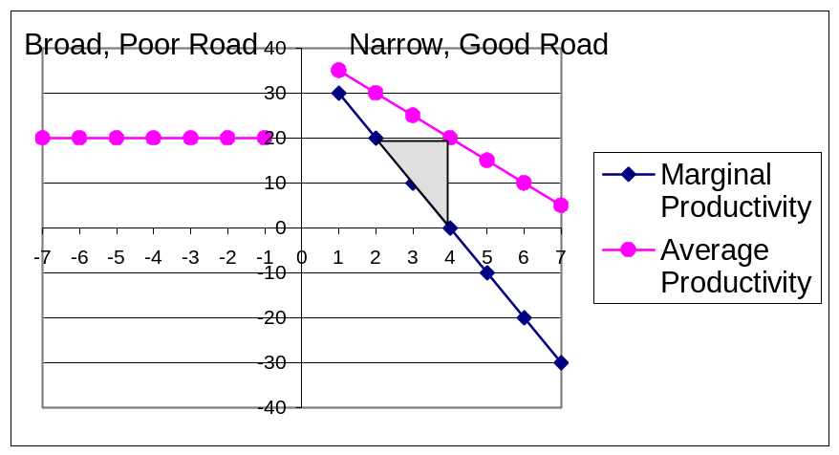

The productivity loss of 20 units (from optimal productivity minus observed productivity) is described by the area of the triangle and is often called a “deadweight loss.” Pigou calls this a “market failure” and argues that government intervention is needed to fix the misallocation of resources (in this case, trucks).

II) What is Pigou's Solution?

Pigou offered three interventions, in increasing order of severity:

1) Place a tax (or subsidy) in order to generate the optimal result

In this example, that would mean charging a toll to those who travel on the narrow, good road.

2) Use a quota or limit restriction

Only two trucks would be allowed to use the narrow, good road.

3) Nationalization

The government would own the trucks and tell them where to go.

That’s a pun— you’re supposed to smile . . . :)

