Heilbroner and Marx’s Son

Mark Skousen, The Big Three in Economics

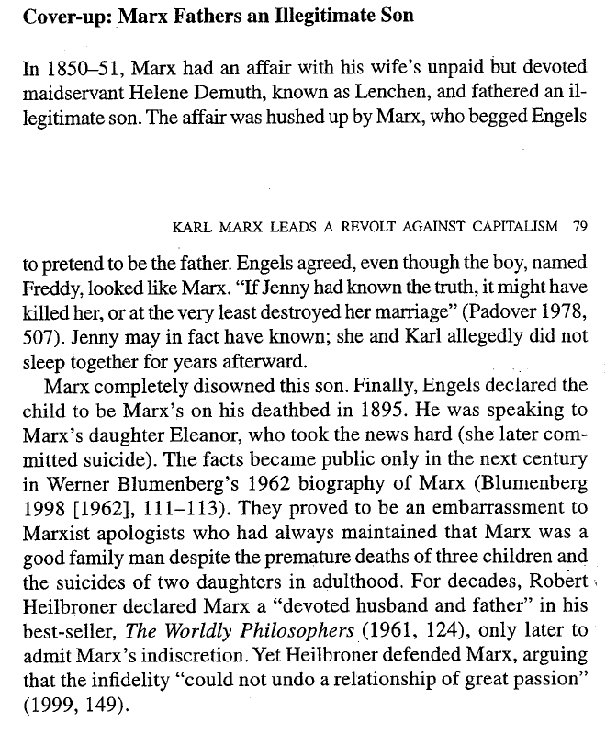

Heilbroner, WP, 1953 First Edition, p. 140:

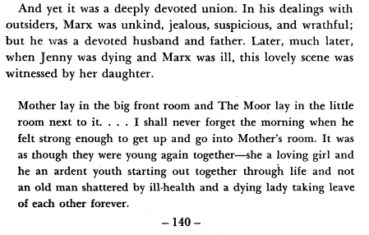

1999 Seventh Edition, pp. 148-49:

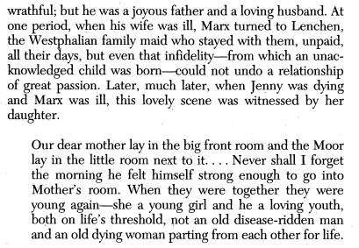
More Skousen (who really hates Marx)

