Barreto
Hist Econ

KARL MARX
(Imagine by John Lennon)

I) Background
A) Biography
B) Major Works

II) Influences
A) Intellectual Influences
1) Ricardian Economics
2) German Idealism: Kant and Hegel
3) The German Historical School
B) Historical Influences: The British Climacteric

III) Problem Orientation
A) The "Laws of Motion"
B) On Method

IV) Capitalism in Practice: The History and Effects of Capitalism
A) Bettman, Johnson, and Rosenberg
B) Reading Marx: The Working Day

V) Capitalism in Theory: Commodity Transformation
A) Simple Economy
B) Capitalist Economy
Defining capitalism as GREED, LUST, and OBSESSION for money.
C) The Theory of Surplus Value
i) The Labor Theory of Value
ii) Profit
iii) The Great Contradiction

VI) The Theory of Capitalist Growth and Inevitable Self-Destruction
The Internal Contradictions of Capitalism

VII) Postmortem: What Comes Next?

VIII) The Socialist Calculation Debate

IX) Conclusion
Imagine
John Lennon
Imagine there's no heaven
It's easy if you try
No hell below us
Above us only sky
Imagine all the people
Living for today
Imagine there's no countries
It isn't hard to do
Nothing to kill or die for
And no religion too
Imagine all the people
Living life in peace
You may say I'm a dreamer
But I'm not the only one
I hope someday you'll join us
And the world will be as one
Imagine no possessions
I wonder if you can
No need for greed or hunger
A brotherhood of man
Imagine all the people
Sharing all the world
You may say I'm a dreamer
But I'm not the only one
I hope someday you'll join us
And the world will be as one

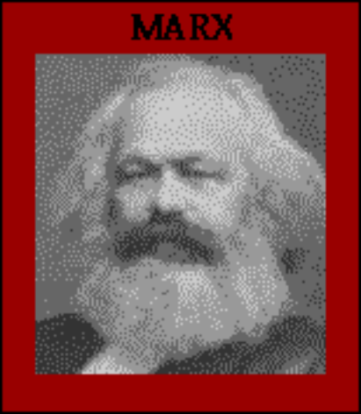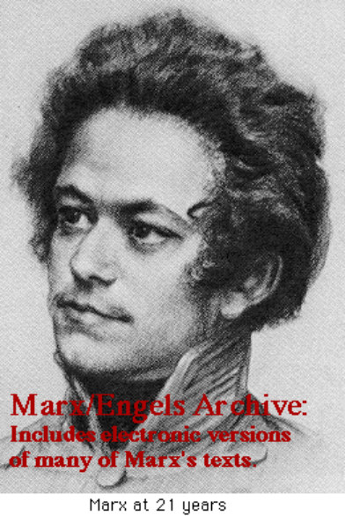
I) Background
A) Biography

B) Major Works

II) Influences
A) Intellectual Influences
1) Ricardian Economics

2) German Idealism
Kant (1724-1804) and Hegel (1770-1831)

3) The German Historical School
http://www.hetwebsite.net/het/schools/historic.htm
B) Historical Influences: The British Climacteric

III) Problem Orientation
A) The "Laws of Motion"
B) On Method

