Barreto
Hist of Econ

The Neoclassical School and the Rise of Modern, Orthodox Economics
(Chapter 6)

I) Introduction
A) Timeline

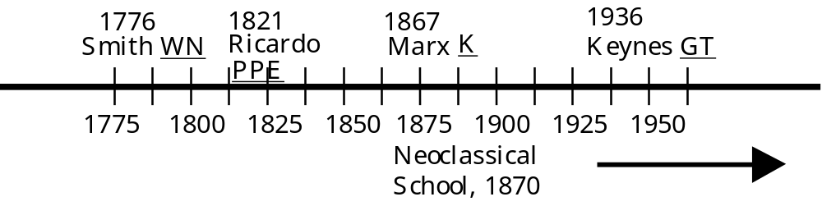
B) We ignore the Neoclassicals in this class Why?

C) Let’s draw the evolutionary tree of economics:
Political Economy becomes Economics starting in the 1870s with the Marginal Revolution.

II) Members
A) Founders
William Stanley Jevons, 1871, The Theory of Political Economy
Carl Menger, 1871 Grundsätze der Volkswirtschaftslehre [Principles of Economics]
León Walras, 1874, Éléments d'Économie Politique [Elements of Pure Economics]
Francis Y. Edgeworth, 1881, Mathematical Psychics
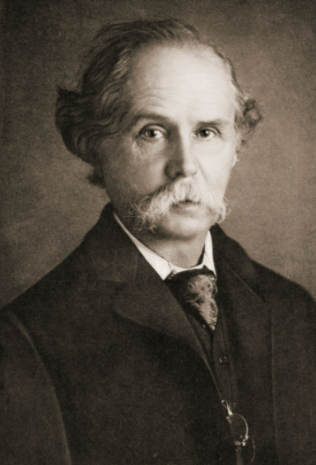
B) Second Generation
Alfred Marshall, 1890, Principles of Economics
Vilfredo Pareto, 1906, Manual d'economie politique [Manual of Political Economy]
Irving Fisher, 1907, The Rate of Interest

C) Third Generation
Joan Robinson, 1933, The Economics of Imperfect Competition
John R. Hicks, 1939, Value and Capital
Paul A. Samuelson, 1947, Foundations of Economics Analysis
Gerard DeBreu, 1956, Theory of Value

III) The Rise—The Marginal Revolution in the 1870s
“Suddenly, capitalism was no longer seen as a fateful historic social vehicle, but as a tame, rather historyless, mode of organization. The driving propulsion of the system—the propulsion that had fascinated all its prior investigators—was now overlooked, ignored, forgotten.” Heilbroner, WP, p. 177.

IV) Classical v. Neoclassical—What’s the Difference?

Some Central Tenets of the Neoclassicals
A) Focus on Individual decision-making

B) Optimization—the Marginal Revolution

C) Static Analysis of Resource Allocation

Tanks
Shoes
Broccoli
Cars
Medical Care

D) Mathematical Presentation

E) Extreme Specialization of areas of study within economics

F) Econometrics

V) The Fall—TBA

In case TBA is confusing—it hasn’t fallen yet. Neoclassical economics is an old term for modern, mainstream, orthodox economics.

In fact, it has gotten stronger and stronger:
“The status of non-neoclassical economists in the economics departments in English-speaking universities is similar to that of flat-earthers in geography departments: it is safer to voice such opinions after one has tenure, if at all.”
E. Roy Weintraub, http://www.econlib.org/library/Enc1/NeoclassicalEconomics.html

