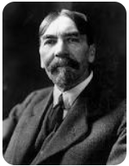
Name: _______________ Thorstein Veblen

Write brief notes from each page.

Include any words (and their definitions) that you didn’t know.

Print and bring to class.

P. 1 | P. 11
P. 2 | P. 12
P. 3 | P. 13
P. 4 | P. 14
P. 5 | P. 15
P. 6 | P. 16
P. 7 | P. 17
P. 8 | P. 18
P. 9 | P. 19
P. 10 | One Question I Have About Veblen:

