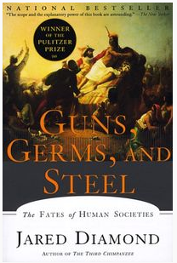
Why did the Spaniards conquer the Incas and not the other way around?
Video: http://tiny.cc/ggs
Transcript: http://tiny.cc/ggstran

November 16, 1532

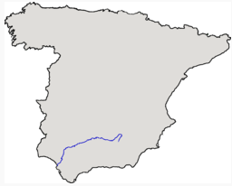
Atahualpa versus Pizarro:
80,000 Inca versus 168 Spanish conquistadores

Guadalquivir River

Cajamarca

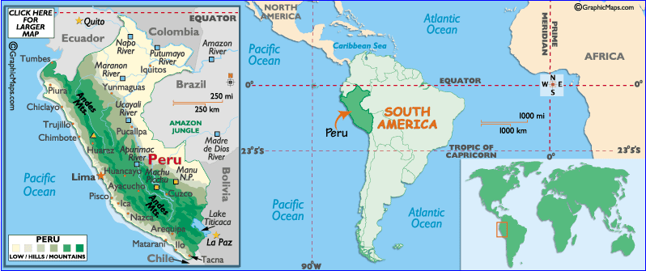

Definitions:
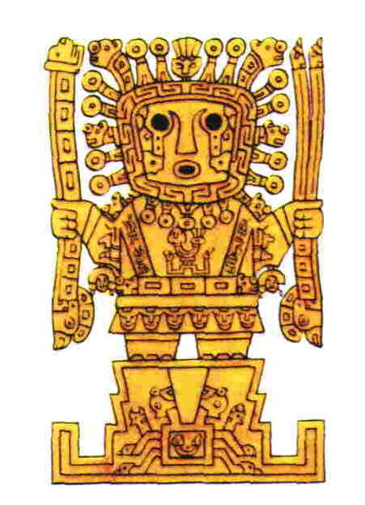
“The arquebus (also spelled harquebus, harkbus or hackbut; from Dutch haakbus, meaning "hook gun") was a primitive firearm used in the 15th to 17th centuries. Like its successor, the musket, it was a smoothbore firearm, although somewhat smaller than its predecessors, which made it easier to carry. It was a forerunner of the rifle and other longarm firearms.”

“Viracocha is the great creator god in the pre-Inca and Inca mythology in the Andes region of South America. Viracocha created the universe, sun, moon and stars, time (by commanding the sun to move over the sky) and civilization itself. He was represented as wearing the sun for a crown, with thunderbolts in his hands, and tears descending from his eyes as rain.”

“A garrote (a Spanish word; alternative spellings include garotte and garrotte) is a handheld weapon, most often referring to a ligature of chain, rope, scarf, or wire used to strangle someone to death. The term especially refers to an execution device, but is sometimes used in assassination because it can be completely silent.”

