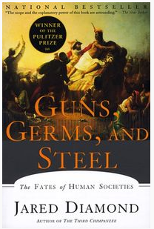
Why did the Spaniards conquer the Incas and not the other way around?
Video: http://tiny.cc/ggs
Transcript: http://tiny.cc/ggstran

November 16, 1532

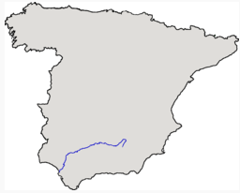
Atahualpa versus Pizarro:
80,000 Inca versus 168 Spanish conquistadores

Guadalquivir River

Cajamarca

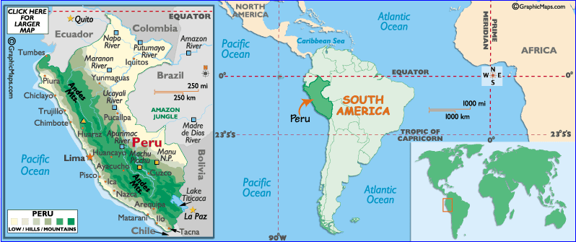

Definitions:
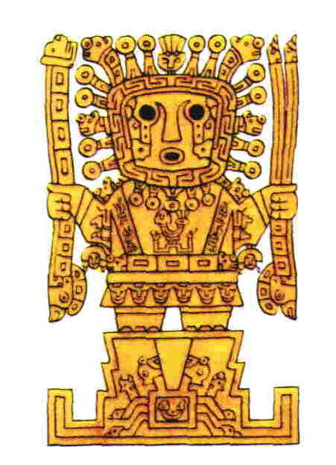
“The arquebus (also spelled harquebus, harkbus or hackbut; from Dutch haakbus, meaning "hook gun") was a primitive firearm used in the 15th to 17th centuries. Like its successor, the musket, it was a smoothbore firearm, although somewhat smaller than its predecessors, which made it easier to carry. It was a forerunner of the rifle and other longarm firearms.”

“Viracocha is the great creator god in the pre-Inca and Inca mythology in the Andes region of South America. Viracocha created the universe, sun, moon and stars, time (by commanding the sun to move over the sky) and civilization itself. He was represented as wearing the sun for a crown, with thunderbolts in his hands, and tears descending from his eyes as rain.”

“A garrote (a Spanish word; alternative spellings include garotte and garrotte) is a handheld weapon, most often referring to a ligature of chain, rope, scarf, or wire used to strangle someone to death. The term especially refers to an execution device, but is sometimes used in assassination because it can be completely silent.”
Source: Wikipedia
Print only page 1. This page is my instructions.

NEW

https://www.youtube.com/watch?v=dCBod2jFFyQ

(If deleted, search to find a new one.)

Start at 34:41 – 41:05. This is Fatal Error and Atahualpa captured. 6 ½ minutes

Watch 49:50 – 53:43 4 minutes

Point: Spanish conquest made them rich. They were extremely powerful. Spain was the leading power in the world in the 16th century. The Spanish Armada was defeated in 1588.

OLD
Use DVD in computer.

Go to Episode 2. Go to Scenes 7-12.

Go to Fatal Error. Watch until the Atahualpa is captured scene (skip germs). 7 minutes

Click the Title Menu button. Go to the Conclusion. Watch until the end. 5 minutes. Click quit.

