Barreto
Hist Econ

PRE-SMITHIAN ECONOMICS

I) Scholastics

A) St. Thomas Aquinas (1225-1274)

B) General Characteristics

1) Just price

a) Monopoly

b) Usury

2) Avoid wealth and if you are wealthy, give it away

C) The Fall

II) Mercantilists

- English: Thomas Gresham (1519?–1579), Thomas Mun (1571-1641)
French: Jean Baptiste Colbert (1619-1683)

B) General Characteristics

1) Bullion = Wealth

2) Trade a zero sum game

a) Export Monopolism: East India Co.

b) Colonies serve mother country

Navigation Acts

3) Massive government regulation in business

C) The Fall

III) Physiocracy

A) François Quesnay (1694-1774)

B) Time Period: 1750 - 1780

C) Historical Background

D) Goal: to make France wealthy (economic development)
Strategy: laissez faire, laissez passer

E) Physiocratic System

1) Foundations

a) The Newtonian View of the Universe

i) Early Celestial Mechanics

ii) The Scientific Revolution

iii) Newton

2) The Model

a) Surplus

b) Classes

c) Inputs

d) Tableau Economique

F) Policy Prescriptions

1) Single tax on landowners (influences Henry George and Marx)

2) Laissez faire

G) Conclusion

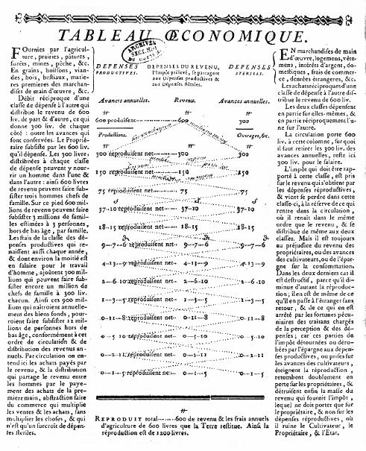

IV) Historical Background

Discussion of Landes’ Winners and Losers chapter

Discussion of Heilbroner’s The Economic Revolution chapter

