Barreto
Hist Econ

Ricardo’s "On Machinery"—The Effects of Technological Change

Paper Assignment on Ricardo

Background:
The following newspaper account is taken from Hobsbawm and Rude's Captain Swing, p. 125:

[24 November 1830] . . . At Wilton, west of Salisbury, considerable
damage was done to John Basher's manufactory for woollen cloth: 500
men arrived at his mill that afternoon and announced that “they would break his machinery 'in order to make more work for poor people.”

Suppose you, representing David Ricardo, were assigned to respond to this angry mob of 500 men. They have assembled in front of the building where John Basher keeps the loud, powerful engines that power his spinning jennies and other machinery. The Luddite mob intends to break into the building and smash the hated machines that have taken their jobs. You stand in front of them.

The Question:
What do you say?

Some Additional Information:
1) Your response should be between 5-7 pages long.

2) You do not need to consult secondary sources. Read Ricardo's "On Machinery" -- it contains all the information you need.

3) Your response must be well organized. The points in your argument should
flow together smoothly. The response should contain an introduction with a clearly
stated thesis (your response in a nutshell), a game plan paragraph where you present
the order of your argument, a body with points and evidence, and a conclusion with
a clear statement of your position.

4) Check carefully for typos!

5) If you have any questions, come see me!
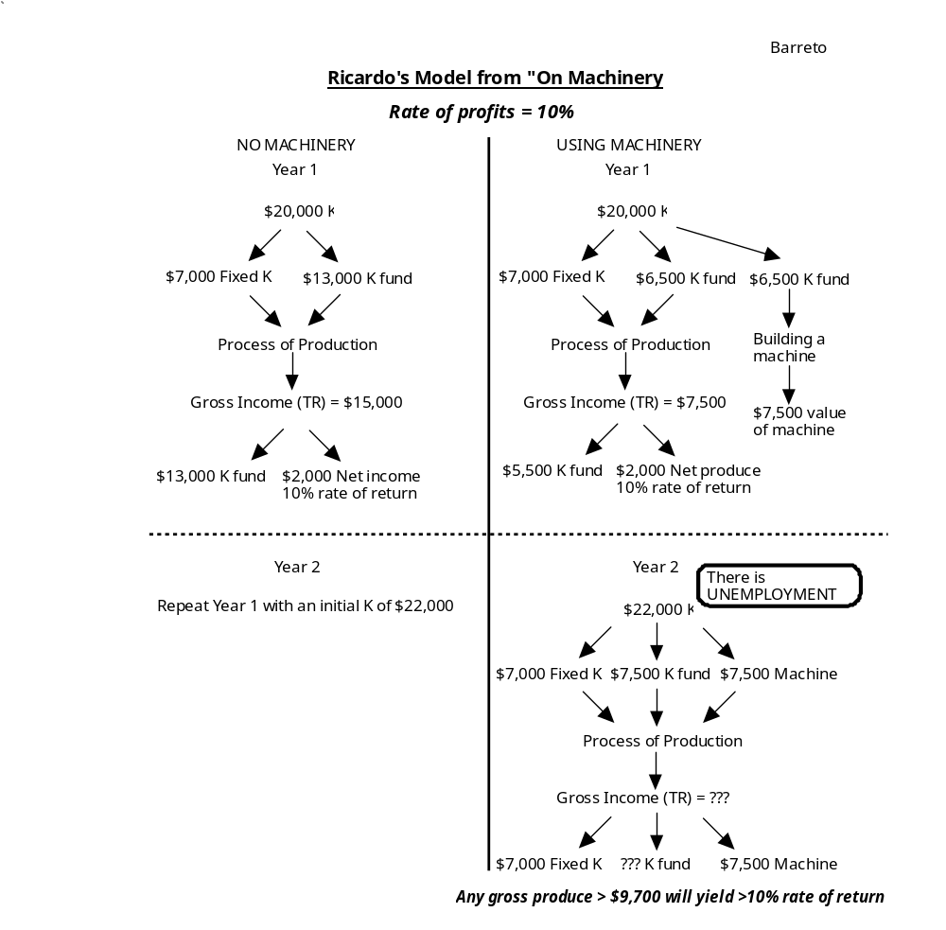

If you're interested, the story ends this way: "They stayed an hour and broke five engines to pieces; the owner later estimated his loss at 500 pounds."

