Barreto
Hist Econ

DAVID RICARDO
(Mercedes Benz – Janis Joplin)

I) Background

A) Biography

B) Major Works

II) Influences

A) Historical Period
i) Industrial Revolution
ii) Corn Laws

B) Intellectual Influences
Thomas Malthus

III) Problem Orientation

A) The Crucial Question

B) On Method

IV) Theory of Growth and Corn Laws

A) Ricardian Rent Theory
i) Casa de Humberto Game
ii) Ricardian Rent Theory Revisited: A Modern Application and Extension
iii) Ricardo’s Original Example

B) The Effects of Population Growth

C) Applying RRT to the Corn Laws

V) "On Machinery"—The Effects of Technological Change

VI) Public Policy Prescriptions

VII) Conclusion

I) Background
A) Biography

B) Major Works

II) Influences
A) Historical Period
i) Industrial Revolution

ii) Population
Arithmetic v Geometric Progression
iii) Corn Laws

B) Intellectual Influences

Of course, Smith and James Mill, father of John Stuart, but the key influence is:

Thomas Malthus

III) Problem Orientation

A) The Crucial Question

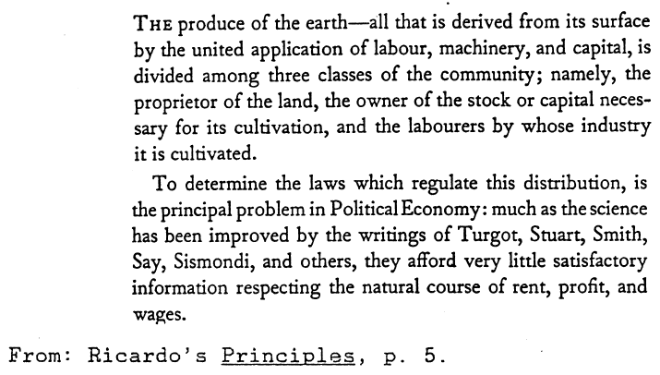

B) On Method

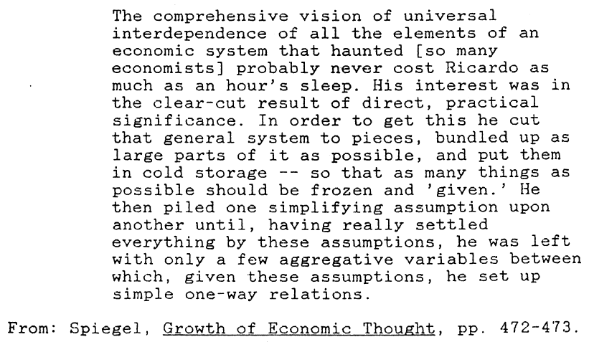
Essay Assignment

Read Barreto’s Ricardian Rent Theory paper and write a 250-word (1-page, double spaced) essay on this question:

What is booth rental and how does it work?

I’m looking for a clear, concise explanation. In your essay, please include information from the conversation you have with a stylist (read carefully below).

Phone Call Assignment

Call a barbershop or beauty salon and ask if they booth rent. You may call your own stylist or look one up in your hometown.

If your hometown is in another country, just randomly call a stylist anywhere in the United States.

Please fill in the row for your name in this Google spreadsheet:
https://tiny.cc/boothrental

Please include any additional interesting information from the phone call in the spreadsheet, especially if it’s funny. Definitely include who you called and what you talked about in your essay.

