Barreto
Hist of Econ

JOSEPH ALOIS SCHUMPETER
(Bob Dylan, “The Times They are a Changin”)

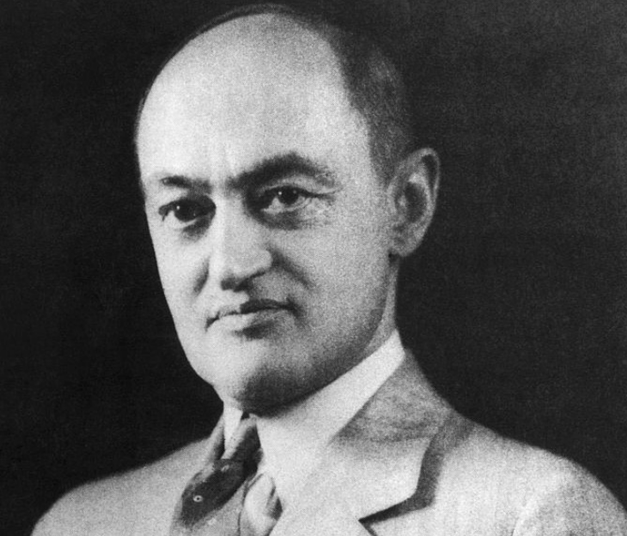
I) Background
A) Biography
B) Major Works

II) Influences
A) Historical Period
B) Intellectual Influences
i) Leon Walras
ii) Eugen von Bohm-Bawerk
iii) Karl Marx
iv) John Maynard Keynes

III) Problem Orientation

IV) Calculating Growth Rates and Understanding Economic Performance
MaddisonData.xls

V) The Data of Capitalist Growth
(From Capitalism, Socialism and Democracy)
A History of what Actually Happened

VI) The Theory of Capitalist Growth
(From The Theory of Economic Development)
Two Crucial Questions and Answers about Capitalist Growth
1) Why Does Output Increase Over Time?
2) Why Does It Increase Cyclically OR Why Are There Business Cycles?

VII) The Future of Capitalism
(From Capitalism, Socialism and Democracy)
"Can capitalism survive? No. I do not think it can."
A) The Spread of Rational Behavior
B) The Obsolescence of the Entrepreneur
C) The Demise of Capitalism

VIII) Conclusion

I) Background

A) Biography

B) Major Works

II) Influences
A) Historical Period
B) Intellectual Influences
i) Leon Walras

ii) Eugen von Bohm-Bawerk

iii) Karl Marx

iv) John Maynard Keynes

III) Problem Orientation
Static—we know (see Neoclassical Economics); Dynamic—we have to figure out


Joseph A. Schumpeter: His Life and Work

by Richard Swedberg
PUBLISHER
Polity Press
DATE
1993-05-07

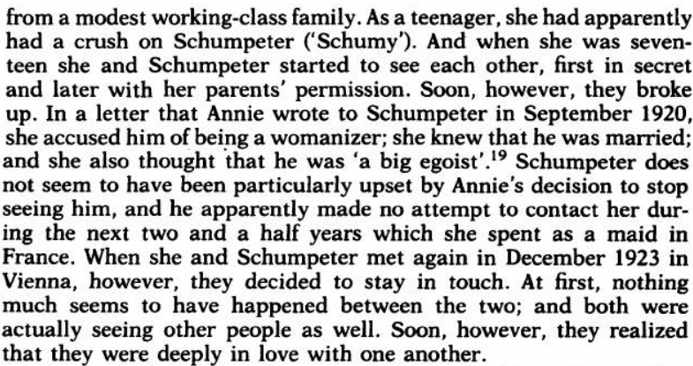
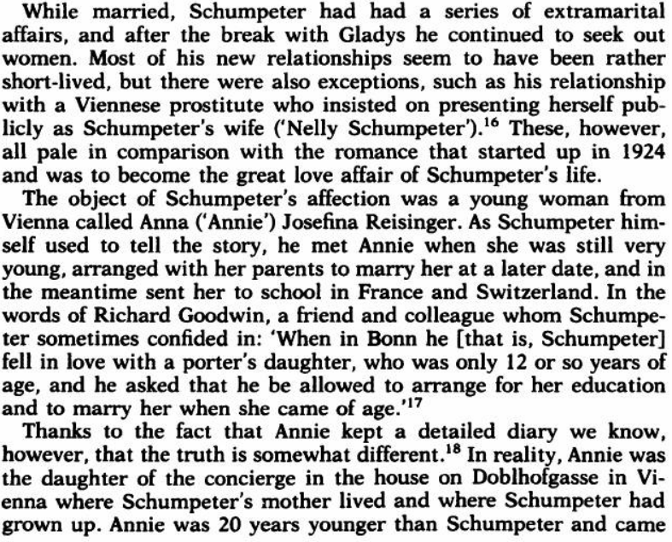
p. 72 p. 73

This footnote is to a sentence supporting the claim that both Joseph and Gladys had many affairs.
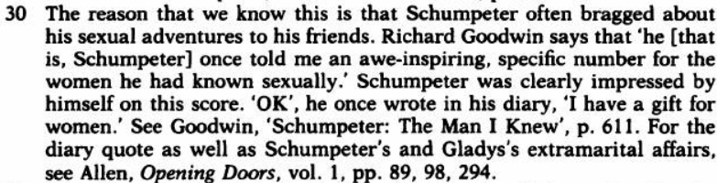

So there you have it: Schumpeter is both the Humbert Humbert and Wilt Chamberlain of the Worldly Philosophers.

