Barreto

Understanding the Problem

If firms treat the air and water as free, they pollute too much. Let’s say there are 2 firms, A and B. Their pollution costs are given below:

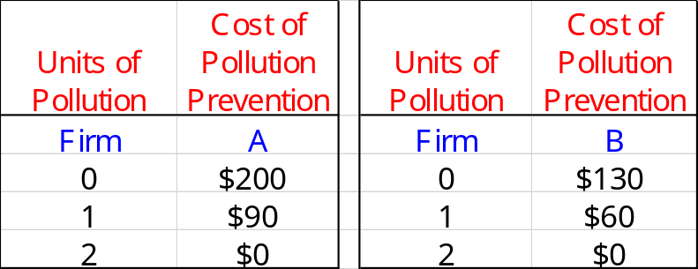

Right now, they are both polluting 2 units worth for a total of 4 pollution units because they are unwilling to spend any resources to abate (or reduce) pollution. Although their costs of pollution abatement are zero, they are harming the environment and imposing a social cost on all of us. The costs in the table above are NOT the costs of pollution, but the costs of reducing pollution to one or zero units.

Let’s suppose that somehow we decide that we should have only 2 total units of pollution. The question immediately becomes, how should we ALLOCATE pollution reduction between the two firms?

Often, people argue, “Make ‘em each only produce 1 unit—that’s fair.” Well, maybe, but note that such a plan results in Total Pollution Prevention Costs of $150 ($90 from Firm A and $60 from Firm B).

Is there a cheaper solution? What’s the cheapest allocation?

Playing the Pollution Permit Game

Each firm knows its own cost data—that is, how much it can save if it buys a permit and how much costs will increase if it sells a permit. Use the firm information provided below to decide whether or not to buy or sell and at what price.

At the beginning, each firm has one permit that it may continue to use OR trade at any mutually agreeable price as it sees fit.

When you trade a permit,
1) you record it by announcing the price to Pollution Exchange Recorder (me)
2) then you have one more permit than before if you are the buyer or one fewer permit than before if you are the seller

All trades must be publicly announced and recorded to be valid.

You may sell or buy more than once. You can buy, then sell, so you’re back to 1 permit.

You do NOT have to buy or sell.

Buying more than 2 permits makes no sense.

All trades are recorded and prices are made public as the trades occur.

Grading: + 5 on IH essay if play CORRECTLY
- 5 if play INCORRECTLY

------------------------------------------------------------------------------------------------------------------------------------------------------------------------------------------------------------------------------------------------------------------

This POLLUTION PERMIT allows one unit of pollution.

