Barreto
Hist Econ Thought

Signaling Theory

The Situation:
Firms sell tires.

But some tires are better than others. They last longer and are less likely to break. What’s a good tire?

Simplifying Reality:
Let’s suppose the world is made up of two kinds of tires — Good Ones and Lemons. The Good Ones are worth $50, while the Lemons are worth $25. In the world of tires, 50% are Good Ones and 50% are Lemons.

Unfortunately, you can’t really tell them apart by just looking at them. The seller knows if the tire is a Good One or a Lemon, but the buyer doesn’t know. Asymmetric Information

“Ummm, Bertie?”
Yeppie?
“Why doesn’t the buyer ASK the seller if the tire is a Good One or a Lemon?”
Gee, I dunno. Why doesn’t the buyer ASK the seller if the tire is a Good One or a Lemon?

The Problem:
Owners of low quality tires will lie to buyers in order to collect the $50 Good One price. “Oh yeah, this tire is top ‘o the line. It’s definitely a Good One worth every bit of that $50.”

Buyers are not stupid, of course: with a 50% chance of getting a Good One and a 50% chance of getting a Lemon, buyers figure that the tire they’ll get is worth, on average, $37.50 so that’s what they’ll be willing to pay.

Uh oh! Do you see the problem????

The Problem:
Lemons drive out Good Ones. There will be no market for Good Ones. This is Gresham’s Law.

Elements of a Solution:
Find some way to reveal the true quality of the tire; find a means to eliminate the lying.
Find a mechanism to sort the tires into two separate categories — Good Ones (worth $50) and Lemons (worth $25).

A Pictionary® for you:

The Market Solution:

The consumers require the sellers to offer a Warranty for Good Ones.

“How will that stop the Lemon owners from lying?”
Watch carefully!

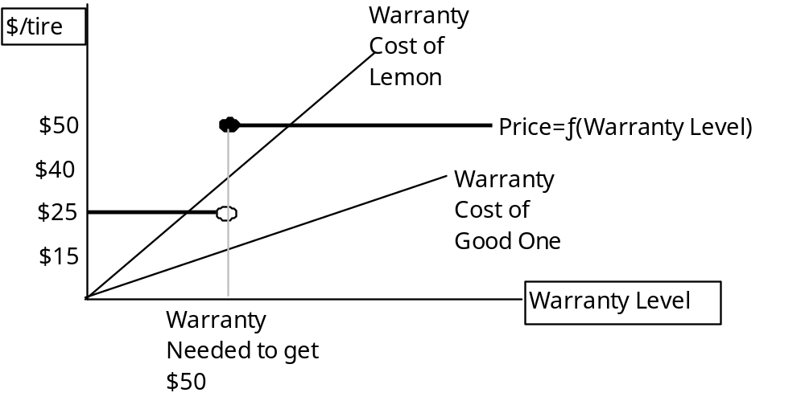

Determining the Seller’s Decision of whether or not to offer a warranty:
 | If Good One | If Lemon
No Warranty
Warranty

