Barreto
Hist Econ

ADAM SMITH
(Bachman Turner Overdrive: Taking Care of Business)

I) Background
A) Biography
B) Major Works

II) Influences
A) Historical Period—the DAWN of the Industrial Revolution
B) Intellectual Influences
i) Sir Isaac Newton
ii) Prevailing Economic Thought
a) Mercantilism
b) François Quesnay
c) David Hume

III) Problem Orientation
An Inquiry into the Nature and Causes of the Wealth of Nations, or,
Why do some economies grow rapidly and others don't?

IV) Smith’s Two Theories of Growth
Output Theory of Growth (Reading the Wealth of Nations)
Wage Theory of Growth (A modern interpretation of Smith’s words)

V) Application—Smith on Education
A) The Role of Competition
B) Signaling Theory

VI) Chicago versus Kirkcaldy Smith

VII) Public Policy Conclusions
A) Natural Liberty
B) Qualifications to Laissez Faire

VIII) Conclusion

I) Background
A) Biography

When did he live? Where? How? Was he rich or poor? What was his job?

Interesting facts about his life?

Any other things you remember from Heilbroner’s chapter on Smith?

B) Major Works

That’s so easy: _____ and _____.

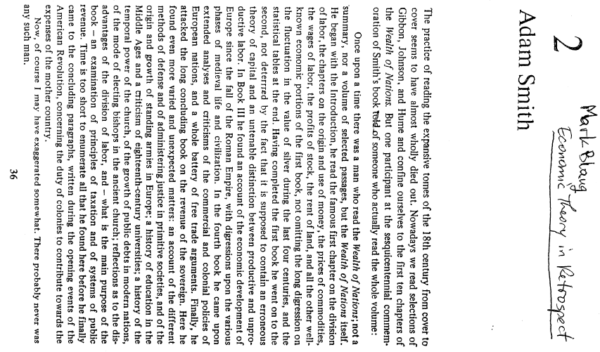
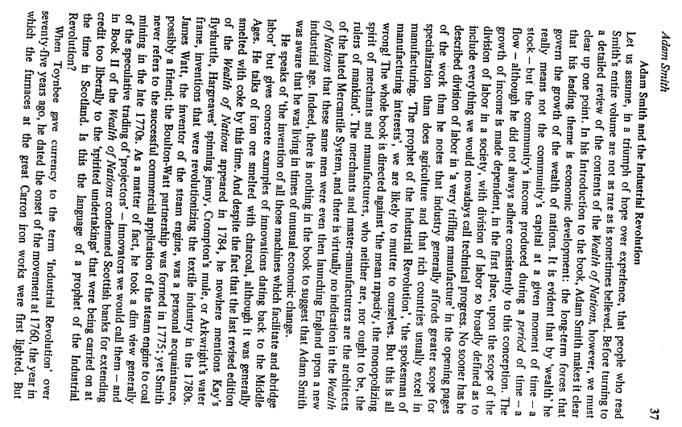

II) Influences
A) Historical Period—the DAWN of the Industrial Revolution

B) Intellectual Influences

i) Sir Isaac Newton
Smith: Newton’s system was “the greatest discovery that was ever made by man.”
“Human society, when we contemplate it in a certain abstract and philosophical light, appears like a great, immense machine, whose regular and harmonious movements produce a thousand agreeable effects.” TMS

ii) Prevailing Economic Thought
a) Mercantilism

b) François Quesnay

c) David Hume

III) Problem Orientation
An Inquiry into the Nature and Causes of the Wealth of Nations, or,
Why do some economies grow rapidly and others don't?

The source for our version of Smith’s Wealth of Nations is the Library of Economics and Liberty, at

http://www.econlib.org/LIBRARY/Smith/smWN.html
Watch your email for your writing assignment based on this reading.

