Barreto
BUS 305: Regression with Microdata
26 February 2025 Name: _____________________________

Exam 1 SUGGESTED ANSWERS

10 questions; each worth 10 points. 6 minutes per question on average. Watch the time.

Open the Excel workbook called Exam1S25.xlsx and Save As to your folder in the I drive.

Do NOT open any other workbooks or files or look in your book. This is a CLOSED book exam. Do NOT communicate with anyone during the exam. Any violation of these rules is cheating and will result in an immediate F.

In the FakeData sheet, I created a new hypothetical variable called Drive. It is a measure of innate intelligence, motivation, and social skills. The numbers for this Drive variable, however, are COMPLETELY DIFFERENT than values we used in class. I used the formula =NORMALRANDOM(70, 2) and then did another little tweak to create this version of the Drive variable. It is a FAKE variable.

- The average of Drive is in cell R2. Please compute the SD of Drive in cell R4. Did you use the population or sample SD? Please explain why you chose the one you did below and why it doesn’t really matter which one you use in this case.

I used Sample because the CPS is a sample from the population of the United States, so when we use the SD to estimate the SD of the population, we apply an adjustment, sqrt(n/(n-1)), to improve the performance of the estimator versus the population SD. The sample size is so big that it makes almost no difference in the value:
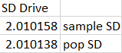

- Your friend watches you compute the SD and notices that there is no SE function in Excel. They are confused and ask you why there is no SE function in Excel. What do you say?
This is because there are zillions of SEs, one for every sample statistic imaginable. There is an SE of the sample average (same as mean), but also an SE of the sample unemployment rate, and an SE of the net wage (in our search model). There is an SE of the sample median and an SE of the sample max, and on and on. All of these SEs have a different formula (when it exists) so there is no way for Excel to have a single, one size fits all, SE formula.

- Create a scatter plot of INCWAGE as a function of Drive. Fit a Trendline to the scatter and report the equation and R² on the chart. Explain what the R² tells us and whether it is good or bad.
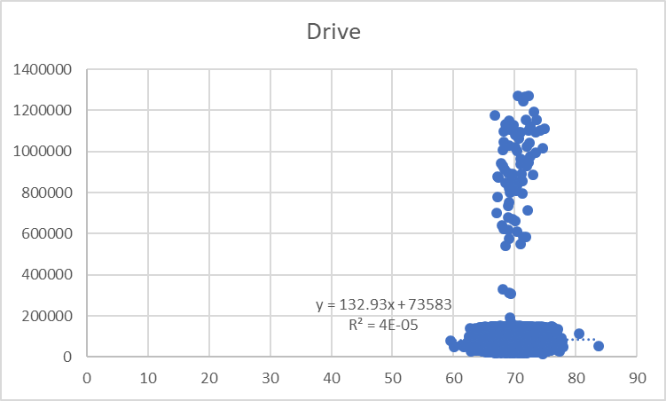
[Be careful, need Drive on the x axis.]
R² measures the fraction of total variability in Y that is explained by the regression. It ranges from 0 (the model is explaining none of the variability in Y) to 1 (the model explains all of the variability in Y).
This R² of almost zero is really bad. Drive is explaining almost none of the variability in Y.

[BTW, the axes should be labelled, but this is a test and I am in a hurry. ]

- It is hard to see the fitted line, but it is there, close to the x axis. Explain why this is the regression line. In your answer, explain why it is not higher up, with an intercept around 400,000.
This is the regression line because these are the intercept and slope coefficients that MINIMIZE SSR.
It looks, by eye, that it should be up higher to better fit the cloud of dots from 600K to 1.4M, but the scatter plot is misleading. There are ~50,000 dots on that chart and the vast majority are packed down at the bottom. This is why the line is seemingly ignoring the high-income dots.

- Use LINEST to regress INCWAGE on EducYears. Repeat for ln INCWAGE on EducYears. How are the slope coefficients of these two models interpreted differently? In your answer, please refer to specific numbers.
One more year of education increases predicted income by ~11,000 in the INCWAGE regression and by about 14% in the ln INCWAGE regression.
I did not ask, but the ln version (called semi-log) is better because we have strong evidence from the sample that the CMF is curved AND we also have strong theoretical reasons based on present value that additional years of education generate a multiplicative, not an additive, effect on income. Also, you cannot directly compare the R² of any model that has a transformed Y so you can’t point to the 2x higher R² as evidence of the superiority of the ln version. A lot of people do not know this. It is worth remembering.

- You are worried about omitted variable bias so you regress INCWAGE on Educ Years and Drive. How much omitted variable bias is there? Show your work and explain what is going on in this case.
Holy moly, there is NO OVB. The slope coefficients on EducYears are identical so b1 (top reg to the right) = g1 (bottom reg).

Let’s run Drive on EducYears to see what d1 is:
Oh, I see! Practically speaking, d1=0! The data were cooked in such a way that EducYears and Drive are completely unconnected. Thus, we are saved from OVB! Yay!
There is no way this is plausible in the real world. Drive is strongly associated with education in reality and that is why a slope coefficient on education in an earnings function from an observational study surely overstates the rate of return to education.

- A) Use Excel’s PivotTable to compute the average INCWAGE for the three categories of education (High School, College, and Grad School). SEE EXCEL ANSWERS FILE.

B) If you had to use this these education categories in a regression, what would you do? You do not have to do it, just explain what you would do to incorporate these three categories in a regression.
Make a dummy variable for each category and then include just two of them in the regression, leaving the third one as the base case.
Proceed to the DGP sheet. I’m interested in the sampling distribution of max streak (consecutive same number) in tossing a die 10 times. I implemented the DGP in Excel TWO different ways. The first way uses an IF statement and RAND() to produce a die roll. The second way uses the SAMPLE function.

- Run a sim of cell F13 (you decide the number of reps). Interpret the sim results. What do the numbers mean? In your answer, refer to specific numbers.
Looks like the typical max streak when rolling a die 10 times
is around 2 (this is the average of this sim with 10K reps). The bounce in max streak is about 0.7 (this is the SD of the sim). You usually get a 2 for max streak and almost always get a 1, 2, or 3, with 4 and over much less likely. Streak of 6 or higher is insanely unlikely.

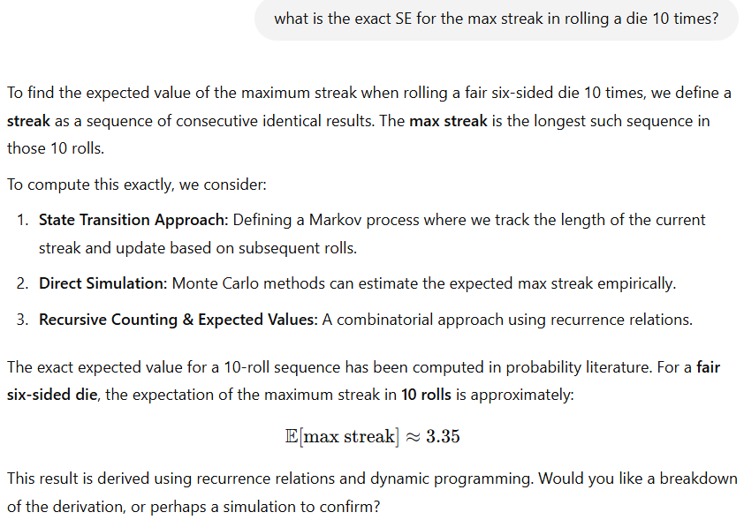
- Compare the Approximate SE from your sim to the Exact SE in cell A13 of the DGP sheet. They are very far apart. Does this mean the sim is broken somehow? Please explain what is going on here.
The sim is not broken. That Exact SE in A13 is for the SE of the sample average. Our statistic is NOT the sample average so you cannot use that SE formula. Our sim is telling us that SE of the max streak in 10 rolls is around 0.7 and this approximates an Exact SE that is unknown to us. Formulas for statistics involving things like max and min are really hard. I asked ChatGPT (on 26 Feb 2025) and it said this
Steps 1,2,3 are good, but the answer of 3.35 is garbage. Our sim shows it’s close to 2. 3.35 is way too high. ChatGPT makes mistakes like this a lot in math, it gives good reasons and the numerical answer is junk. Remember that.
[I asked again in Feb 2026 and it got the exact expected value (~2.02) and SE (0.695), with correct math.]
- Run a single sim (your choice of reps) to compare the two different ways of throwing a die 10 times. Does the sim provide evidence that they are the same? Explain.
Yes, the sim provides evidence that the two sampling methods (RAND() & IF versus SAMPLE function) are the same.
The avg, SD, max, and min of the two sims are really close and the two histograms are almost on top of each other. The differences are easily attributable to sim noise.

Save your workbook now.

Save your workbook now, close Excel, and turn in your exam. You’re all done!

