Barreto

Hist Econ

*Hernando de Soto and Power of the Poor Viewing Guide*

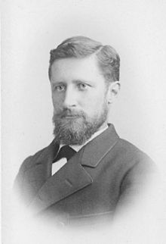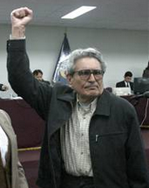🡨 At **3:41**: “They call themselves the Sendero Luminoso, or the ‘Shining Path. Their goal is to bring down the government, and anyone not with them is a target. Their foot soldiers are recruited among the poor and disenfranchised. And there are thousands of them.”

At **35:13** 🡪

Here he is-- Eugen Huber, the man who literally changed Switzerland. He changed the rules of the game and allowed it to move from a backward to a very forward-looking economy. There he is, among the weeds. I don't think that many people in Switzerland know the name Eugen Huber.

Abimael Guzman Eugen Huber

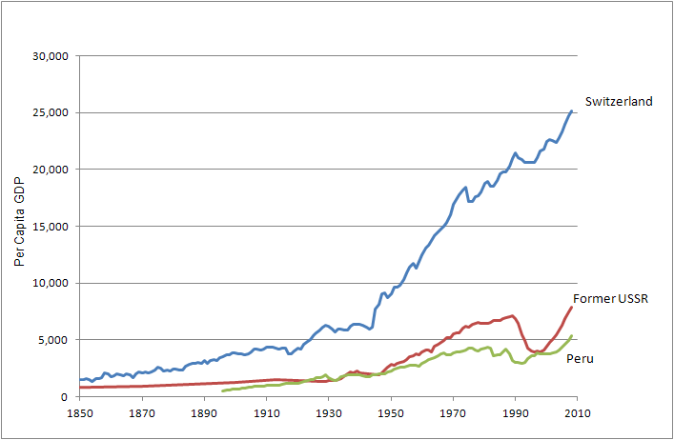

As you watch, think about this chart. Why is Switzerland so rich and Peru so poor?

Why is the USSR so poor? What happened from 1990 to 2010?

So many questions. So few answers . . .

Source: MaddisonData.xls

Entrepreneur at **11:35**: “Here we are with Doña Herreria Luna. She is an entrepreneur. First of all, she picked a site, a location. She chose products, she’s got eggs. She managed to put a refrigerator inside, so that some could buy for a little higher price, cold drinks. She’s made selections. She’s made decisions. She’s an entrepreneur. She took a full risk without any guarantees; you can’t get tougher than that.”

**14:56**: “the legal systems are simply unfriendly to poor people.”

Illegal v extralegal at **15:37**: “What's the difference between illegal and extralegal?”

**30:12**: “To be poor is to be assaulted by impossibility.”

**53:42**: “For ages we’ve been told that we are different. And it is true, we have cultural differences, but we are all looking for the same thing. We have families, we want to give them homes, we want to do business, we want to create prosperity, we want to have security.”

**54:25**: “But if you do not have an order that tells you who owns what, who is where, and who's accountable for what, none of the rest work.”