Humberto Barreto

hbarreto@depauw.edu

March 4, 2023

Population Pyramids

Simulating the Population Pyramid

Real Data



More Examples

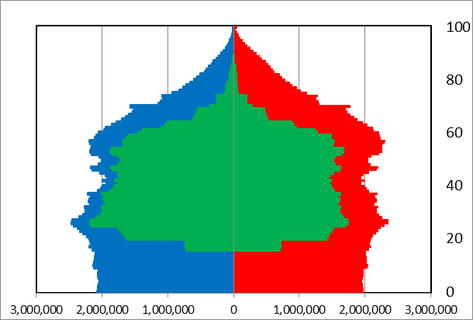 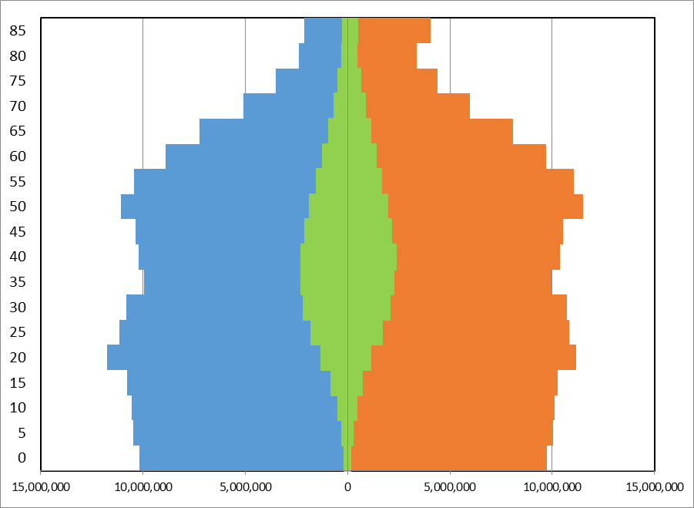 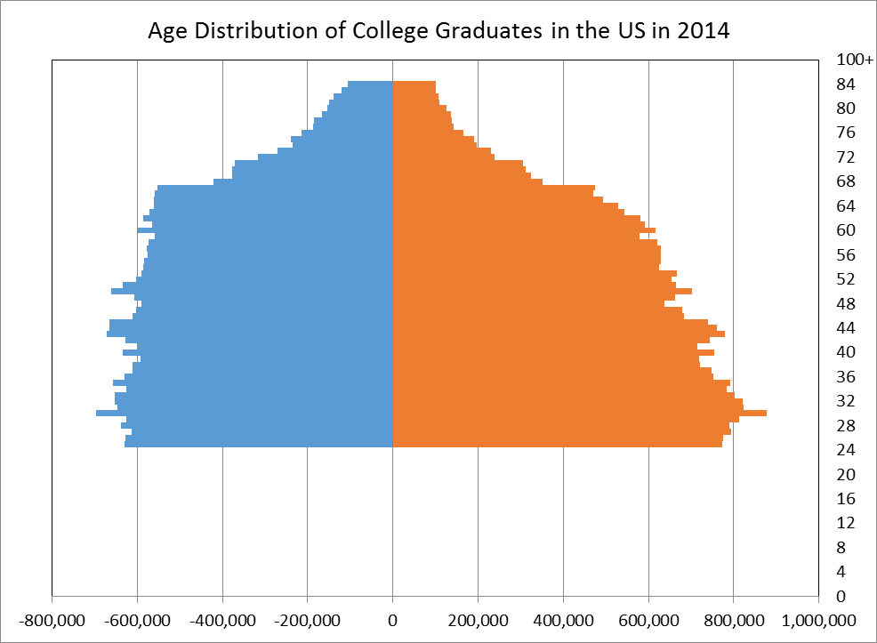

Labor Force Immigration College Graduates