Humberto Barreto

Hist Econ

Using Demography to Understand Keynes

Paper: <http://tiny.cc/hbdemo>

Excel file: Get PopPyr.xlsm from the class web page

HW: Create a 2023 population pyramid (like below) for a country of your choice, copy and paste the pyramid in a Word doc and write a few sentences on something of interest in the pyramid. Print and turn in on Friday. Email me the country you will present in class so I can have it ready to go. You will use PopPyr.xlsm to give a 1 to 2 minute presentation. I will time it and an alarm will go off after 2 minutes so practice it a little to make sure what you say makes sense in 90 seconds or so.

Simulating the Population Pyramid

1. Animation and the dynamic nature of the chart
2. Live changes—cut ASFRs in half in Year 100. What happens?
3. Afghan population in 2014, with Egyptian ASFRs and American ASDRs. What happens?

Real Data



More Examples

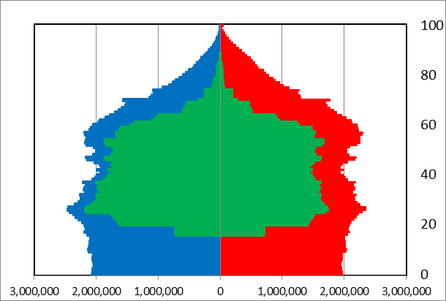 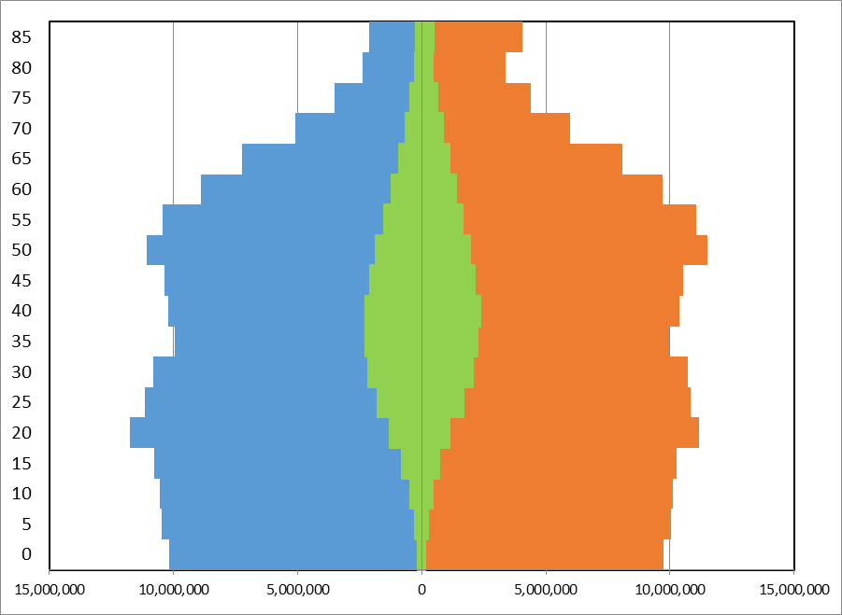 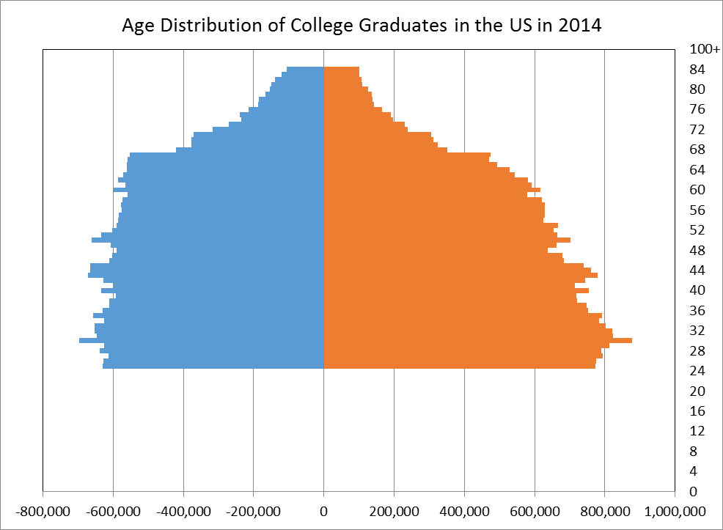

Labor Force Immigration College Graduates