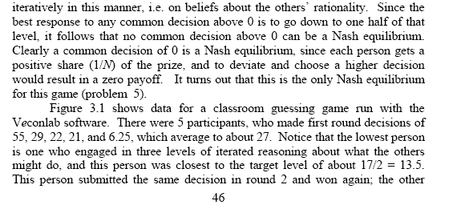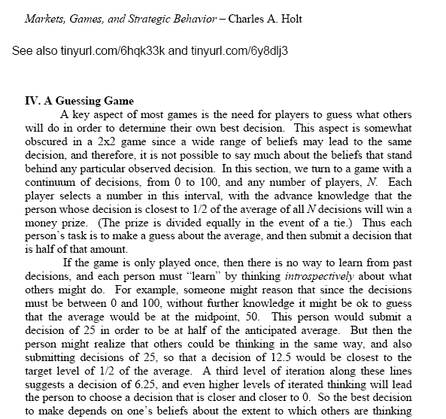

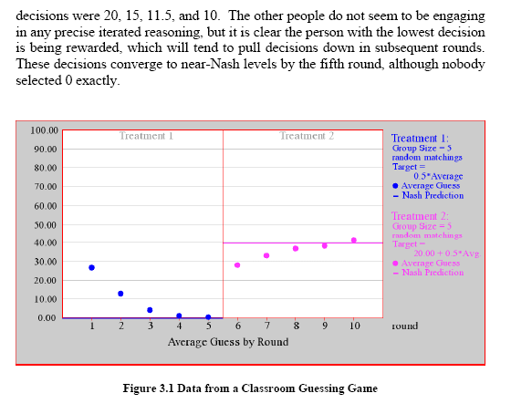

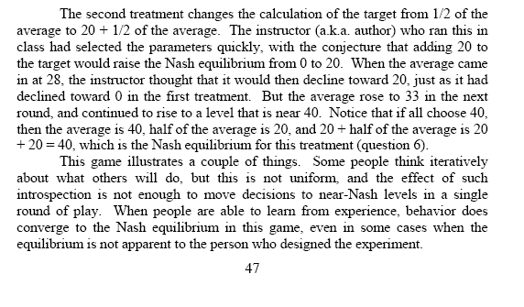

|  |  |  |
| --- | --- | --- |
| Name:  Game 1 Guess: _______  Game 2 Guess: _______  Game 3 Guess: _______ | Name:  Game 1 Guess: _______  Game 2 Guess: _______  Game 3 Guess: _______ | Name:  Game 1 Guess: _______  Game 2 Guess: _______  Game 3 Guess: _______ |
| Name:  Game 1 Guess: _______  Game 2 Guess: _______  Game 3 Guess: _______ | Name:  Game 1 Guess: _______  Game 2 Guess: _______  Game 3 Guess: _______ | Name:  Game 1 Guess: _______  Game 2 Guess: _______  Game 3 Guess: _______ |
| Name:  Game 1 Guess: _______  Game 2 Guess: _______  Game 3 Guess: _______ | Name:  Game 1 Guess: _______  Game 2 Guess: _______  Game 3 Guess: _______ | Name:  Game 1 Guess: _______  Game 2 Guess: _______  Game 3 Guess: _______ |
| Name:  Game 1 Guess: _______  Game 2 Guess: _______  Game 3 Guess: _______ | Name:  Game 1 Guess: _______  Game 2 Guess: _______  Game 3 Guess: _______ | Name:  Game 1 Guess: _______  Game 2 Guess: _______  Game 3 Guess: _______ |
| Name:  Game 1 Guess: _______  Game 2 Guess: _______  Game 3 Guess: _______ | Name:  Game 1 Guess: _______  Game 2 Guess: _______  Game 3 Guess: _______ | Name:  Game 1 Guess: _______  Game 2 Guess: _______  Game 3 Guess: _______ |
| Name:  Game 1 Guess: _______  Game 2 Guess: _______  Game 3 Guess: _______ | Name:  Game 1 Guess: _______  Game 2 Guess: _______  Game 3 Guess: _______ | Name:  Game 1 Guess: _______  Game 2 Guess: _______  Game 3 Guess: _______ |
| Name:  Game 1 Guess: _______  Game 2 Guess: _______  Game 3 Guess: _______ | Name:  Game 1 Guess: _______  Game 2 Guess: _______  Game 3 Guess: _______ | Name:  Game 1 Guess: _______  Game 2 Guess: _______  Game 3 Guess: _______ |
| Name:  Game 1 Guess: _______  Game 2 Guess: _______  Game 3 Guess: _______ | Name:  Game 1 Guess: _______  Game 2 Guess: _______  Game 3 Guess: _______ | Name:  Game 1 Guess: _______  Game 2 Guess: _______  Game 3 Guess: _______ |