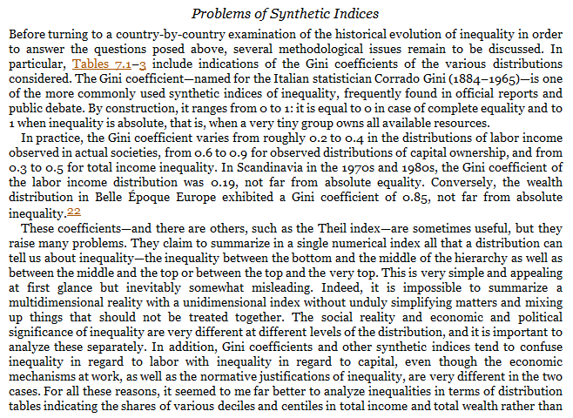Piketty on why he doesn’t like the Gini coefficient:

p. 266

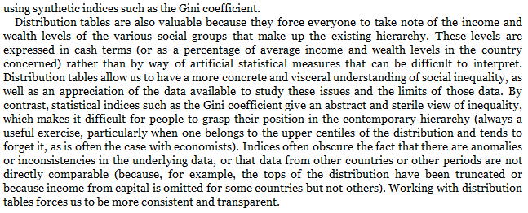

p. 267

Piketty, T. (2014), *Capital in the Twenty-First Century*, pp. 266-67

“This is soooo confusing. Why am I writing my Keynes paper with the Gini coefficient when Piketty says it sucks?”

Because everybody uses the Gini coefficient and I want you to know what it means and what it does (and that it’s flawed). You can show a Gini coefficient and other graphs or tables that measure inequality from

<http://wid.world/>