Barreto

Hist Econ

Piketty’s Capital in the 21st Century

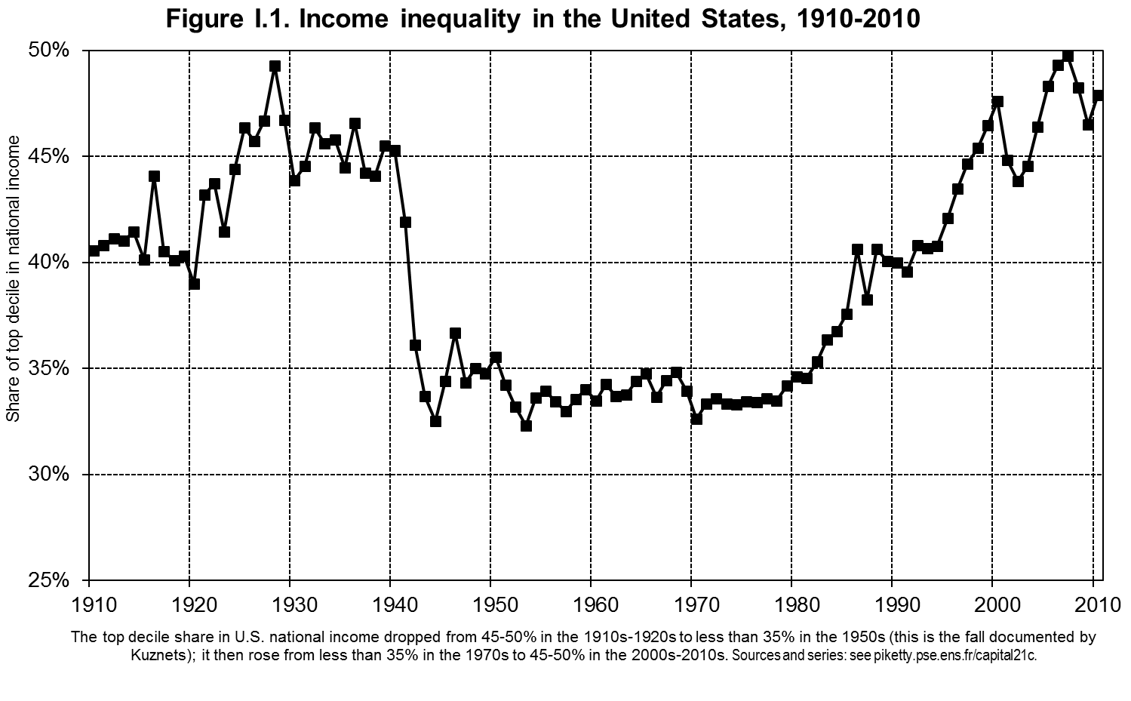 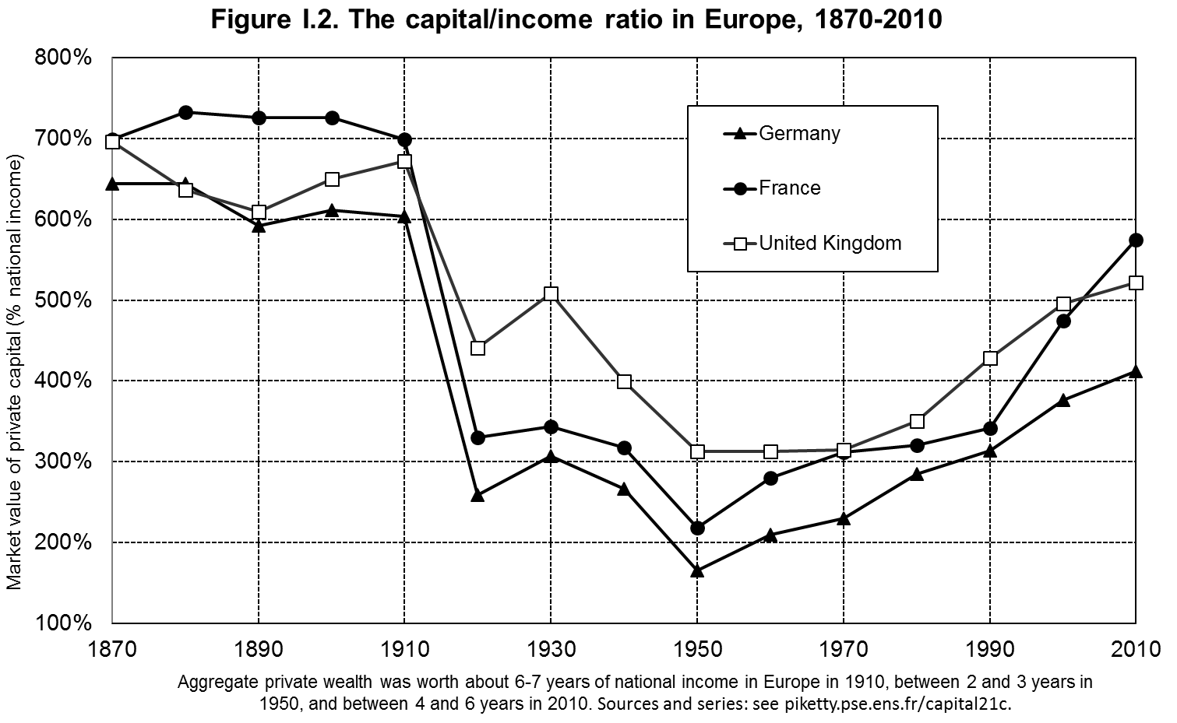

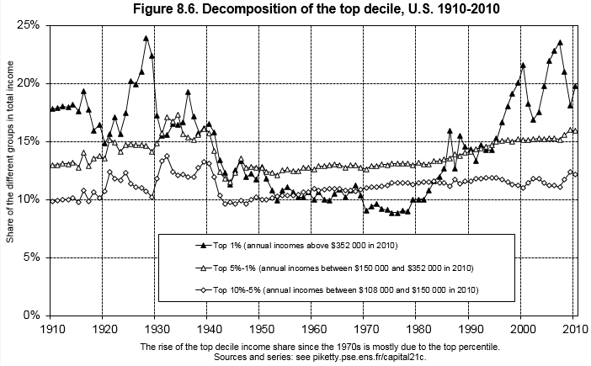

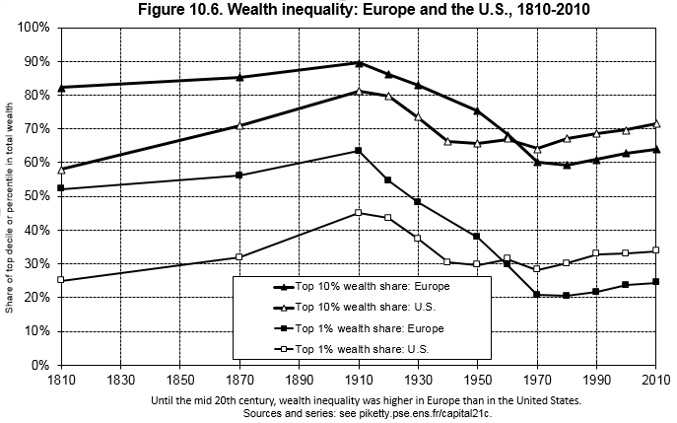

Chap 5: The Capital/Income Ratio Over the Long Run: p. 166

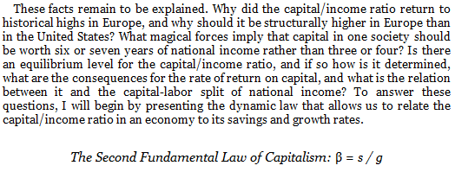

[but it’s really  = s/(+n+g+ng)]

First Law:  = r x 

Chap 6: The Capital-Labor Split in the 21st Century: p. 234

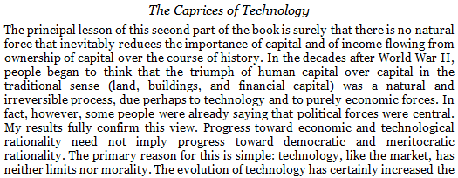

Conclusion: p. 571

