Barreto

Hist Econ

Inequality

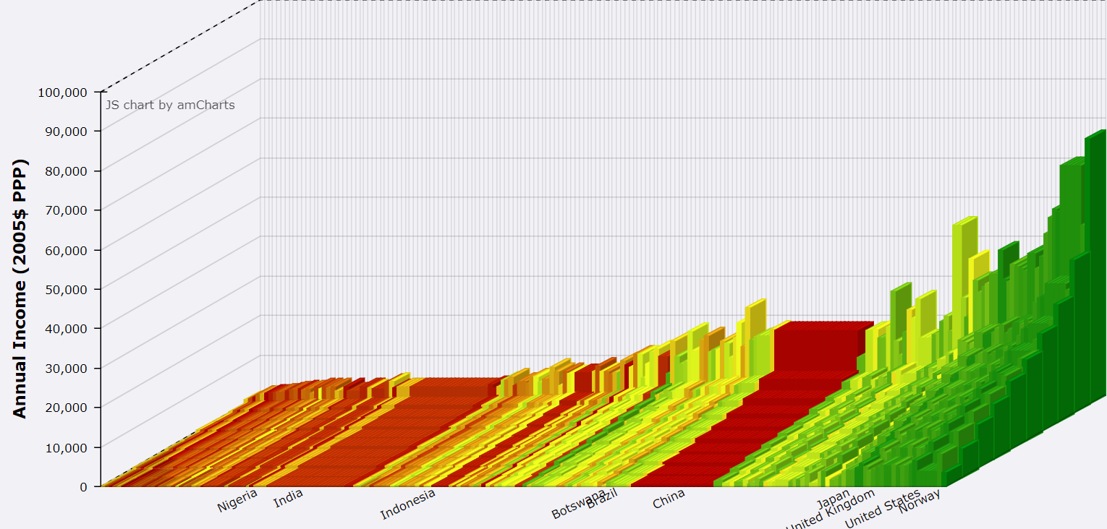

Source: <https://jackblun.github.io/Globalinc/html/fig_1980.html> (above is 2014)

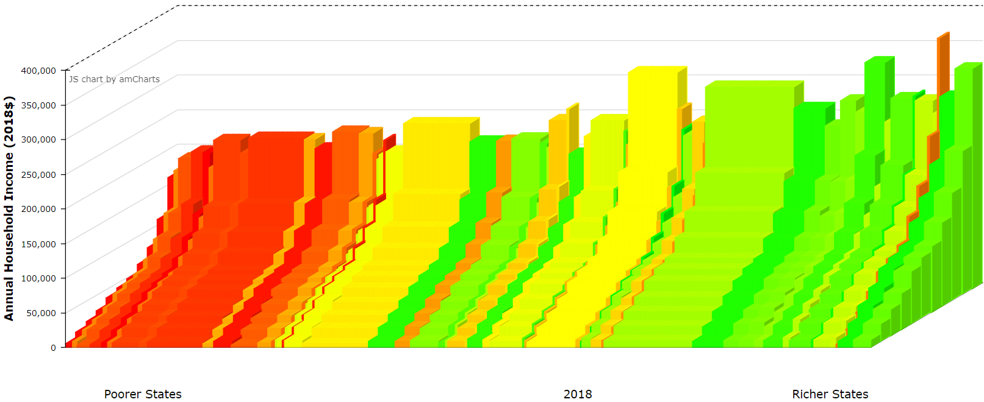

Source: <https://research.depauw.edu/econ/incomevis> (click Start to get 1976)

Connecting the Blocks in the Charts above to the Lorenz Curve and Gini Coefficient

Data

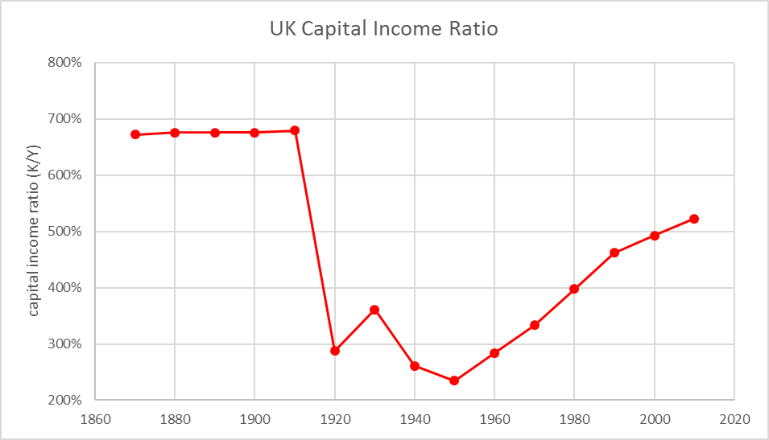 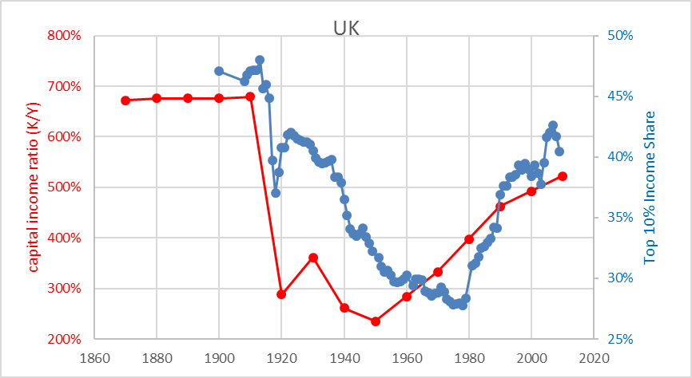

What Determines Income Inequality? The Solow Model

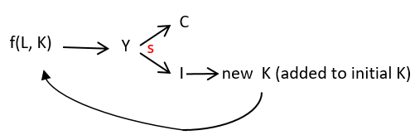

Working with Capital.xlsm

Final

Piketty’s Worry: low *g* & *n* 🡪 high *K/Y* and high *K/Y* 🡪 high inequality