*The Ghost Map: The Story of London's Most Terrifying Epidemic - and How it Changed Science, Cities and the Modern World* by Steven Johnson is an excellent account of how John Snow solved the puzzle of cholera and where it came from. If you are interested in science and like to read a good story, you should read this book. Johnson sets the stage, London in Marx’s day, with an incredible account of the night-soil men. Listen and read along, underlining and circling ideas that catch your attention and jotting notes on the side. You have to be fast and listen carefully.

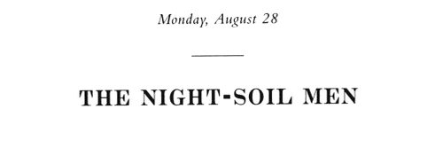

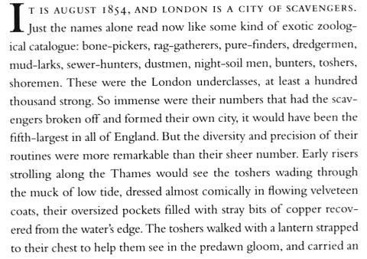

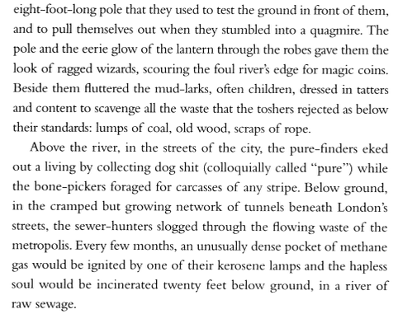

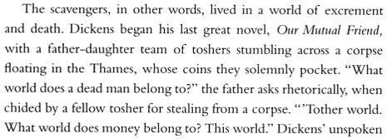. . .

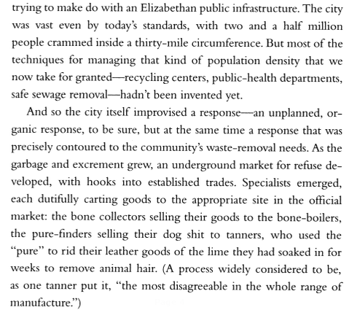

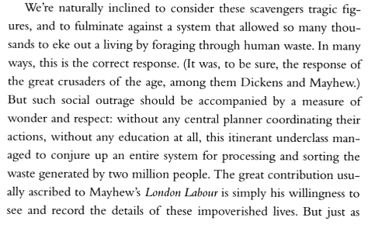

*London Labour and the London Poor* is a careful, detailed description of London in the 1840s by journalist Henry Mayhew.

and Marx!

  

