Ricardo was involved in a fierce debate on whether food prices were high because of high rent or rent was high because of high food prices (his view). Here is a modern twist on this argument:

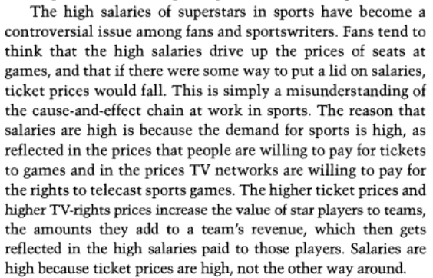

Quirk and Fort, *Hard Ball* (2010), p. 89

<https://www.amazon.com/Hard-Ball-Abuse-Power-Sports/dp/0691146578>