**Growth Basics**

A geometric progression is multiplicative and, therefore, more powerful than an arithmetic (additive) sequence.

"The consequences for human welfare involved in questions like these are simply staggering: Once one starts to think about them, it is hard to think about anything else." Robert Lucas

**Rule of 70**: 

Real GDP per capita (or per person) is how we measure a country’s economic performance.

We care about both *level* and *percentage change*.

Level is the actual number (bigger is better); **percentage change** is 

When percentage changes bounce around, we can take the average or compute a **CAGR** = ${\left[\frac{new}{initial}\right]}^{1/t}-1$

The **percentage change in Real GDP per person should be about 2%** for a rich country like the United States. That is considered very good performance.

In addition to using Real GDP, when we compare GDP per person across countries we should adjust for **PPP** (purchasing power parity). Maddison did this.

**Using the MaddisonData.xls workbook** (available at [www.depauw.edu/learn/macroexcel](http://www.depauw.edu/learn/macroexcel))

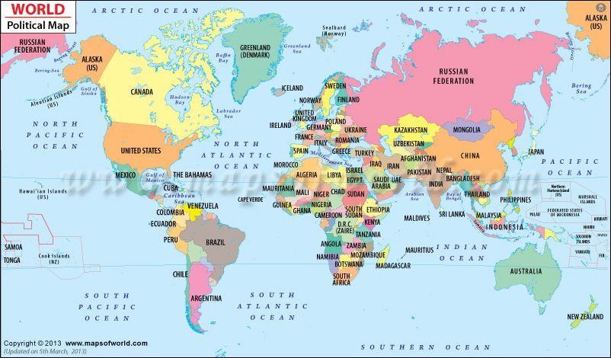

Source: www.mapsofworld.com/world-political-map.htm