Barreto

Hist Econ

Schumpeter and *Knowledge and the Wealth of Nations* (by Warsh)

Schumpeter is about the LONG RUN; about the success of Kism over decades and, now, even centuries, but just two, really—it’s brand new (few people know this).

p. 335: “To put it another way, ordinary people became rich.”

Three Adjustments we must make to compare GDP over time

1. Prices
2. Exchange rates
3. Quality

Nordhaus and Light

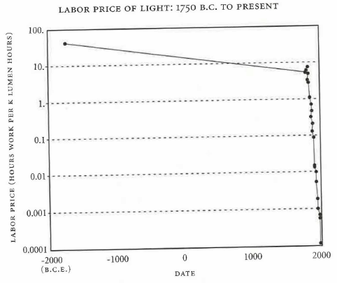 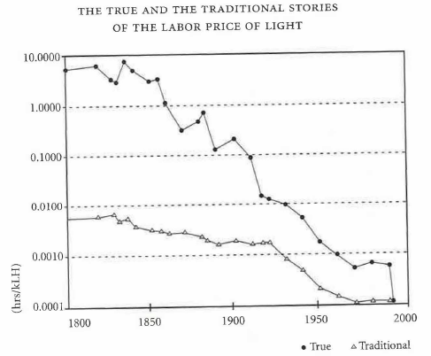

“Think about statins, the remarkable drug that lowers cholesterol and reduces deaths from heart attacks. By 2003, statins were the best-selling pharmaceutical product in history. By then it was in the price index. And when patents expired and generic forms of the statins became available, the prices fell and the BLS recorded that, implying a rise in real incomes. But it never estimated anything for the value that consumers would place on the major reduction in mortality that came about as a result of the introduction of statins.”

Feldstein (2017, p. 4-5) <http://www.nber.org/papers/w23221>