Vocabulary from Heilbroner’s Chapter on Veblen

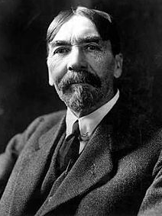(in order of appearance)

Modicum

Punctilio

Parvenus

Caveat

Melee

Physiognomy

Gulling

Callous

Défi

Hermetic

Piquant

Enigmatic

Involuted

Iconoclastic

Toper

Rapprochement

Capricious

Mordant

Sedulously

Brocaded

Retrogression

Canons (no, not a howitzer, that’s spelled cannon)

Sagacious

Irksomeness

Derogation

Coruscating

Animus

Comely

Recrudescence

Dilettante

Halcyon

Mores