**------------------------------File Distribution Time------------------------------**

Client-Server: $D≥max⁡\{\frac{NF}{μ_{s}},\frac{F}{d_{\min{}}})$

P2P: $D≥max⁡(\frac{F}{μ_{s}},\frac{F}{d_{min}},\frac{NF}{μ_{s}+\sum{μ_{i}}})$

**------------------------------Socket Programming------------------------------**

UDP:

Client:

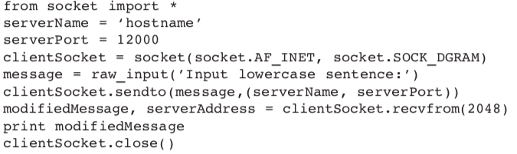

Server:

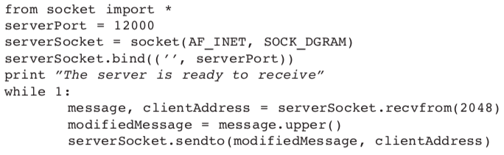

TCP:

Client:

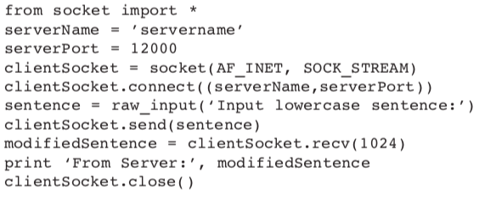

Server:

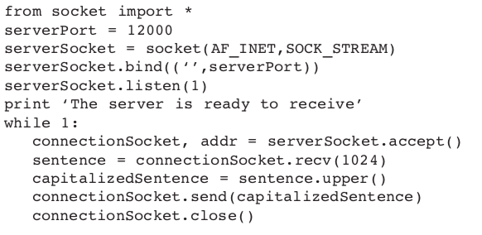

**------------------------------RDT-----------------------------**

1.0: Reliable transfer, Reliable channel

2.0: channel with bit errors

Question: recover from errors

Solution: 1.error detection. 2. Feedback(ACK, NAK)

2.1: sender, handles grabled ACK/NAK

Solution: sequence number

2.2: NAK-free

3.0: channels with errors and loss

Solution: timer

**------------------------------TCP structure------------------------------**

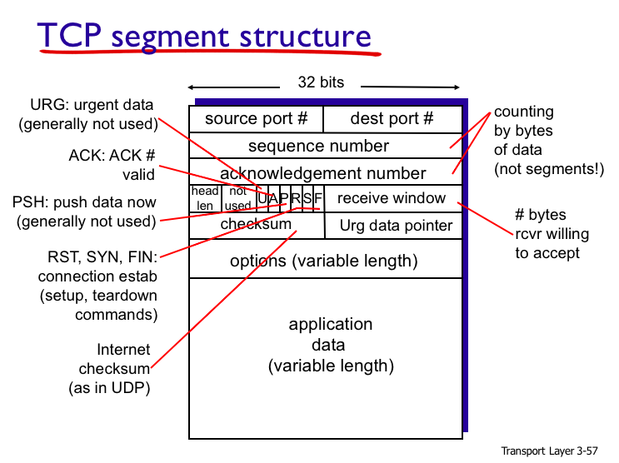

**------------------------------RTT Estimation------------------------------**

$$EstimatedRTT=α*SampleRTT+\left(1-α\right)*EstimatedRTT$$

$$DevRTT=β*\left|SampleRTT-EstimatedRTT\right|+\left(1-β\right)*DevRTT$$

$$TimeoutInterval=EstimatedRTT+4*DevRTT \\ Typical α=0.125, β=0.25$$

**------------------------------TCP Three Way Hand-Shake------------------------------**

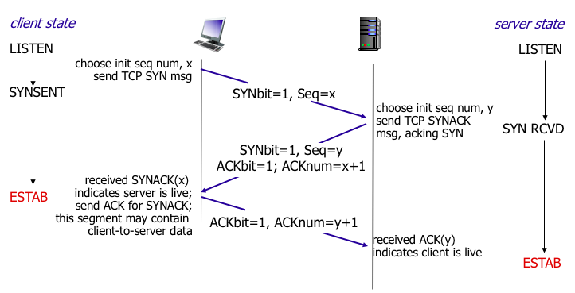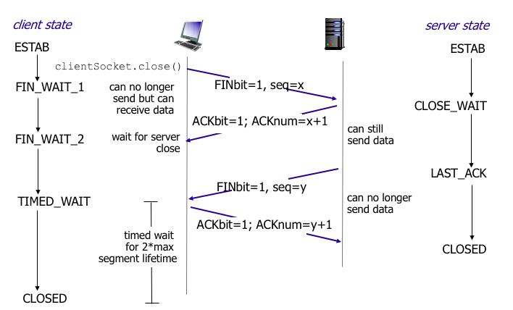

**------------------------------TCP Congestion Control------------------------------**

**Slow Start**: double cwnd every RTT

**Congestion Avoidance**:

cwnd += (MSS/cwnd)*MSS upon every incoming non-duplicate ACK

**Fast retransmit / fast recovery**:

ssthresh = cwnd/2

cwnd = ssthresh + 3MSS

retransmit the lost packet

increase cwnd by 1 MSS upon every duplicate ACK

**Time out**:

Ssthresh = cwnd/2, Cwnd=1

**------------------------------TCP Throughput------------------------------**

Avg Throughput = 0.75*W/RTT bytes/sec

With loss probability, L: throughput = 1.22*MSS/(RTT*sqrt(L))

**------------------------------Example------------------------------**

