* 1. detX = 2 ≠ 0. So, x is invertible.
  2. $X=\left(\begin{matrix}2 & 4 \\ 1 & 3\end{matrix}\right)→\left(\begin{matrix}2 & 4 \\ 0 & -5\end{matrix}\right)$ The rank of X is 2

1. 1. mean = (1 + 1 + 0 + 1 + 0) / 5 = 0.6
   2. = 0.3
   3. Assume
2. 1. False
   2. True
   3. False
   4. False
   5. True
3. (a) -> (v)  
   (b) -> (iv)  
   (c) -> (ii)  
   (d) -> (i)  
   (e) -> (iii)
4. 1. E[X] = p  
      Var(X) = p(1 - p)
   2. Var(2X) = 4 Var(X) = 4σ2  
      Var(X + 2) = Var(X) = σ2
5. 1. 1. Both
      2. g(n) = O(f(n))
      3. g(n) = O(f(n))
   2. Assume the name of array is a, and name of the function is transition  
      transition (start, end):  
      middle = (start + end) / 2  
      if a[middle] == 1:  
       return transition (start, middle)  
      else if a[middle + 1] == 1:  
       return middle  
      else:  
       return transition (middle + 1, end)  
        
      The recursion stops when a[start] == 0 and a[start + 1] ==1. So, it fulfills the question.  
      The running time T(n) = T(n/2) + O(1), so the complexity is O(logn)
6. 1. E(X)E(Y)
      1. Due to the Law of Large Numbers, the number of times 3 shows up should be close to 6000 \* 1/6 = 1000
      2. According to Central Limit Theorem, √n(Sn − µ) converges in distribution to a Norm N(0,σ2)
7. 1. 1. 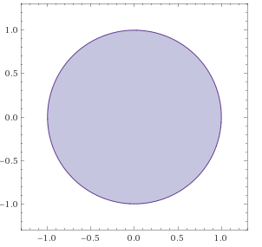
      2. 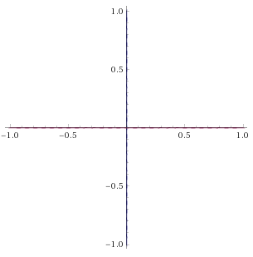
      3. 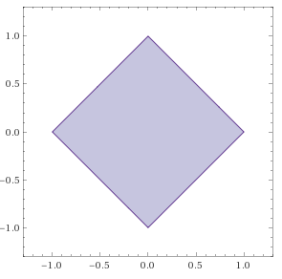
      4. 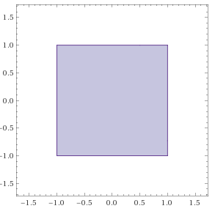
   2. 1. Assume A is a n x n matrix, if there exists a vector X such that $AX=λX$ 
         , for some scalar ,   
         then ambda is called the eigenvalue of A with corresponding eigenvector X.
 $Set \left|M-λI\right|=\left|\begin{matrix}2-λ & 1 \\ 1 & 2-λ\end{matrix}\right|=3-4λ+ λ^{2}=0$ $$λ=1 or λ=3 \\ v=\left[\begin{matrix}1 \\ -1\end{matrix}\right] or v=\left[\begin{matrix}1 \\ 1\end{matrix}\right]$$

    3. By induction,  
         Hypothesis: $A^{k}x=λ^{k}x for some positive integer k$  
         Assume the hypothesis is true: $$A^{k+1}x=A\left(A^{k}x\right)=A\left(λ^{k}\right)x=λ^{k}\left(Ax\right)=λ^{k+1}x$$ 
         Conclude that
   4. 1. Recall that $x_{1}-x_{2}$ is parallel to the line, w is orthogonal to the line
      2. Suppose origin is o and a is a point on the plane, so it satisfies $w^{T}a+b=0$ $$d=\left\|proj_{w^{T}}\left(o-a\right)\right\|=\left\|\frac{\left(o-a\right)*w^{T}}{w^{T}*w^{T}}*w^{T}\right\|=\left|o*w^{T}-a*w^{T}\right|*\frac{{\left\|w\right\|}_{2}}{{\left\|w\right\|}_{2}^{2}}=\frac{\left|o*w^{T}-a*w^{T}\right|}{{\left\|w\right\|}_{2}}$$ 
         because
8. 1. 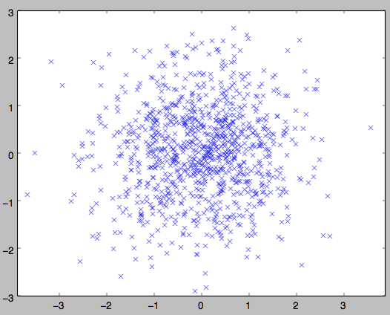
   2. 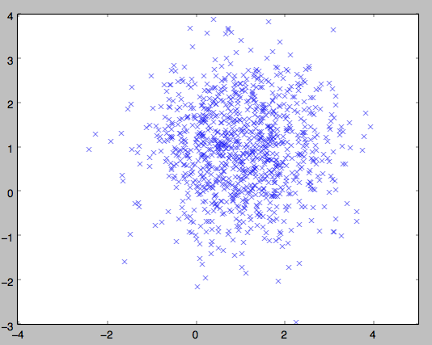
   3. 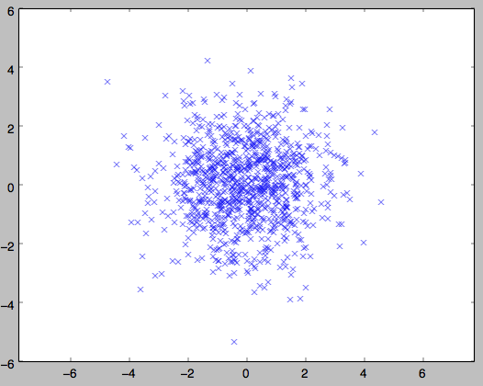
   4. 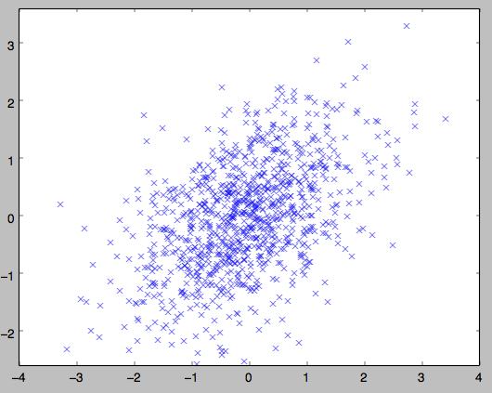
   5. 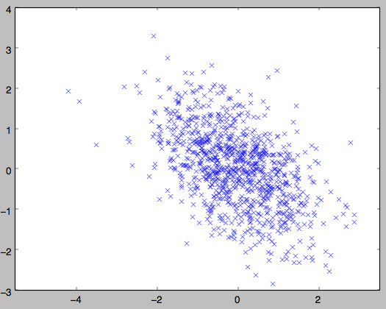
9. [ 0.          0.89442719]
10. 1. Service requests received by the Oakland Call Center
    2. <https://data.oaklandnet.com/Infrastructure/Service-requests-received-by-the-Oakland-Call-Cent/quth-gb8e/data>
    3. The datasets include the information of the requests, such as source, addresses and the predicted value is the request is open, referred or pending.
    4. 481K
    5. 12