WAM Arm
TM

Quick-Start Guide

This Quick-Start Guide steps you through initializing the WAM system and running a simple program (gravity compensation). This can be used in conjunction with the instructional videos located at http://wiki.barrett.com/index.php/WAM_operation_notes for new users. Please refer to the WAM™Arm User’s Manual for more detailed instructions on installation and setup.

Lab Space Setup
Requirements for operation:
- 110/220 VAC, 50-60 Hz (see System Setup in the User’s Guide for power requirements)
- Flat surface to mount WAM using four M10 or 3/8” socket cap screws (see System Setup in User’s Guide for hole placement)
- A networked computer for logging in to the WAM PC

Assembly
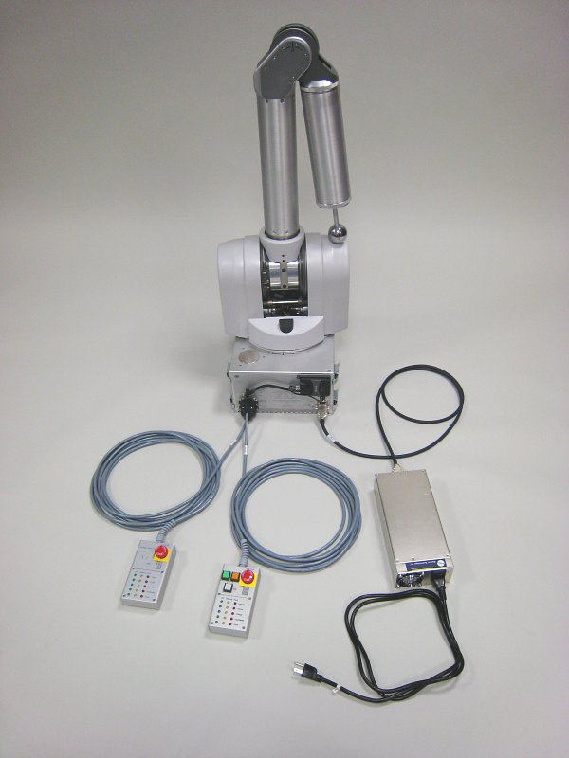
After mounting the WAM to a suitable platform (detailed in User’s Guide), arrange and connect the electrical cables as shown below. If you are using wired Ethernet to communicate between your personal computer and the internal WAM PC, attach the Ethernet cable from the network port on the WAM to a port on an Ethernet switch or hub. If you are using wireless Ethernet, mount the provided wireless access point (AP) to the WAM backplate and connect it to network port of the WAM as shown to the right. When the WAM turns on, it will request an IP address from a DHCP server. The provided AP will return an address of the form: 192.168.nnn.100, and the ssid of the AP is WAM-nnn, where nnn is the serial number of your WAM. You can use a laptop PC or other wireless-enabled device to connect to the AP. You can also log in and configure the AP by going to http://192.168.nnn.30. Username is “admin”, password is “WAM”. Once logged in to the AP, you can check the IP addresses assigned by DHCP by clicking on the “DHCP” button on the left-hand side of the web page. Your PC’s network name will be listed there, and there should be an entry without a name- that is the WAM PC and its corresponding IP address. This is the address you will use to control the WAM. You may want to add a static entry for the WAM in your DHCP server to make future log-ins easier.
Blue DC power cable
Wireless access point
Haptic ball tool
48 VDC power supply
Internal PC/104 WAM control PC
Wireless Access Point
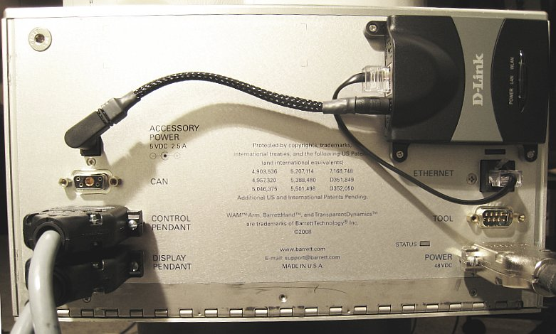
Wireless Access Point
Power for Access Point
Network Port
Display pendant
AC line cord
Control pendant

Starting the WAM™Arm
1) Turn on the main power to the WAM
login: root
password: WAM

--- Linux ---
# cd btclient/src/btdiag
# ./btdiag

2) Use a secure shell (ssh) program (such as PuTTY for Windows)
to connect to the WAM PC
3) Launch control program (btdiag) on WAM PC
4) Follow the on-screen directions:
Turn on 48V supply, then press <Enter>
Safety system comes online
Safety system loads defaults from flash/EEPROM
Safety system mode is set to JOINT velocity limiting
Safety system clears pendant and exercises pendant lights
Fault recovery steps

If the yellow IDLE button is not lit:
- Press ‘x’ to exit the control application
- Press Shift+Reset/Idle to clear the fault
- Return the WAM to its home position
- Re-launch the control application
If the yellow IDLE button is lit:
- Stop any running trajectories (press ‘/’)
- Set the PID controllers to an idle state (press ‘p’, if necessary)
- Stop sending gravity torques (press ‘g’ and enter zero)
- Press Shift+Reset/Idle to clear the fault
- Press Shift+Activate to re-activate the controllers
- Enable gravity compensation

Safety system recognizes critical bus undervoltage, critical fault
Safety system resistively brakes the WAM’s power bus
Make sure both pendant E-STOP buttons are reset (up)
Press <Shift+Reset/Idle> on pendant, then press <Enter>
Safety system clears voltage fault
Safety system releases the resistive braking
Safety system turns on the power bus
Motor controllers come online and wait for “Initialize” command
There is no WAM braking at this stage
Safety system enumerates motor controllers
*** Safety system is fully operational now ***
Safety system registers heartbeat error, displays warning
Place the WAM into the home (folded) position, then press <Enter>
Host program defaults to IDLE (zero-torque) mode
Host program sends “Initialize” command to Motor controllers
Motor controllers load defaults from flash/EEPROM
Motor controllers apply FET braking at WAM motors
Host program sets the motor controllers’ initial positions
Safety system mode is set to CARTESIAN velocity limiting
Host program sets the safety system velocity and torque limits
Host program requests positions from motor controllers
Motor controllers send positions to host program
Default home position
(specified in wam.conf)
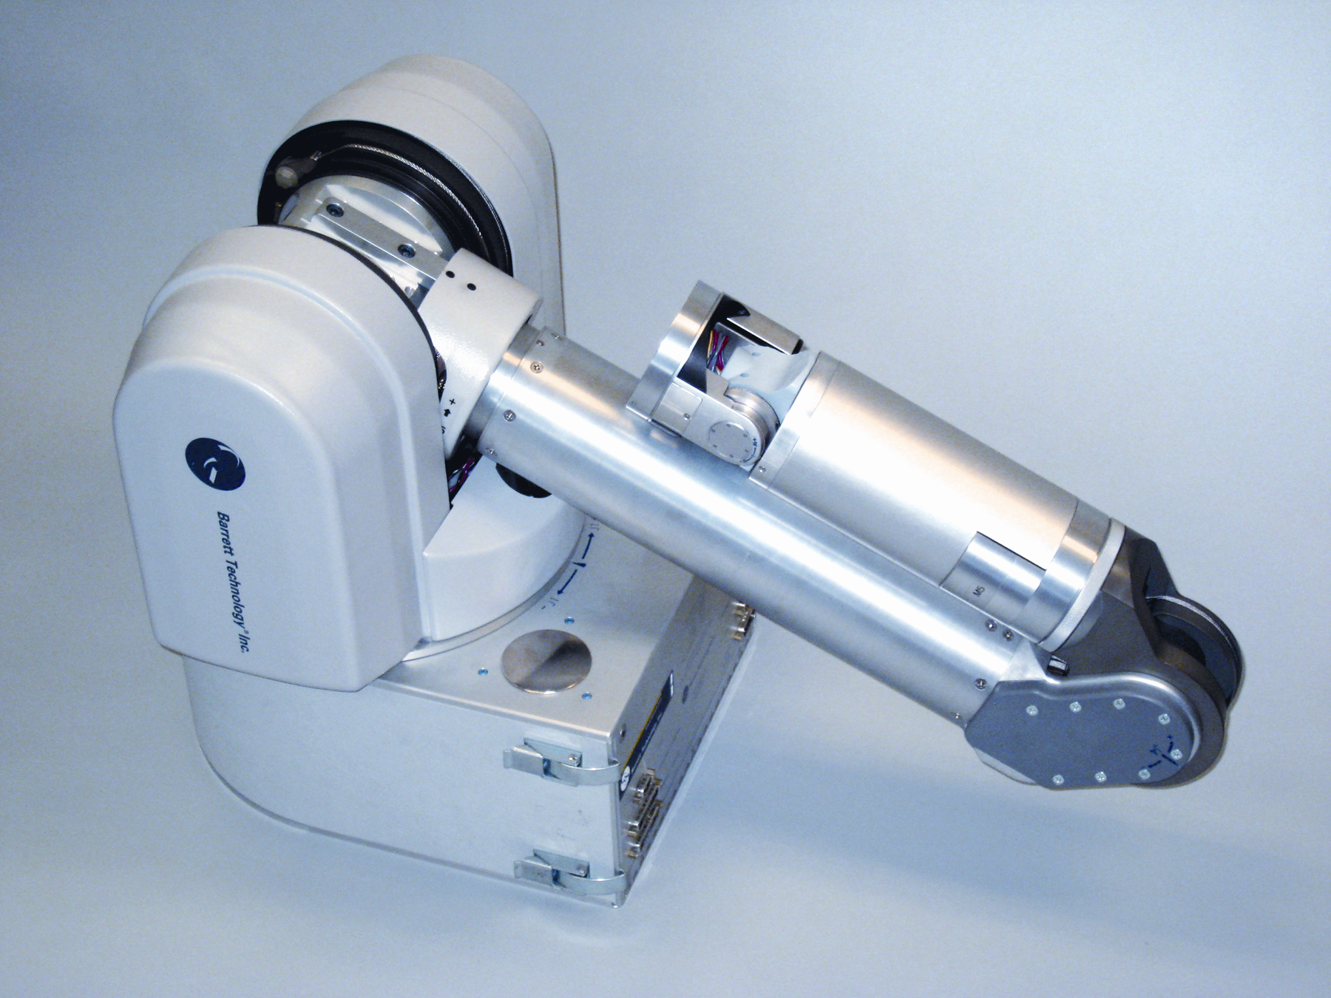
Safety system calculates/limits elbow & arm end-tip velocities
Host program sends zero-value torques to motor controllers
Safety system records latest torques
Safety system clears heartbeat error (it sees periodic torques & positions)
*** Pendant should now display all OK ***
5) Press Shift-Activate on pendant
If there are no warning or faults, safety system tells controllers to “Activate”
Motor controllers release their FET braking and apply received torques
*** Motor controllers are actively commutating zero torque now ***
6) Enable gravity-compensation (press ‘g’, enter ‘1’ for a scaling factor)
Host program calculates and applies gravity compensation torques for the WAM
WAM should be free-floating now
7) Perform a joint-based Teach & Play session
Press ‘<tab>’ until the WAM’s control mode is JOINT (not CARTESIAN)
Press ‘Y’ – Host program begins recording joint positions at 10Hz
Grab the WAM and move it in a desired motion (try not to exceed 1 m/s)
Press ‘y’ – Host program stops recording
Press ‘?’ – Host program moves WAM to initial position, then plays back your recorded motion in a loop
Press ‘/’ – Host program stops playback, returns to gravity-compensation mode

Congratulations! You have set up your WAM Arm!
(Tip: Place the WAM back into its home position, then press <Shift+Reset/Idle> on pendant
before pressing ‘x’ to exit the host program- this will avoid a heartbeat fault)

