Reproducible Research: Peer Assessment 1

## Basic Set-up Processes

This is setting up the working directory, saving the data file link, and saving the downloading date.

setwd("C:/Users/bdfitzgerald/Desktop/Data Science Specialist/RepData_PeerAssessment1")  
data.link <- "https://d396qusza40orc.cloudfront.net/repdata%2Fdata%2Factivity.zip"  
date.download <- format(Sys.time(), "%b %d, %Y")

Note: The data file was downloaded on Jan 13, 2015.

## Loading and preprocessing the data

This process is downloading the data, unzipping the data file, and reading the file into R.

unzip("activity.zip")  
data <- read.csv("activity.csv")  
data$date <- as.Date(data$date)

## What is mean total number of steps taken per day?

Note: If ggplot2 package has not be installed, you will need install the package first.

steps.taken <- aggregate(data$steps, by = list(Date = data$date), sum, na.rm = TRUE)   
colnames(steps.taken)[2] <- "num_steps"

library("ggplot2")  
ggplot(steps.taken, aes(Date, num_steps)) +   
 geom_bar(stat = "identity", colour = "green4",   
 fill = "green4", width = 1) +   
 labs(title = "Total Number of Steps Taken by Day",   
 x = "Date", y = "Number of Steps by Taken per Day")

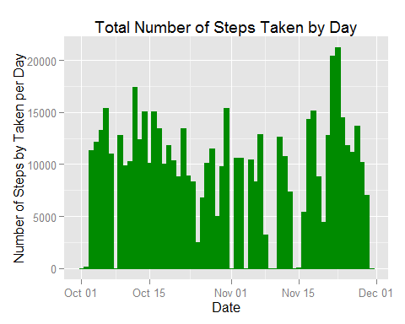

## What is the average daily activity pattern?

## Imputing missing values

## Are there differences in activity patterns between weekdays and weekends?