Retail Expansion Readiness Dashboard
An interactive Excel dashboard and business case analyzing four years of retail sales data to recommend where a company should prioritize a new subsidiary or branch expansion.

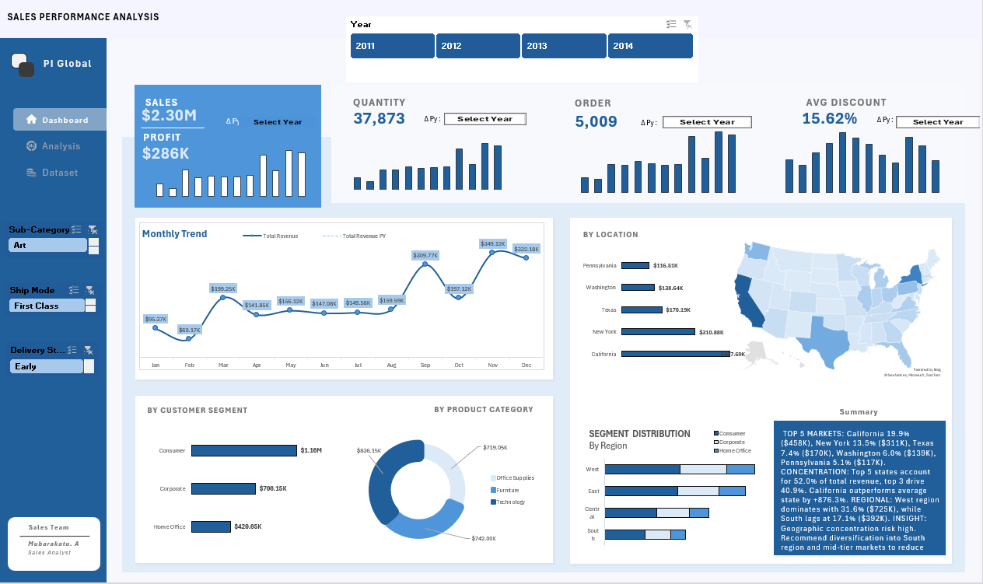

Business Brief
Scenario: A retail superstore is planning a rebrand and the launch of a new subsidiary. Before committing resources, leadership asked for a clean, interactive one-page executive summary to evaluate historical sales patterns and identify the company's strongest markets, segments, and product lines.

Questions the dashboard answers:

- What key metrics define overall business performance, including total revenue, profit, order volume, quantity sold, and average discount rate, and how do these compare on a year-over-year basis? total revenue, profit, order volume, units sold, and average discount rate, and how does it compare year-over-year?
- How have monthly sales trended against the prior year?
- Which customer segments (Consumer, Corporate, Home Office) drive the most revenue and volume?
- Which product categories (Technology, Furniture, Office Supplies) are the top revenue contributors?
- Which states and regions are the biggest revenue strongholds, and how is customer segment mix distributed geographically?
- Where should the company prioritize resources for its new subsidiary?

Data Source
This project uses the Sample – Superstore dataset (9,994 order-line records, 2011–2014), originally distributed with Tableau Desktop as a demo/training dataset and widely mirrored on Kaggle and the Tableau Community. It is synthetic data, used here to demonstrate an end-to-end analysis workflow rather than to represent a real company.

Four columns were engineered on top of the original fields for this analysis: Discounted Unit Price, Profit Margin, Lead Time, and Delivery Status.

What's in the Workbook
Sheet | Purpose
Dataset | Raw order-level data (9,994 rows, 24 columns), loaded as an Excel Table and connected to the Data Model.
Analysis | Staging layer — PivotTable outputs (monthly trend, segment, category, state, and segment-by-region breakdowns) that feed the dashboard's charts and KPI cards.
Dashboard | The final one-page executive summary — see below.

Data model: Built on Power Pivot, with a dedicated Calendar date table related to the Dataset table, and DAX measures for time-intelligence calculations (e.g. Year-over-Year revenue and a prior-year comparison measure using HASONEVALUE / SELECTEDVALUE patterns).

Dashboard components:

- 5 KPI cards: Total Revenue, Profit Generated, Total Quantity, Average Discount, and Total Orders, custom-formatted to display in thousands/millions (e.g. $2.3M, $286.4K) via a dynamic number format.
- Monthly Trend chart: Current-year revenue plotted against the prior year to surface seasonality and YoY momentum.
- Segment breakdown: revenue by Consumer / Corporate / Home Office.
- Category breakdown: revenue by Technology / Furniture / Office Supplies.
- Top 5 states by revenue: geographic revenue leaders.
- Filled map visual: revenue by state, for at-a-glance geographic distribution.
- Segment × Region matrix: how customer segment mix varies (or doesn't) across regions.
- Slicers: Year, Sub-Category, Ship Mode, and Delivery Status, so any visual can be filtered interactively.

Key Insights
- Growth is outrunning profit. Revenue grew ~20.6% year-over-year while profit grew only ~14.4%, as average discounts ticked up and margin slipped, a reminder that top-line growth alone doesn't confirm financial health.
- Furniture is a profitability trap. It drives roughly a third of all revenue but returns a razor-thin margin, dragged down specifically by Tables and Bookcases, which carry the highest average discounts in the catalog and are net loss-making.
- Discounting is the mechanism, not demand. Discount rate and profit margin are strongly negatively correlated; margin turns negative once a line item's discount passes roughly 20%.
- Revenue size is misleading without profitability. California and New York are both high-revenue and high-margin, the strongest expansion signal in the data. Texas, Ohio, Pennsylvania, and Illinois generate comparable revenue but are net loss-making, driven by much heavier average discounting.
- Segment mix doesn't vary by geography. The Consumer/Corporate/Home Office split is nearly identical in every region, so segment mix isn't a useful screen for site selection; regional and state-level profitability is.

Recommendation: Prioritize the new subsidiary in markets with a California/New York profile proven revenue and margin strength, rather than markets chosen on revenue size alone, and address discount governance (especially on Tables and Bookcases) before scaling the current product mix into a new location. See Expansion_Recommendation.docx in this repo for the full one-page write-up.

Skills Demonstrated
Excel Data Model / Power Pivot · DAX measures & time intelligence (YoY, prior-year comparisons) · Power Query · PivotTables & PivotCharts · slicers for interactive filtering · custom number formatting · dashboard design and one-page executive storytelling · translating data findings into a business recommendation.

Repository Contents
Sales_Performance_Analysis.xlsx # Full workbook: raw data, data model, analysis, dashboard

Expansion_Recommendation_Memo.docx # One-page business recommendation memo

assets/

dashboard-preview.png # Screenshot of the Dashboard tab

Data Source Acknowledgement
Sample – Superstore dataset, originally distributed with Tableau (Tableau Software / Salesforce); publicly available via the Tableau Community and Kaggle. Used here for independent portfolio analysis; all figures in this README and the accompanying memo were calculated directly from the raw order-level data.

