**Compiler Design＿ＨＷ０6**

系級：資工１１１　學號：４０７４７０３１Ｓ　姓名：劉子弘

40747031S_hw06.l：

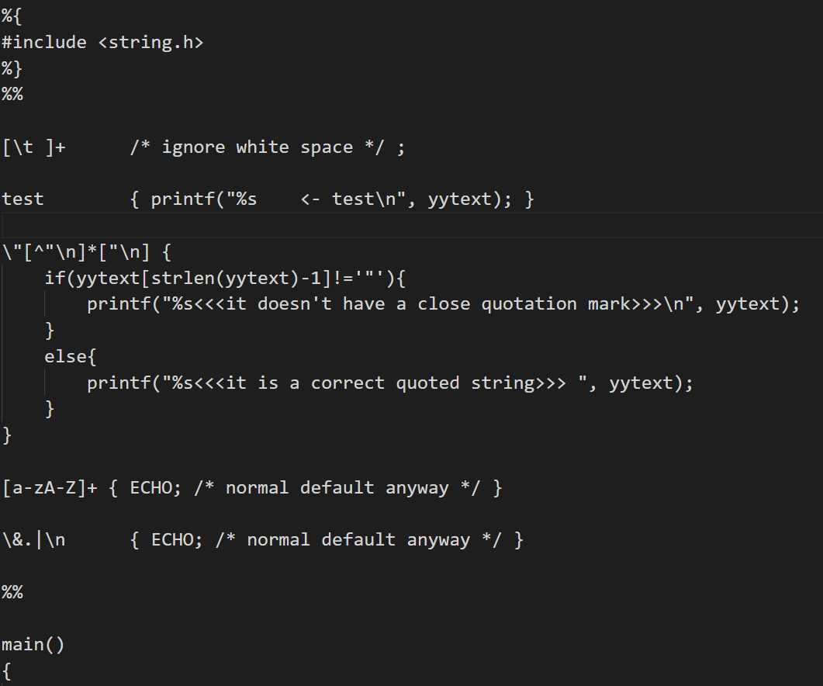

gen_bigc.c

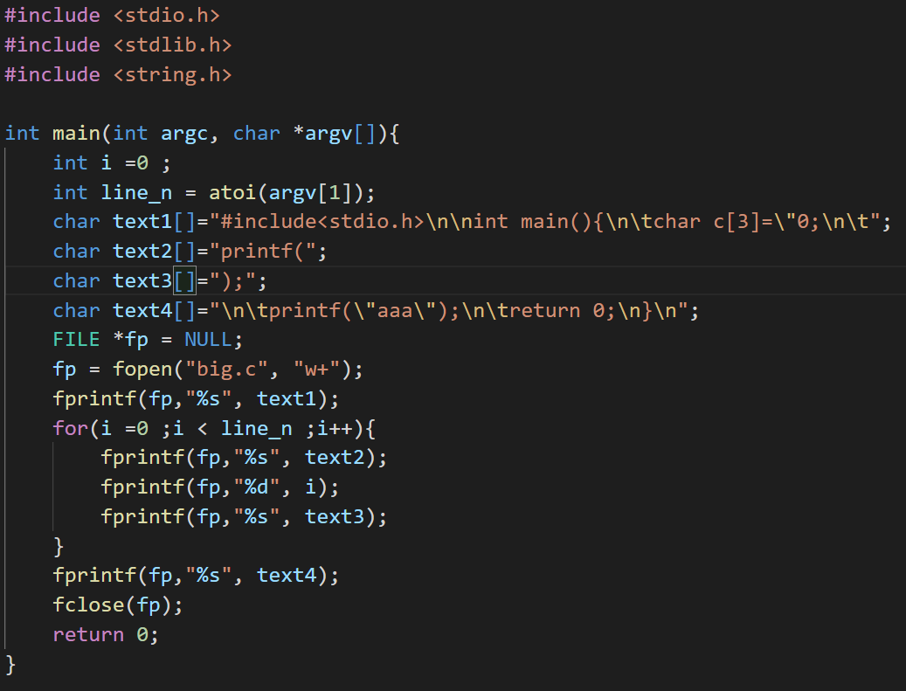

normal.c

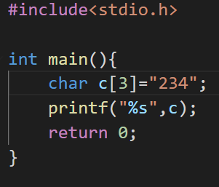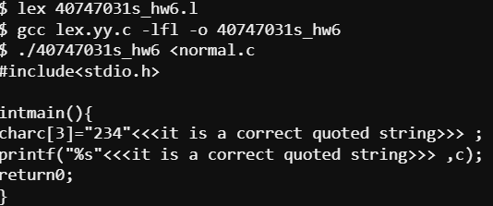

with wrong code

